Major dates concerning the strategic history of Germany:
1648 – 1792 – 1803/06 – 1814/15 – (1848/49) – 1866 – 1870/71 – 1918/19 – 1933 – 1945 – 1949/55 – 1989/90

Germany 1648 (Source: http://www.ieg-maps.uni-mainz.de/gif/p648d_a4.htm):
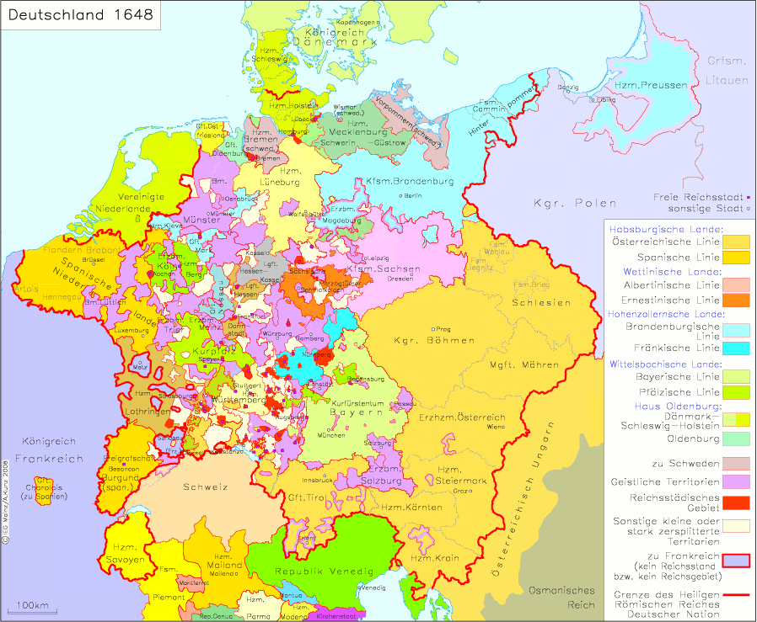

Germany post-WW I (Source: http://www.dhm.de/lemo/objekte/karten/versailles/index.html)
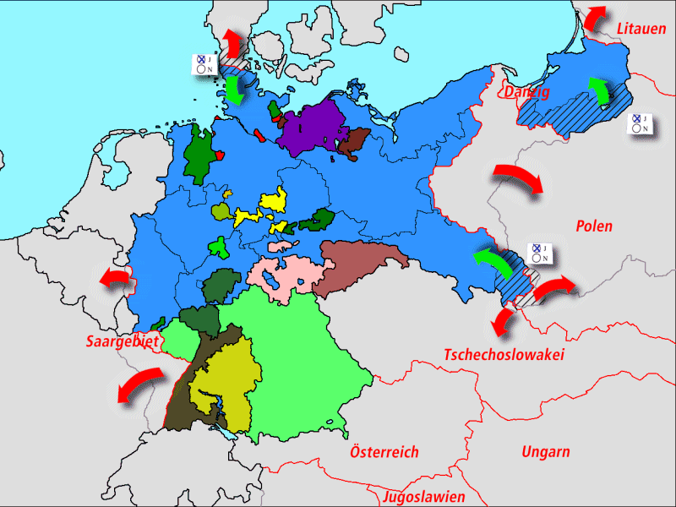

Reading assignment for next week: Treaty of Westphalia http://se2.isn.ch/serviceengine/FileContent?serviceID=23&fileid=BD05098C-2A1C-A7AC-9796-19E4BE38F0B8&lng=en

