CHAPTER 9

FAMILIES, KINSHIP, AND DESCENT

CHAPTER OUTLINE

I. Families

A. Nuclear and Extended Families
1. The nuclear family consists of a married couple and their children.
2. The nuclear family is ego-centered, and impermanent, while descent groups are permanent (lasting beyond the life-spans of individual constituents) and reckoned according to a single ancestor.
3. One’s family of orientation is the family in which one is born and grows up, while one’s family of procreation is formed when one marries and has children.
4. Claims made for the universality of the nuclear family, based upon the universality of marriage, do not hold up--the nuclear family is widespread, but not universal.
5. In societies where the nuclear family is important, this structure acts as a primary arena for sexual, reproductive, economic, and enculturative functions, but it is not the only structure used by societies for these.
6. In many societies, the extended families are the primary unit of social organization.

B. Industrialism and Family Organization
1. The most prevalent residence pattern in Europe is families of procreation living neolocally.
2. In large, industrialized societies, patterns of residence and family types may change from class to class, in response to the conditions of these different contexts (e.g., extended families as a response to poverty).

C. The Family among Foragers
1. The two basic units of social organization among foragers are the nuclear family and the band.
2. Typically, the band exists only seasonally, breaking up into nuclear families when subsistence means require.

II. Descent

A. Descent Groups
1. A descent group is a permanent social unit whose members claim common ancestry.
- With matrilineal descent individuals automatically join the mother’s descent group when they are born. (see picture below)
3. With patrilineal descent individuals automatically join the father’s descent group when they are born. (see picture below)
4. Matrilineal and patrilineal descent are types of unilineal descent in which individuals only recognize one line of descent.
5. A lineage is a descent group who can demonstrate their common descent from an apical ancestor.
6. A clan is a descent group who claims common descent from an apical ancestor but cannot demonstrate it (stipulated descent).
7. When a clan’s apical ancestor is nonhuman, it is called a totem.

B. Lineages, Clans, and Residence Rules
1. In tribal societies, the descent group, not the nuclear family, is the fundamental unit.
2. In many societies, descent groups are corporate, sharing resources and property.
3. Unilocal Residence
a. Patrilocality—married couple lives with husband's family; associated with patrilineal descent and is more common than matrilocality.
b. Matrilocality—married couple lives with wife's family; associated with matrilineal descent and is less than patrilocaility.

C. Ambilineal Descent
1. People can choose the descent group that they want to belong to.
2. Membership is fluid as people can change their descent group membership.
3. With unilineal descent, membership is ascribed, but for ambilineal descent, membership is achieved.

III. Kinship Calculation

A. Kinship calculation is any systemic method for reckoning kin relations.

B. Genealogical Kin Types and Kin Terms
1. Kin terms are the labels given in a particular culture to different kinds of relatives.
2. Biological kin type refers to the degree of actual genealogical relatedness.

C. Bilateral Kinship
1. Used by most Americans and Canadians
2. Kinship is traced through both male and female lines.
3. Kin links through males and females are perceived as being similar or equivalent.

IV. Kinship Terminology (see pictures below)

A. Kinship terminologies are native taxonomies (emic), not developed by anthropologists.

B. Lineal terminology: most Americans and Canadians use lineal terminology, which distinguishes lineal, collateral, and affinal relatives. (see picture below)

C. Bifurcate merging terminology: this is the most common, associated with unilineal descent and unilocal residence.

D. Generational terminology: typical of ambilineal societies, this calls ascending, same sex relatives by the same names.

- Bifurcate collateral terminology: common to North Africa and the Middle East, this is the most particular system.

Matrilineal descent group
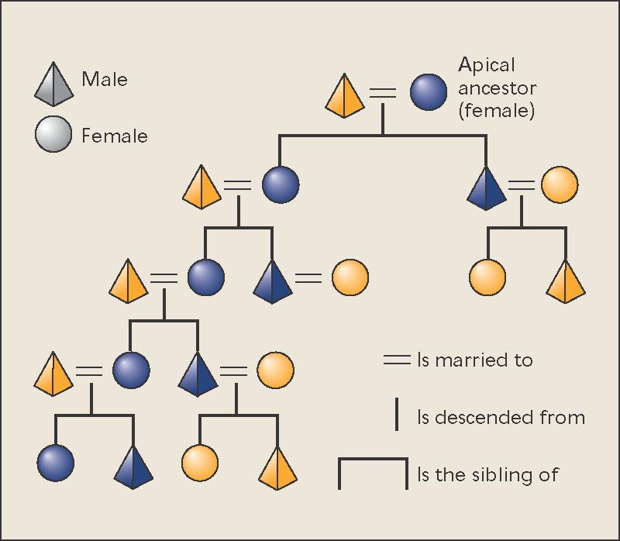

Patrilineal descent group
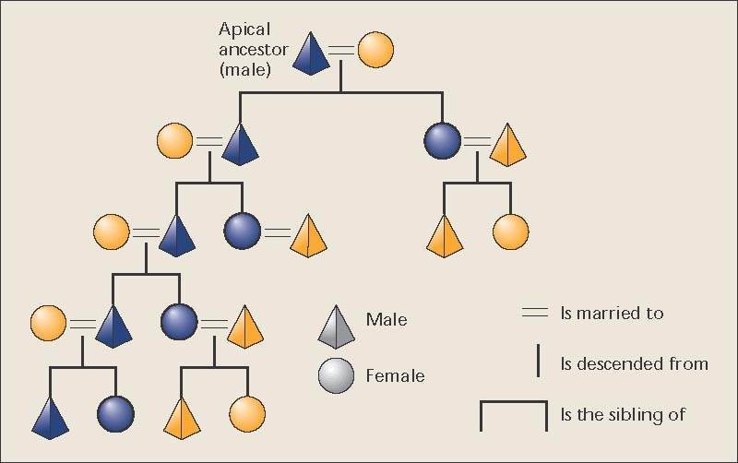

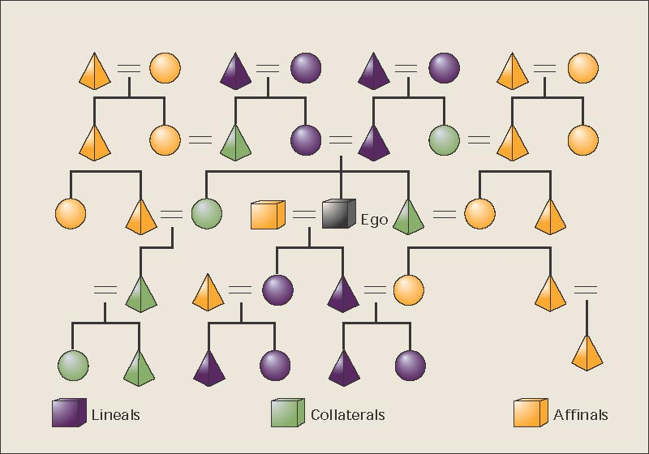
lineals, collaterals, affinals

Lineal terminology
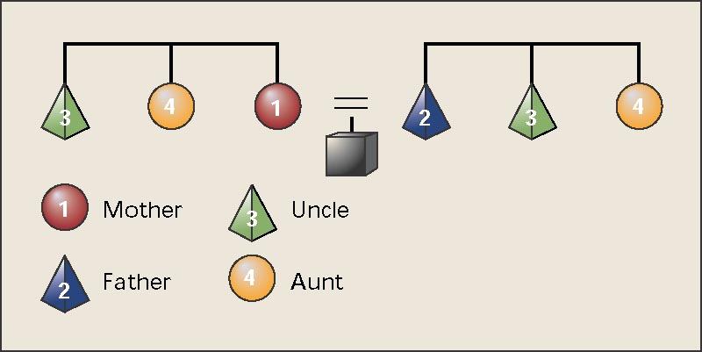

Bifurcate merging terminology
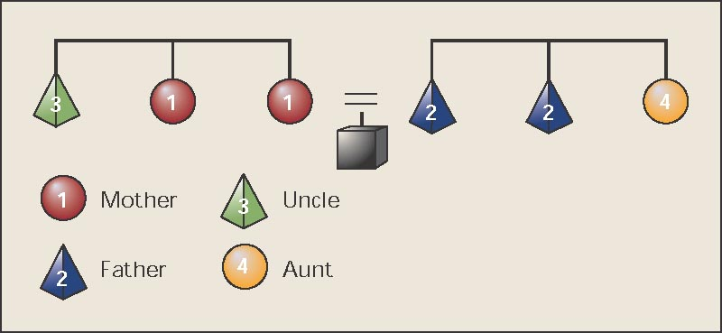

Bifurcate collateral terminology
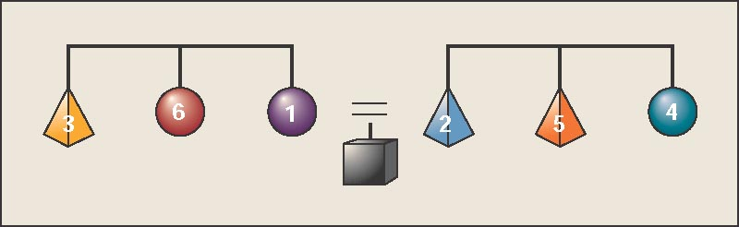

In ancient Slovak: 1 – matka, 2 – otec, 3 – ujo, 4 – stryná, 5 – strýko, 6 – teta

Generational terminology
