Masaryk University
Exploring Local Economic Alternatives
Tutor: Tim Crabtree

Assignment
Students will be asked to choose and describe a local food enterprise – this can be real or hypothetical – and describe the key inputs required. They will then be asked to describe the key operations of the enterprise and the way in which those operations will be managed. Students will explore how outputs will get to consumers, through marketing and distribution. They will also how waste will be eliminated or recycled. Finally, students will explore opportunities for collaboration with other local food initiatives.

- Name of the enterprise and brief description of activities

- Key purpose of the enterprise

- Key services, and outcomes sought

Key services:

Outcomes:
- Economic
- Social
- Environmental

- Who are the customers/clients of the enterprise?

Include where appropriate:
  - Direct (paying customers)
  - Indirect (providers of third party payments, e.g. foundations & government)

- Describe your operations

What are you producing? Include goods and services if relevant.

What do you have to do to produce these outputs?

- Inputs – the 5 capitals

6.1 Social capital

Who are the members of your enterprise?

Social economy initiatives have some element of “social ownership” -
- Consumer membership
- Employee membership
- Supplier membership
- Investor membership (with limited rights)

What rights will the members have?

Potential stakeholder | Membership:  Yes or no? | Voting rights? | Income rights? | Property rights?
Consumer

Employee

Supplier

Investor

What rules will you adopt?

E.g.
- charity
- co-operative
- company

6.2 Financial capital

Who will provide this?
  - Grants?
  - Loans?
  - Equity?

6.3 Natural Capital

What natural capital will you require:
  - Resources
  - Sinks
  - Services

Will you be able to access any commons-based, non-market inputs?

6.4 Physical Capital

What is required?
  - Buildings
  - Equipment
  - ICT
  - etc

Will you be able to access any commons-based, non-market inputs?

6.5 Human Capital

What will your enterprise require?
  - Staff?
  - Volunteers?
  - Trainees/apprentices?
  - People disadvantaged in the labour market?
  - Board members?

Will you be able to access any commons-based, non-market inputs?

- Summary diagram 1

Please create a summary diagram, using the template below. Please fill in the boxes with your own details:

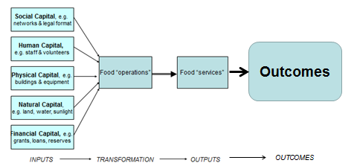

- Creating a circular, sustainable enterprise

- Think about pollution, waste and resource conservation
- How could you address this by creating circular, closed loop processes?

- Involving customers

Could your customers provide social capital, human capital or financial capital?
Please describe how they might do this.

- Summary diagram 2

Please draw a summary diagram, using the model described during the course:

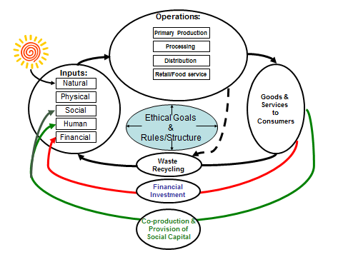

- A note re costs:
The model which you have built can be used as a starting point for business planning, where the costs of inputs and the costs of operations will be identified to create income and expenditure, and cash flow, estimations.

- Building local food systems

Describe how your enterprise could collaborate with one or more enterprises in its region

Please send completed assignments, marked with your name, to:

tim.crabtree@schumachercollege.org.uk

Deadline: 30 November, 2012

