Tim Crabtree
Discussion paper for the new economics foundation

Think and Do: Linking the National and the Local

1. Introduction

This brief paper has been written by an ex-employee of nef to stimulate a dialogue between current staff at the organisation and people working independently “in-the-field” to implement “new economics” solutions. The new economics foundation was established 20 years ago, in 1986, so it is an interesting juncture to be reflecting on progress around the new economics agenda. This paper suggests that there is much scope for linking the work of a national “think-tank” with action on the ground, but that it is sometimes difficult to reconcile the demands faced by policy organisations to focus on “realistic solutions” with the work of local organisations which can appear marginal, piecemeal or lacking in wider applicability.

In the South West, a number of organisations active at a local level have linked together through the Wessex Reinvestment Trust (a community development financial institution), and are proactively developing new economics approaches – it is hoped that this paper could stimulate a discussion with colleagues in the new economics foundation and possibly encourage some areas of joint working.

The paper briefly explores three levels of new economics activity at a local/regional level:
Level 1: direct provision of goods and services which meet local needs;
Level 2: provision of secondary business services, in order to underpin the provision of goods and services;
Level 3: the embedding of the 4 key “factors of production” - land, labour, capital and knowledge – in non-marketised (or de-commodified) frameworks, to ensure their availability for levels 1 & 2.

It is suggested in the paper that the building of a “new economics” at these 3 levels will entail building economic institutions that are subordinated to 3 key principles:
- direct and participative democracy in the economy (control by producers, consumers or community, or a combination of the 3);
- environmental sustainability (meeting the needs of the present generation without compromising the ability of future generations to meet their own needs);
- social justice (including equality of opportunity and redistribution of wealth).

Of course, building “new economics” structures is not an easy task, not least because we have to deal not just with the supply side but also with the processes which create demand in an economy. In particular, it is important to understand the personal and political processes which create attachment and dependency and thereby underpin the status quo (these have been well explored by writers such as Erich Fromm, Carl Rogers and E.F. Schumacher, and more latterly by Jeremy Seabrook, Oliver James, etc). These are themes which are at the heart of the current debates about well-being, and were explored in the early days of nef for example through projects on the economics teachings of the world’s religions. The key point here is that we are discussing not just technical solutions and institutional innovations but also deeper psychological processes which resist the adoption of “new” ways of acting.

Erich Fromm describes the problem:
“While the majority of people living in the west do not consciously feel as if they were living through a crisis of western culture (probably never have the majority of people in a radically critical situation been aware of the crisis), there is agreement, at least among a number of critical observers, as to the existence and the nature of this crisis. It is the crisis which has been described as “malaise”, “ennui”, mal du siecle”, the deadening of life, the automatization of man, his alienation from himself, from his fellow man and from nature. Man has followed rationalism to the point where rationalism has transformed itself into utter irrationality. Since Descartes, man has increasingly split thought from affect; thought alone is considered rational – affect, by its very nature, irrational: the person, I, has been split off into an intellect, which constitutes my self, and which is to control me as it is to control nature. Control by the intellect over nature, and the production of more an more things, became the paramount aims of life. In this process man has transformed himself into a thing, life has become subordinated to property, “to be” is dominated by “to have”. Where the roots of Western culture, both Greek and Hebrew, considered the aim of life the perfection of man, modern man is concerned with the perfection of things, and the knowledge of how to make them. Western man is in a state of schizoid inability to experience affect, hence he is anxious, depressed and desperate. He still pays lip service to the aims of happiness, individualism, initiative – but actually he has no aim. Ask him what he is living for, what is the aim of all his strivings – and he will be embarrassed. Some may say they live for he family, others “to have fun”, still others, to make money, but in reality nobody knows what he is living for; he has no goal except the wish to escape insecurity and aloneness.”
Erich Fromm Psychoanalysis and Zen Buddhism, Unwin Paperbacks 1960

Jeremy Seabrook gives his own explanation of the problem:
“Those who propose economic alternatives often refer to them as though the problems were mainly technical. If these can be solved, it is felt, people will see the logic and necessity for change, and everything will fall naturally into place. The truth is that this takes no account of the real relationship between the majority of the people and the existing structures; and that, far from being a technical or intellectual problem, the habits of attachment to, and the fear of loss of, what already exists are deeply emotional and irrational.
If the status quo survives relatively unscathed, it is not because of apathy, as it is sometimes asserted, but because of the creation of dependency, which is an essential part of its project………..
Our much vaunted freedom of choice does not occur in a void. If freedom of choice has any meaning, it must surely imply choosing in the full knowledge of the foreseeable consequences, implications and effects of our choices. But we have given ourselves, or have been given, permission to live them only at the point of consumption, dissociated from any of the disagreeable consequences, like children carefully shielded by those who know best from any awareness that death and disease exist in the world. And these consequences which have been severed from our choices take their toll, not only in the lives of the poorest on earth, but equally within the rich societies of the West………..
Our project must be to make connections that have been allowed to lapse, or have remained in shadow. “
Jeremy Seabrook ‘Needs and Commodities’ in Ekins, P (ed) The Living Economy, 1986

2. Needs, not wants – a key element of the new economics critique of market liberalism

The aim of the “new economics” is to promote individual well-being while supporting sustainable communities. The debate about well-being is complex, but one key strand is the debate about needs and wants. Manfred Max-Neef explains further:

“The best development process will be that, which allows the greatest improvement in people’s quality of life. The next question is: what determines people’s quality of life? Quality of life depends on the possibilities people have to adequately satisfy their fundamental human needs……Fundamental needs are finite, few and classifiable. Fundamental human needs are the same in all cultures and in all historical periods. What changes, both over time and through cultures, is the way or the means by which needs are satisfied.”
From ‘Human Scale Development’, in Development Dialogue, 1989:1

Max-Neefs’ basic needs are subsistence, protection, affection, understanding, participation, idleness, creation, identity and freedom. These needs are then satisfied in various ways, including through the production of economic goods and services.

individual well-being & sustainable communities
requires

satisfaction of basic needs, through e.g.
food
energy
housing
care
culture
communication

Needs are met not by the market alone. Wealth creation (the enhancement of well-being and the maintaining of sustainable communities) occurs in four ways, and together these four processes constitute the “whole economy”:
- production by “households”;
- production through processes of mutuality and reciprocity;
- production for exchange in markets;
- production by the public sector.

whole economy approach
Householding
/ self-help / DIY
Mutuality / reciprocity / volunteering
Market exchange
Public provision & redistribution

Over the last 25 years, market liberalism has become the dominant political and economic ideology, and the market has increasingly “crowded out” activity in the other sectors.
- much of the production formerly undertaken at the household level has transferred to the market sector;
- mutuality and reciprocity is now much less widespread, as individualism usurps mutuality;
- production of many of the goods and services formerly created by the public sector has now been “privatised”.

Market liberalism promotes the notion of preferences (or wants) in place of the issue of needs, and argues that “freeing up” the market will lead to the greatest welfare. This is an enormous area, which will not be explored here, but according to Joseph Stiglitz:
“Today, there is no respectable intellectual support for the proposition that markets, by themselves, lead to efficient, let alone equitable outcomes.”

The “old” economics, based on the ideology of self-regulating markets free from government intervention, has caused a crisis in the key areas of need – a long series of food crises (BSE, FMD, CHD, obesity, etc), an energy crisis (global warming, peak oil), a housing crisis (lack of affordable housing and a growing divide between those with an equity stake and those building up the assets of the rich), a cultural crisis (the “culture” of violence in schools, binge drinking on the streets, etc), a crisis of care (how do we care for an ageing population, how do we pay for pensions, etc), a crisis of communication (increasing ways to communicate, but less and less actual talking and listening), a crisis of transportation (congestion, pollution, unsustainable air travel, etc).

Again, this is an enormous area, but these negative effects have been analysed in terms of:
- increasing alienation due to the dominance of wants over needs, underpinned by a stress on effective demand not re-distribution or socially-useful production;
- the free-rider problem inherent in un-regulated market processes, causing externalities, including pollution and adverse health impacts;
- the commodification (and consequent privatisation) of land, labour, capital, and knowledge, as identified by Marx, Polanyi and others.

3. Embedding the economy in society: from market economy to social economy

Despite rhetoric to the contrary, the main political parties in the U.K., and the agencies of government at all levels, remain committed to the agenda of market liberalisation. Even the former “new economics” supporter Jonathan Porritt has decided that there is no alternative to capitalism, and that the market is the route to sustainability!

Many people would disagree with such a conclusion, and I will argue in this paper that the “social economy” offers the seeds of a transformation of the market and the wider economy. The social economy combines non-market activities based on mutuality, reciprocity and volunteering with market-based activities subordinated to basic needs and the 3 principles described above.

satisfaction of basic needs, e.g.
food
warmth
shelter
care
culture
transport

whole economy
Householding
/ self-help / DIY
Mutuality / reciprocity / volunteering
Market exchange
Public provision & redistribution

production in the social economy
Social
enterprises
Co-operative and ethical businesses
Voluntary/ community initiatives

It should be noted, however, that the approach described in this paper does not preclude working with the public sector or private businesses driven by profit.
4. Social economy development in Devon, Dorset and Somerset

Over the last 10 years there has been a growing level of “new economics” or social economy activity in Devon, Dorset and Somerset. Many of these initiatives are connected through the Wessex Reinvestment Trust (a rural Community Development Finance Initiative) – either through membership or through investment in activity.

These activities are taking place at the 3 levels described above:
Level 1: direct provision of goods and services which meet local needs;
Level 2: provision of secondary business services, in order to underpin the provision of goods and services;
Level 3: the embedding of the 4 key “factors of production” - land, labour, capital and knowledge – in non-marketised (or de-commodified) frameworks, to ensure their availability for levels 1 & 2.

The participants are also committed to ensuring that the economic institutions being developed are subordinated to the 3 key principles:
- direct and participative democracy in the economy;
- environmental sustainability; and
- social justice.

Examples of these activities are given below.

4.1 Direct provision of goods and services which meet local needs

As explained above, profit-driven, free-market capitalism is failing to satisfy basic needs, by focusing on the production of goods which are not genuine satisfiers, by creating unsustainable externalities or through by-passing whole sections of the population who cannot mobilise effective demand.

In Devon, Dorset and Somerset there is a growing level of new economics activity focused on two particular areas of need: food and housing. These initiatives share a commitment to social justice, environmental sustainability and economic democracy (though with different emphases – e.g. affordable intermediate market housing and sustainable housing produced for sale at market prices).

Food:

West Dorset Food and Land Trust
An educational charity which started Farmers’ Markets in the county, runs a range of cookery workshops and deliver vocational training. The Trust has established a Centre for Local Food (see below) which offers managed workspace and a commercial kitchen.

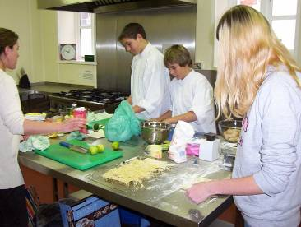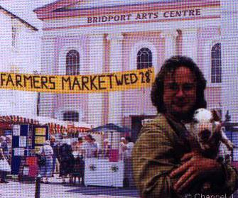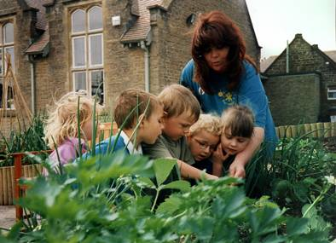

Local Food Links
The Trust’s trading subsidiary, which runs a fruit scheme supplying schools, fruit & veg stalls, and is now operating a hot lunch scheme for primary schools (which in Dorset have no kitchens).

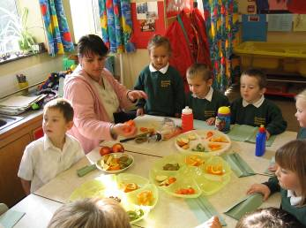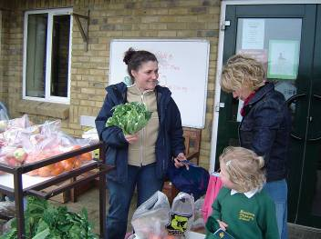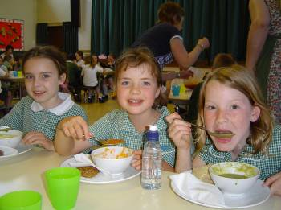

Dorset Farmers’ Markets Ltd
This producer led organisation has taken on the running of 12 markets across the county.

Somerset Food Links
An independent agency with 3 key aims:
- To help producers sell more of their produce locally
- To raise awareness of the benefits of locally produced food
- To help consumers find ways to buy locally produced food
SFL has supported the development of 3 independent social enterprises (see below), and is currently developing proposals for a Somerset Centre for Local Food.

Somerset Local Food Direct
A producer led company which distributes local food from 40 producers to households and via village shops. It has traded for 5 years, and has 280 weekly customers spending an average of £40. Weekly turnover is £12,000.

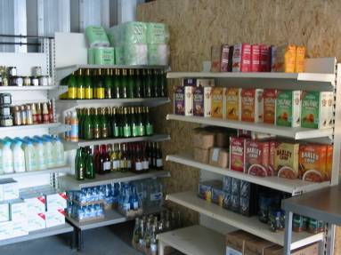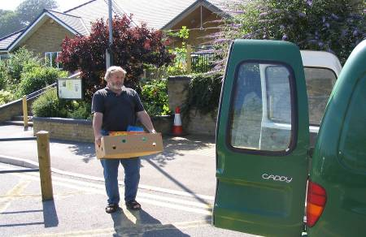

Somerset Organic Link
A producer co-operative with linked marketing company. 5 producers are involved, it has been trading for 3 years and has an annual turnover of £300,000. Customers include community food co-ops, Local Food Links and retailers.
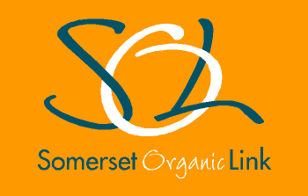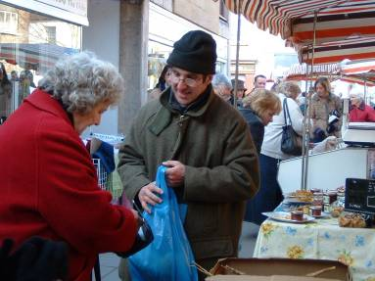
Source (Exmoor and Quantock Local Food Ltd)
A producer led company with 25 members, which distributes local food to retail outlets, tourism businesses and caterers.
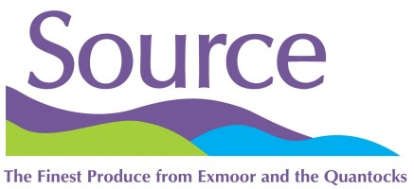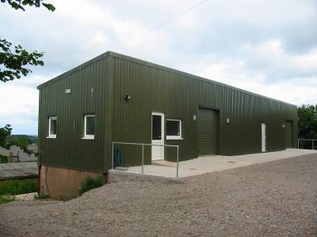

Housing:

Somerset Trust for Sustainable Development & SW Eco-Homes:
Great Bowyard Development
The Trust and its trading subsidiary are promoting sustainable construction, and have completed their first development of 12 green homes in Langport.

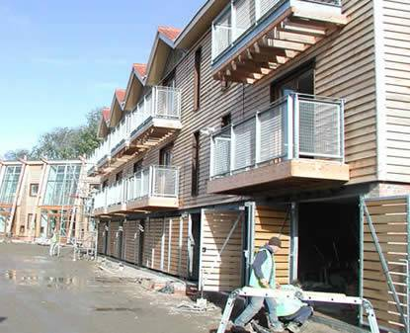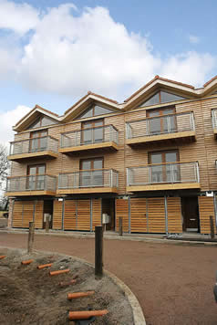

Bridport Community Property Trust
The Countryside Agency funded research into the feasibility of a community land trust structure for the Bridport area. The research was hosted by Wessex Reinvestment Trust, in partnership with West Dorset Food and Land Trust. The Property Trust is seeking to purchase a site from Wessex Water to create a community resource centre and affordable housing. In addition, the Trust is seeking to work with partners on the redevelopment of the St.Michael’s Trading Estate. Proposals include a new covered market and retail space for local food.

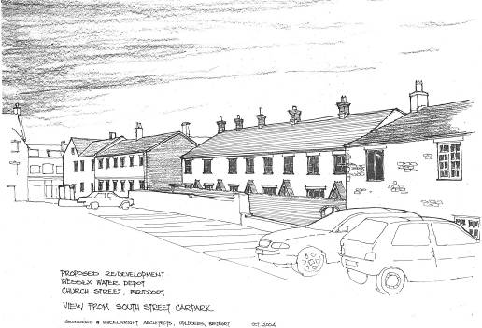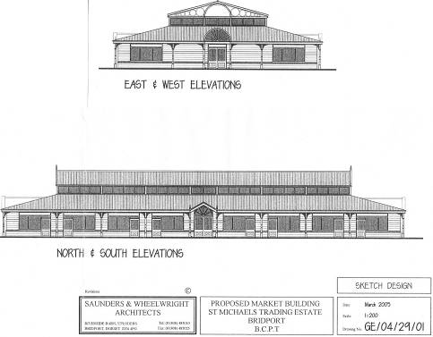
Buckland Newton Community Land Trust
A CLT is being established to support the development of “intermediate market” housing on an exception site at the edge of this village in West Dorset. Sustainable construction methods are being explored, including straw bale, in order to address build costs and running costs.

High Bickington Community Property Trust
The Trust has been established by the community to develop a farm owned by the county council. The redevelopment would encompass housing, workspace and a school.

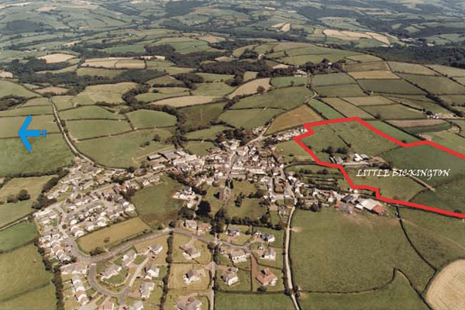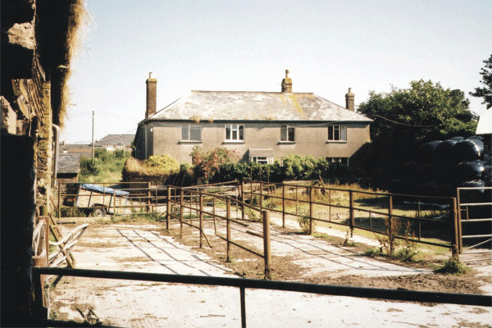

4.2 Secondary services

Many social enterprises provide a secondary services or “Community Anchor” function, by providing a series of secondary services. These can support the production of goods and services by other actors within the economy.

basic needs, e.g.
food
warmth
shelter
care
culture
communication
production in the social economy
Social
enterprises
Co-operative and ethical businesses
Voluntary/ community initiatives
secondary services
Workspace & Facilities Mgt
Technical assistance/ training
ICT services
Local supply chain services
Fund-raising & financial mgt

Bridport Centre for Local Food
In Bridport, West Dorset Food and Land Trust has established a managed workspace, the Centre for Local Food, and there is also a new organisation - Social Enterprise West - developing a service offering around technical assistance, facilities management, financial management and ICT services.

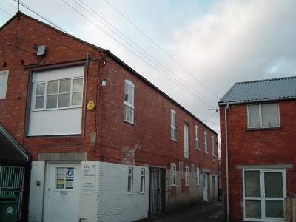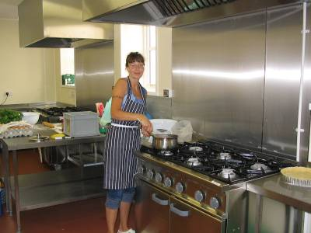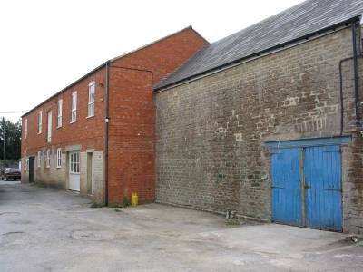

Lyme Regis Community Resource Centre
In Lyme Regis, the Development Trust is currently completing the purchase of the St.Michael’s Business Centre from West Dorset District Council. The Trust has been assisted by Social Enterprise West and Wessex Reinvestment Trust.

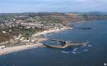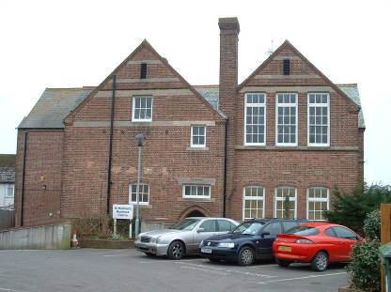

Somerset Centre for Local Food

The Centre will be a partnership with the National Trust at Barrington Court. There will be an educational centre and training kitchen, as well as retail units and the rental of workspace and offices. A Community Interest Company, Limited by Share, is proposed for the development and operation of the Centre.

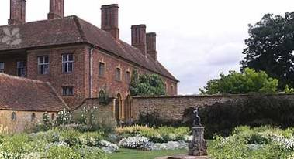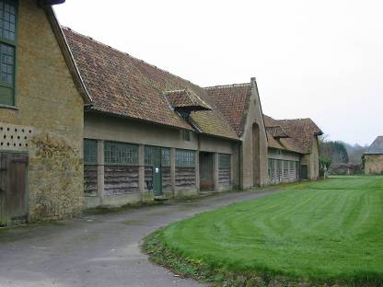

4.3 Trusteeship and “common-wealth” functions
Thirdly, social economy organisations can play a role in safeguarding and making available a set of resources which, arguably, should not be entirely “privatised” and “commoditised”. These resources are land, labour, capital and knowledge. Any community, if it is to meet its basic needs, will need access to these 4 resources, but they are all subject to different types of “market failure”:

- Land: In rural areas of the South West, land for housing and employment cannot be “created” (because of natural and planning constraints) so the market cannot clear at levels that are affordable for local residents and businesses. The logical solution is to hold land in trust, and create markets for the housing or workspace alone. This separation of the land from the buildings is a “community land trust” approach, and can ensure availability and permanent affordability. It also allows tenants to have equity participation through their leaseholds.

- Labour: Young people are leaving rural areas, because of the greater financial (and non-financial) rewards in larger urban areas, but there is a need to attract back younger individuals with skills and experience. This is another area of market failure which could be addressed through links with FE/HE institutions, intern programmes linked to social economy activity and so on.

- Capital: levels of aggregate savings in areas such as West Dorset are high, but the majority of these funds are not reinvested in the local economy. There is therefore a need for “reinvestment” mechanisms which can offer local investors secure opportunities in enterprise and asset-based projects.

- Knowledge: through patenting and the processes described under the “labour” section, areas like West Dorset are struggling to compete in the knowledge-based economy. There is therefore a need for local learning processes linked to “open-source” knowledge.

A social economy organisation, then, can play a role in acting as a “trustee” of such resources, for the benefit of the community, or act as a co-ordinating body which accesses such resources to support secondary services or direct provision. This is summarised in the diagram below:

Labour

Local or regional development organisation:
- Trusteeship
- Co-ordination

Land

Capital

Knowledge

The three levels of economic activity can be represented diagrammatically:

The diagram below shows where actual activity might fit within the model:

It should be noted that the underlying theory for the approach described in this paper is drawn from Karl Polanyi, whose work “The Great Transformation” argued that land, labour and capital should not be treated as commodities and made subject to “self-regulating” markets.

Fred Block, in his Introduction to The Great Transformation, writes:

“For Polanyi, the definition of a commodity is something that has been produced for sale on a market. By this definition, land, labour, and money are fictitious commodities because they were not originally produced to be sold on a market. Labour is simply the activity of human beings, land is subdivided nature, and the supply of money and credit in modern societies is necessarily shaped by governmental policies. Modern economics starts by pretending that these fictitious commodities will behave in the same way as real commodities, but Polanyi insists that this sleight of hand has fatal consequences:

"Our thesis is that the idea of a self-adjusting market implied a stark utopia. Such an institution could not exist for any length of time without annihilating the human and natural substance of society; it would have physically destroyed man and transformed his surroundings into a wilderness.”

Severyn Bruyn, in Real Life Economics (ed. Paul Ekins and Manfred Max-Neef), develops Polanyi’s idea of embedding “fictional” commodities in institutions separate from the market. He argues that these institutional innovations are the land trust, the democratic firm (for the labour element e.g. ESOPs and Mondragon), the community development credit union (in the UK, CDFIs), local learning centres (for knowledge) and community development corporations (in the UK, development trusts or similar bodies) to provide co-ordination.

5. Level 3 activity in the South West: the role of Wessex Reinvestment Trust

In the South West, a set of partners in the social economy and the public sector have come together to create an institution, the Wessex Reinvestment Trust, which assists in the mobilisation of these four key factors of production.

The Wessex Reinvestment Trust Group is developing programmes designed to increase the availability of:

Capital: through business loans, home loans, and increasingly through “reinvestment” mechanisms.

Land: through promotion of common ownership and trusteeship mechanisms such as community land trusts, community property trusts and development trusts (this work is carries out in partnership with organisations at a local level).

The WRT Group is also developing a role focused on the factors of Labour and Knowledge. This role would underpin work on the Land and Capital factors by WRT Group and local partners. It would also provide a supply of Labour and Knowledge into organisations directly delivering goods and services at the local level.

The conclusion has been reached that the supply of labour and knowledge in the Wessex area – both for the work being undertaken by the WRT Group and its partners in relation to the mobilisation of land and capital, and for use by WRT supported initiatives at a local level – is inadequate or constrained by cost.

This conclusion is based on a number of observations, touched on above:
- The need to build capacity both within the WRT Group and of local partners, as the scale and complexity of asset development and enterprise projects increases.
- The difficulty of recruiting suitable staff, particularly at a local level e.g. in market towns.
- The underlying out-migration of young people from rural areas, who seek education or employment opportunities elsewhere, but are discouraged from returning due to high house prices and/or available career opportunities and wage levels.
- The difficulty of identifying suitable candidates who have both technical expertise/experience and a commitment to the 3 key principles of the WRT Group and its partners at a local level (social justice, environmental sustainability and economic democracy).

Research into the Mondragon Co-operative Corporation (200 co-ops in the Basque area of Spain who currently employ 70,000 people) shows that mobilisation of the Labour and Knowledge factors has been crucial to the success of the group. In particular the Technical College, Research Institutes and Business Incubation Programmes have been essential in supporting the growth of the co-operatives, and have worked closely with the group’s bank (the Caja Laboral Popular).

The charity within the WRT Group is therefore currently seeking funds to establish a Wessex Research Institute (or “Wessex Academy”) which focuses on the Labour and Knowledge elements.

Labour: the aim would be to increase the supply of labour into initiatives of the WRT Group or its key partners at a local level, through:
- Internships
- Work placements
- Work-based learning programmes

Knowledge: the aim would be to increase the knowledge base around re-investment (availability of capital) and community asset development (availability of land). This would be achieved through:
- Research and development projects.
- Knowledge transfer from HE and FE institutions.
- Training programmes and Action Learning Sets for WRT Group staff and key partners.
- Web-based learning and knowledge sharing tools.
- Monitoring and evaluation programme.
- Dissemination of good practice.

These roles are shown in the diagram below alongside the mobilisation of Land and Capital.

LAND LABOUR KNOWLEDGE CAPITAL
ECONOMIC
INITIATIVES SATISFYING
LOCAL NEEDS
Support for CLTs, CPTs, Dev Trusts
Reinvestment mechanisms, business loans & home loans
WRS and local Reinvestment Services
WRT Charity
WRS, Wessex Business Loans & Wessex Home Loans

6. Conclusion

The image of a triangle has been used to portray the three levels of economic activity, because economic activity designed to satisfy needs should rest on a stable base of secondary support and institutions or processes which make land, labour, capital and knowledge available.

However, the image of a triangle can suggest that the economy is a static entity, and also fails to show the enormous diversity of activity at level one. Max-Neef points out that while human needs are finite, satisfiers of those needs are culturally determined and therefore constantly evolving:
“The very essence of human beings is expressed palpably through needs in their twofold character: as deprivation and as potential. Understood as much more than mere survival, needs bring out the constant tension between deprivation and potential which is so peculiar to human beings………..To understand human beings in terms of needs, that is, conceived as deprivation and potential, will prevent any reduction of the human being into a category of a restricted existence. Moreover, if needs are conceptualised in this way, it is inappropriate to speak of their being ‘satisfied’ or ‘fulfilled’. They reflect a dialectic process in as much as they are in constant movement. Hence, it may be better to speak of realizing, experiencing or actualizing needs, through time and space.”

In her book, “The Nature of Economies”, Jane Jacobs describes how the economy can be thought of as part of nature, and explains how development – defined as “significant qualitative change, usually building up incrementally” – operates according to a number of universal principles, which she summarises as follows:
“Development is differentiation emerging from generality. A given differentiation is a new generality, from which further differentiations can potentially emerge. Thus the process is open-ended and it produces increasing diversity and increasingly various, numerous, and intricate co-development relationships.”

A better image for the economy might therefore be a tree (or perhaps a forest!). In Cradle to Cradle – Remaking the Way we Make Things, William McDonough and Michael Braungart use the image of a cherry tree:
“Consider the cherry tree: thousands of blossoms create fruit for birds, humans and other animals, in order that one pit might eventually fall onto the ground, take root and grow. Who would look at the ground littered with cherry blossoms and complain, ‘How inefficient and wasteful!’ The tree makes copious blossoms and fruit without depleting its environment. Once they fall on the ground, their materials decompose and break down into nutrients that nourish micro-organisms, insects, plants animals and soil. Although the tree actually makes more of its ‘product’ than it needs for its own success in an ecosystem, this abundance has evolved (through millions of years of success or failure or, in business terms, R&D), to serve rich and varied purposes. In fact, the tree’s fecundity nourishes just about everything around it.
What might the human-built world look like if a cherry tree had produced it?.......... As it grows, it seeks its own regenerative abundance. But this process is not single purpose. In fact, the tree’s growth sets in motion a number of positive effects. It provides food for animals, insects and micro-organisms. It enriches the ecosystem, sequestering carbon, producing oxygen, cleansing air and water, and creating and stabilizing soil. Among its roots and branches and on its leaves, it harbours a diverse array of flora and fauna, all of which depend on it and on one another for he functions and flows that support life. And when the tree dies, it returns to the soil, releasing, as it decomposes, minerals that will fuel healthy new growth in the same place.
The tree is not an isolated entity cut off from the systems around it: it is inextricably and productively engaged with them. This is a key difference between the growth of industrial systems as they now stand and the growth of nature.”

In Biomimicry – Innovation Inspired by Nature, Janine Benyus has a section entitled “Becoming more like a redwood than a ragweed” in which she describes the “winning strategies adopted by all complex, mature ecosystems.”
“The strategies in the following list are tried and true approaches to the mystery of surviving in one place. Think of them as the ten commandments of the redwood clan. Organisms in a mature ecosystem:
- Use waste as a resource
- Diversify and cooperate to fully use the habitat.
- Gather and use energy efficiently.
- Optimize rather than maximise.
- Use materials sparingly.
- Don’t foul their nests.
- Don’t draw down resources.
- Remain in balance with the biosphere.
- Run on information.
- Shop locally.”

The diagram below is a first attempt to replace the “triangle” diagram with a “tree”:

Level 1
Level 3

In a paper about new economics, it is only fitting that the last word should go to E.F. Schumacher. He echoes Jeremy Seabrook’s recognition that we already have the knowledge to design better economies, and that our challenge goes much deeper than that:

“After Dante (in the Divine Comedy) had “woken up” and found himself in the horrible dark wood where he had never meant to go, his good intention to make the ascent up the mountain was of no avail; he first had to descend into the Inferno to be able fully to appreciate the reality of sinfulness……..The art of living is always to make a good thing out of a bad thing. Only if we know that we have actually descended into infernal regions can we summon the courage and imagination needed for a “turning around”, a metanoia. This then leads to seeing the world in a new light, namely, as a place where the things modern man continuously talks about and always fails to accomplish can actually be done. The generosity of the Earth allows us to feed all mankind; we know enough about ecology to keep the Earth a healthy place; there is enough room on the Earth, and there are enough materials, so that everybody can have adequate shelter; we are quite competent enough to produce sufficient supplies of necessities so that no one need live in misery. Above all, we shall see then that the economic problem is a convergent problem which has been solved already: we know how to provide enough and do not require any violent, inhuman, aggressive technologies to do so. There is no economic problem and, in a sense, there never has been. But there is a moral problem, and moral problems are not convergent, capable of being solved so that future generations can live without effort. No, they are divergent problems, which have to be understood and transcended.”
E.F.Schumacher A Guide for the Perplexed, Harper & Row, 1977

