**Project Eurovea**

**or**

**how has Bratislava since 2010 finally crossed the threshold of a modern city**

Eurovea is a huge multipurpose complex built on the river bank of the river Danube in Bratislava. The area, where the complex is situated, is in a close proximity to the historical city center and right next to the new national theater. In the past, there was an industrial complex of former Apollo refinery, which however definitely ceased to function in 1964 and since then was left to decay. This lasted until the whole parcel was sold to the Irish developer in at the beginning of the new century.

The whole Eurovea project has 2 phases out of which only the first has yet been realized. The relative recently (2010) built complex includes the huge shopping mall, apartment blocks, office blocks and the relaxation zone at the waterfront.

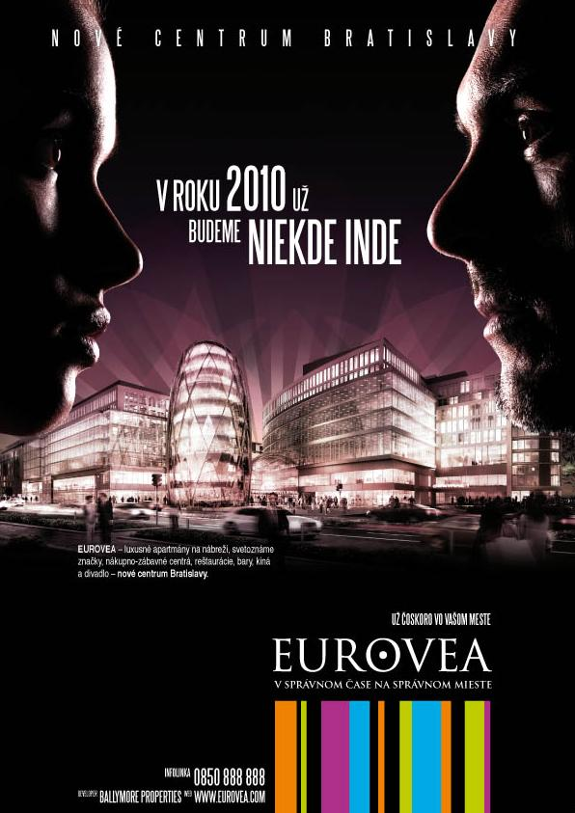Prior to the grand opening, several billboards sprang up in the most crowded places (e.g. public transportation stops) in the city center as well as in suburban quarters. It was neither the hypermodern shopping mall, nor the offices or apartments to be depicted on this particular advertisement, but the park and river promenade. The picture, that thanks to using a lot of green color looked relaxed and peaceful, almost evoked the impression that it had been mostly the huge park being built where one can relax, and not the shopping gallery with other commercial buildings. This impression has been stressed even more by the title “Eurovea Park”[1].

In a sharp contrast was another advertisement, which probably aimed to attract the attention of a different spectrum of the society. This time it was the “idea of the definite progress” that was trying to sell the project to the people. Verbatim, the campaign that was spreading through media, billboards and as a TV spot said “since 2010 we will be somewhere else”, which definitely gives the feeling of a substantial progress. Worth some attention is also the official subtitle of the project “In the right time at the right place” usually integrated in the project´s logo, which might make an impression of rescuing Bratislava on its death-bed. However, what was the reason Bratislava was supposed to be rescued, one may only guess.

source: <http://www.256.sk/blog/2008/03/03/reklamna-kampan-projektu-eurovea/>

When looking at Eurovea´s official webpage, which is undoubtedly what a lot of people might do after being reached with the news of this “wonderful project” in Bratislava, they get confronted with the huge (almost the half of the screen) changing pictures of the constituent parts of the project filled in with the commentaries. The obvious purpose of these is to communicate project´s uniqueness by using the adjectives as e.g. “the most modern”, “luxurious”, “best”. The whole picture is completed by the claim of being the “most modern place for shopping, place, living and entertainment in 21st century´s Europe”.[2]

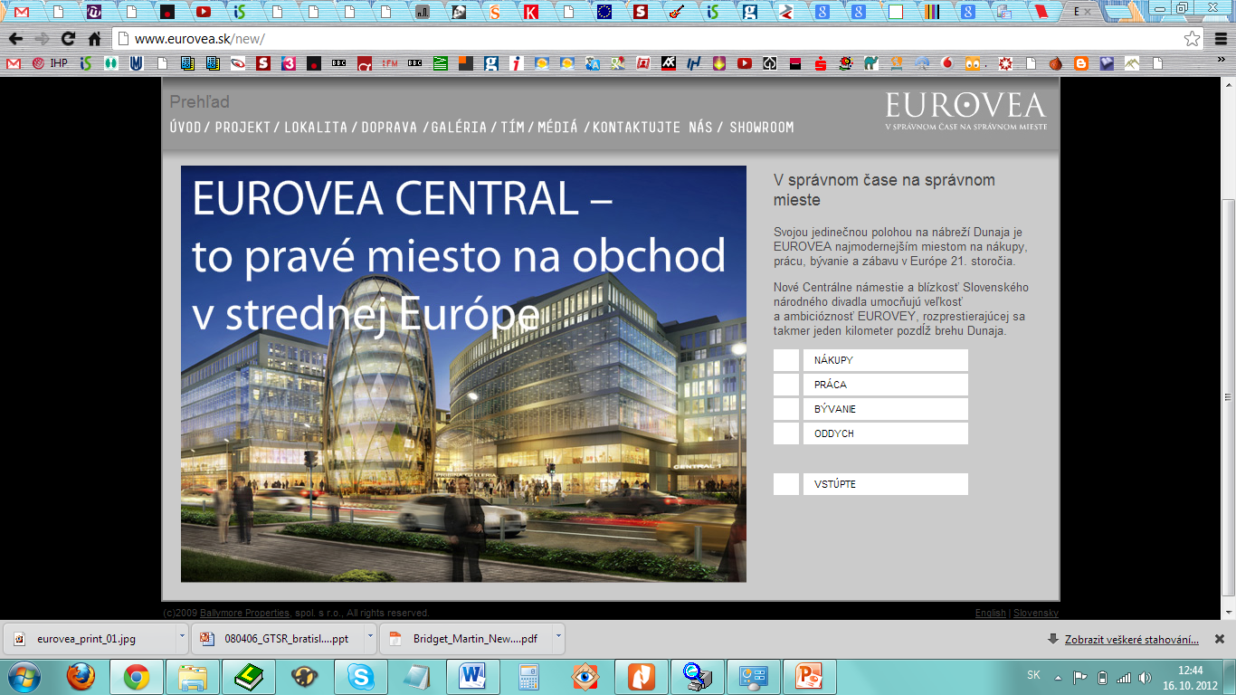source: <http://eurovea.sk/new/>

The Eurovea gallery´s webpage (the shopping mall) is definitely plainer and an excited explorer might get a bit disappointed. At the first sight, the webpage doesn´t differ significantly from the other similar institution´s propagation space. This is however probably a result of its instrumentality and orientation on the whole spectrum of people out of whom the majority don´t seek to be overwhelmed by the modernity discourse when searching for a new sweater. However, one doesn´t need to go far to find trace of this ultramodern picture representations again. It is enough to click on the section “What is Eurovea- history” to find out that the complex is a “brand new and dynamic destination” and “not only a commercial zone, but also a “focal point of Bratislava social life”. The purpose of the object is therefore not only instrumental, but it provides an added value in the form of creation of a public space. To what extent could this artificially created public space fulfill its function and become really public and democratic could be a good incentive for further scrutiny.

Swift search through the articles at the online most visited news portals (eg. [www.sme.sk](http://www.sme.sk), [www.aktualne.sk](http://www.aktualne.sk), [www.webnoviny.sk](http://www.webnoviny.sk)) reveals, that seemingly it is not only the developer and commercial sphere, who help to propagate this particular image of Eurovea, but it is also the politicians and public personalities, who readily contribute by their approval. The ex-major of Bratislava Andrej Ďurkovský stated, that Eurovea project has been recently the most important investment plan as the city was trying to regenerate the area since 1991. He also considers this areal to finally transform Bratislava from the “city by the river” to the “city on the river”, probably getting at the significance of the renewed river bank.[3]

Without doubts, it would be interesting to get the missing piece of the puzzle and find out what the public thinks and thereby if the campaign has fulfilled its purpose or if Eurovea is perceived by the masses just as another commerce stand similar to the dozens else to be found in other Slovak cities.

By this brief introduction I aimed to present basic media representations and campaigns connected to the Eurovea complex, which are in my opinion good examples of place marketing using discourse of modernity, progress and evolution. As a necessary consequence, they are also model illustrations of how are the contemporary cities, maybe too easily, willing to give up their historic identity in favor of ever-going industrial and technological progress. Because it is undoubtedly the impression of the future, exclusiveness, new possibilities, evolution and global modern city, rather than the historical continuity and the relationship to specific locality and Bratislava´s history, that is being communicated to the people. Instead of generating a specific spot of local significance, to borrow Sklair´s concept, Eurovea is simply another “transnational social space”, which could be found anywhere in the world (Sklair 2006 in Colomb 2012).

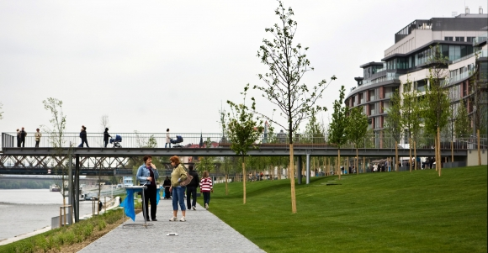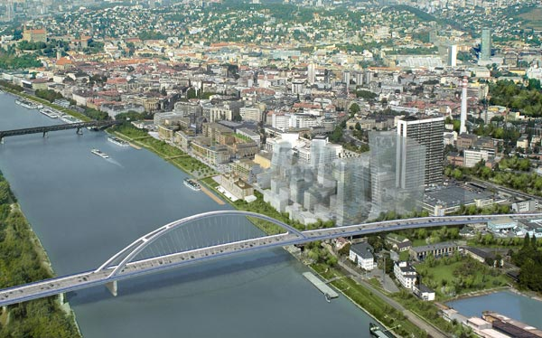

source: <http://bratislava.sme.sk/c/2355571/eurovea-pri-dunaji.html>

source: http://www.webnoviny.sk/slovensko/bratislava-otvara-novu-mestsku-stvr/119951-clanok.html

Sources:

<http://www.256.sk/blog/2008/03/03/reklamna-kampan-projektu-eurovea/>

<http://www.eurovea.com/sk/>

<http://eurovea.sk/new/>

<http://www.webnoviny.sk/slovensko/bratislava-otvara-novu-mestsku-stvr/119951-clanok.html>

<http://bratislava.sme.sk/c/2355571/eurovea-pri-dunaji.html>

<http://www.bratislava.sk/vismo/dokumenty2.asp?id_org=700000&id=78468>

COLOMB, Claire. *Staging the new Berlin: place marketing and the politics of urban reinvention post-1989*. London: Routledge, 2012.

Začiatok formulára

1. the official billboard picture is unfortunately not to be found at the internet
2. The official webpage of the project is <http://eurovea.sk/new/>
3. <http://www.bratislava.sk/vismo/dokumenty2.asp?id_org=700000&id=78468>