**CEMEX case study**

Today CEMEX is one of the world’s largest building materials companies. It is a leading supplier of aggregates (sand, gravel and crushed rock), cement and readymixed concrete. It also produces asphalt and concrete products, and has a significant share of those markets. It operates in more than 50 countries and employs over 50,000 people.

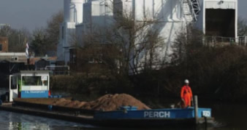 CEMEX UK has three cement plants, 60 quarries and nearly 230 readymixed concrete plants. CEMEX’s customers range from multinational building companies to individuals building their own homes.  In the UK, CEMEX generates £1 billion in annual sales. CEMEX plays an essential role in contributing to creating Britain's infrastructure, housing, schools, offices and hospitals.

Quarries can only be located where minerals occur. However, the business can make decisions where to locate its secondary activity. For example, a readymixed concrete plant could be close to its raw materials (in a quarry) or close to its markets (in a city). CEMEX’s awareness of how its choice of location has an impact on the local environment is vital to its long-term business performance.

CEMEX adopts a sustainable approach wherever possible:

* It transports over 30 million tonnes a year by road, rail, river and sea, including aggregates, cement and fuel. Around 12% of total aggregates movements are made by rail. CEMEX is committed to use of rail, as these journeys give five Times fewer emissions than similar journeys by road.
* 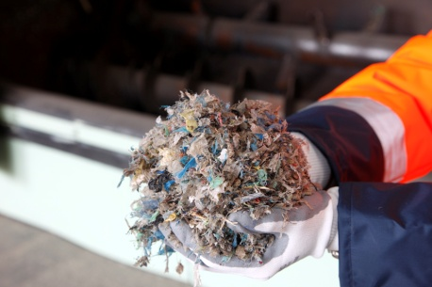CEMEX uses water transport where possible to help minimize its carbon footprint. It transports products via sea, rivers, conveyors and underground pipelines. The longest pipeline is 57 miles long. This saves more than 400 lorry journeys per day and supports the UK Government’s objective of getting trucks off the road wherever possible. It uses barges to transport aggregates on the River Severn, where one barge can carry 350 tonnes, the equivalent of 18 HGV loads or 36 lorries.
* Making cement is energy-intensive. In 2009, CEMEX UK increased by more than 30% the use of alternative fuels such as chipped tyres and treated household waste to heat its kilns. This helped reduce emissions of CO2 across the business by 10%.
* It replaces a proportion of the cement clinker in the concrete-making process with by-products from other industries. These include slag from the steel industry and fly ash from coal fired power stations. This helps to preserve scarce minerals for future generations. Using this method reduces the carbon footprint of cement production by 50%.

As a global business, CEMEX needs to focus on financial returns to ensure long-term business sustainability, but these are not its only measure of performance. The company believes strongly all goals need to be in balance. This is set out in its position statement: ‘CEMEX is dedicated to building a better future and couples financial achievements with a firm commitment to sustainable development.’

 Since entering the UK, CEMEX has invested between £30 and £60 million per annum across the business. This includes the modernisation of equipment and plants to deliver environmental improvements. For example, in 2009, CEMEX commissioned a £49 million new cement plant at Tilbury in Essex, which boasts the first vertical cement mill in the country, which uses 20-40% less energy than traditional horizontal mills.