**The analysis**

**of NS Concept 2000 vs NS Strategy to 2020**

**Part 1.**

***The circumstances of working out***

period

Group of authors

Causes and conditions, the impulse to begin work

Editions, causes of editions

***The circumstances of the adoption***

Date

Who signed

On what internal and external events background was announced

***The analysis of the formal structure***

Parts, main components

The ranking of the most useable terms and concepts

***The essential structure of the text***

The rhetoric features of the text

Any other comments

**Part 2.**

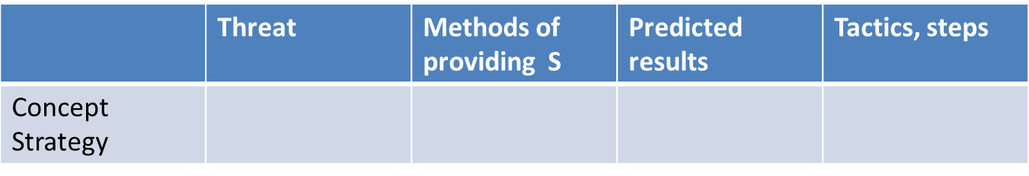

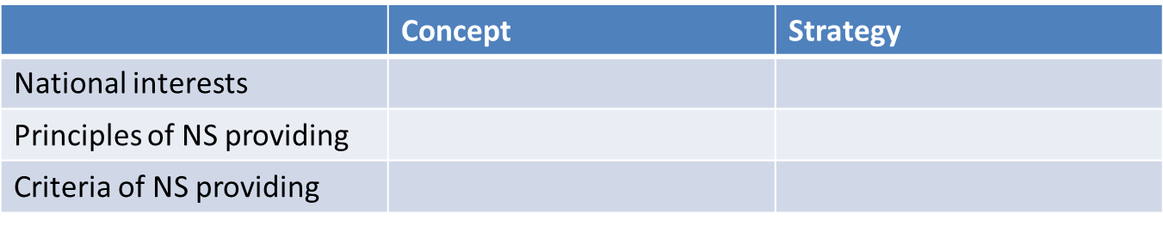

**Part 3.**

**Conclusions**:

Common and special

Assumptions of Russian political system’s evolution based on docs

Research program (questions, hypothesis)

**From 5 to 8 points**

**Deadline – 04 Dec 2014**