Exercise 1

Imagine a situation, where Player 1 and Player 2 randomize over their pure strategies – Player 1 plays A with probability p and Player 2 plays X with probability q. Find a mixed strategy Nash Equilibrium of this game.

 |  | Player 2
 |  | X | Y
Player 1 | A | 4 , 3 | 6 , 2
Player 1 | B | 6 , 0 | 3 , 3

Exercise 2

Consider a situation where two players compete against each other to earn respect of their peer group. They decide to speed their cars against each other. Each is considering two actions: to steer off the collision course or keep going. The one, who steers off the course first, is coward, while the other earns ultimate respect. Cowardice yields payoff -10, while ultimate respect yields payoff 30. If they both steer off the course at the same time, both get 0. If they crash, both get a payoff -100. Find all Nash Equilibriums of this game.

 |  | Player 2
 |  | Steer | Stay
Player 1 | Steer
Player 1 | Stay
Exercise 3

How would the previous game change if social rejection of cowardice would be much stronger and have a similar payoff to crashing each other? What would Nash Equilibriums be in such a case?
 |  | Player 2
 |  | Steer | Stay
Player 1 | Steer
Player 1 | Stay
Exercise 4

Newcomer A is about to propose proposes to build a pipeline in cooperation with national incumbent B.

A is thus deciding whether to invest in the new market or not. If A does not enter the proposal, it loses opportunity, but at the same time saves itself initial investment costs, ending with 1 unit of utility. Company B maintains its position, with 1 unit of utility.

If company A decides to enter the market, company B makes decision over allowing or denying the commission of the project. If B denies the project, A will lose initial investment and is forced out of the project, earning 0. B earns 2 utils as it preserves monopoly over market and possesses knowledge stemming from A’s initial investment.

If pipeline is built, A decides whether to misuse its position, taking over the whole pipeline transit revenue or whether to share half of the revenue with company A.

All actors are fully aware of other’s strategies and payoffs. What is the equilibrium outcome of this game?
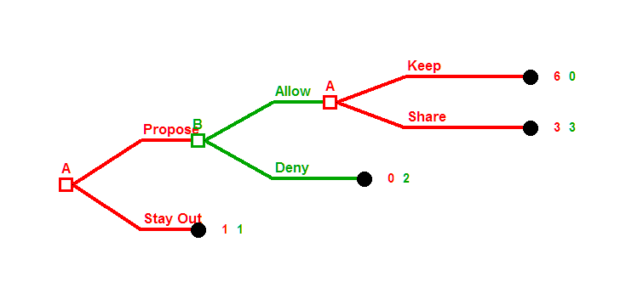
Exercise 5

Player A is deciding to offer Player B a bid x. The bid’s value is from 0 to 10, included. Player B is deciding to accept or reject the bid. If player B accepts the A’s bid, A will get 10 – x and B will get x. If B rejects the bid, A will get payoff 0 and B would get punished, with payoff equal to -1.

What is the outcome of this game? What should be the value of A’s bid?

Bonus question

Watch a scene in the James Dean movie Rebel without a cause. (https://youtu.be/U1DEp8R9kwg)

How should we represent this as a game?

