**How much does trust in national political institutions affect trust in the EU?**

I this study, the researchers calculated how much different independent variables affect trust in the European Union. In other words, they calculated how likely it is that a person will trust the European Union if this person has high or low score on a given independent variable. They studied these independent variables:

1) Evaluation of EU competence (how well the EU performs in different policy areas)

2) European identity (how strongly the individual identifies as European)

3) Trust in national institutions (how much the individual trusts governmental institutions in his or her country)

Your task is to interpret the figure and present your interpretation to class. When describing the figure to the class, make sure you tell us what the y-axis shows and what the bars show.

Also make sure you discuss the following: What did the researchers find about the effects of each of these three variables? Which variable has the strongest/weakest effect on trust in the EU?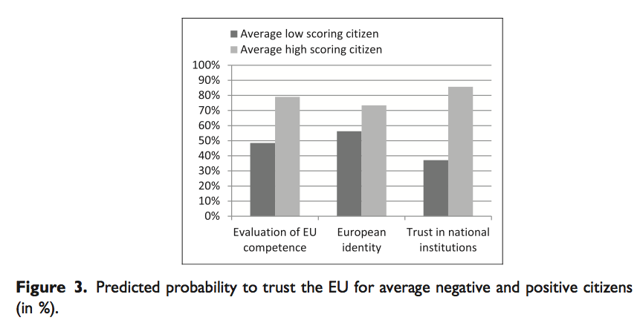

*Figure copied from: Harteveld, E., T. van der Meer, and C. E. De Vries. 2013. "In Europe we trust? Exploring three logics of trust in the European Union." European Union Politics 14 (4):542-65.*