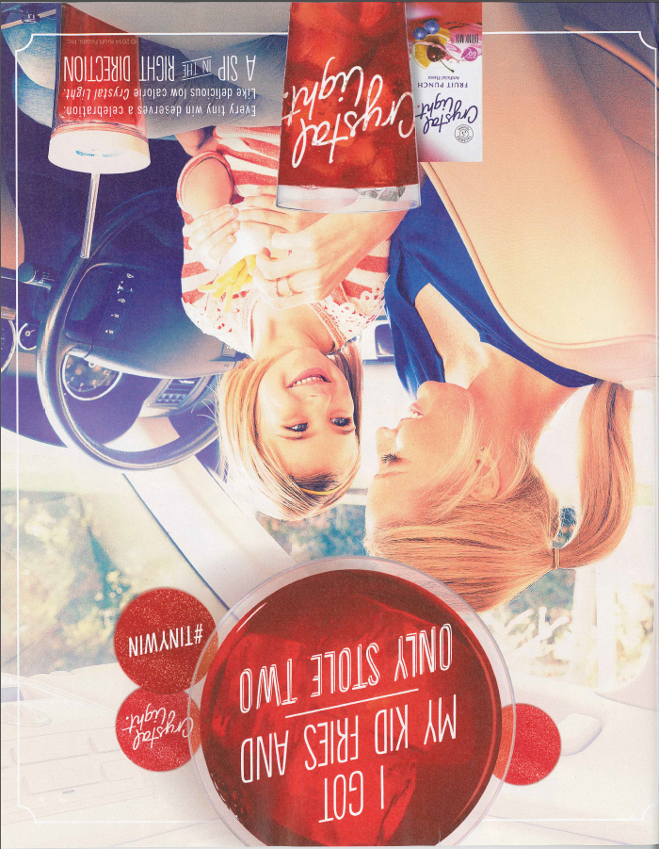

*Real Simple*, September 2014

Copy reads: “Every tiny win deserves a celebration. Like delicious low calorie Crystal Light. A sip in

the right direction.”