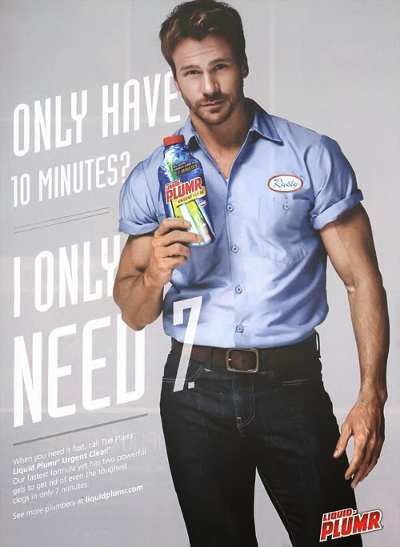

*People,* 1 December 2014

Copy reads: “When you need it fast, call The Plumr. Liquid Plumbr Urgent Clear. Our fastest formula

yet has two powerful gels to get rid of even the toughest clogs in only 7 minutes. See more plumbers at… ”