**Form**

The uncertainty of visual **syntax** (in other words, the lack of a recognizable compositional structure for sense-making) plays a central part in the processes of visual persuasion.

Words have conventionally fixed meanings, rules of grammar and syntax, and a logical structure).

Images escape these controls and can suggest a more complexity.

Often visuals invite the viewer to participate in meaning construction through their form; how the story is presented.

When we talk about **visual syntax**, we are talking about **visual form.**

**Form helps to structure meaning in visuals through spatial and temporal juxtapositions, and color and lighting.**

**Spatial** strategies may include:

* Distance relationships between characters to establish consensus or alienation
* Wide, distance shots to establish setting and context
* Close ups that privilege detail as significant to understanding the narrative
* Low angles looking upwards to make subject look strong and powerful
* High angles looking downwards to make subject seem vulnerable or powerless
* Centered, straight-on perspectives to suggest agency and authenticity
* Marginalized perspectives to diminish importance of subject

**Temporal** strategies may include:

* Long-held shots to establish authority, value, or to guide the narrative
* Time compression though montage or movements within and between frames, including jump cuts, cross-cuts, fast motion, and so on, proposing passage of time and possibly dismissive or marginalizing.
* In static (non-moving) shots, the perception of time can be created through various techniques found in Photoshop and other software.

The **meaning-making role of pictorial form** directs how the content is presented and often imbues it with subtexts of deeper meanings.

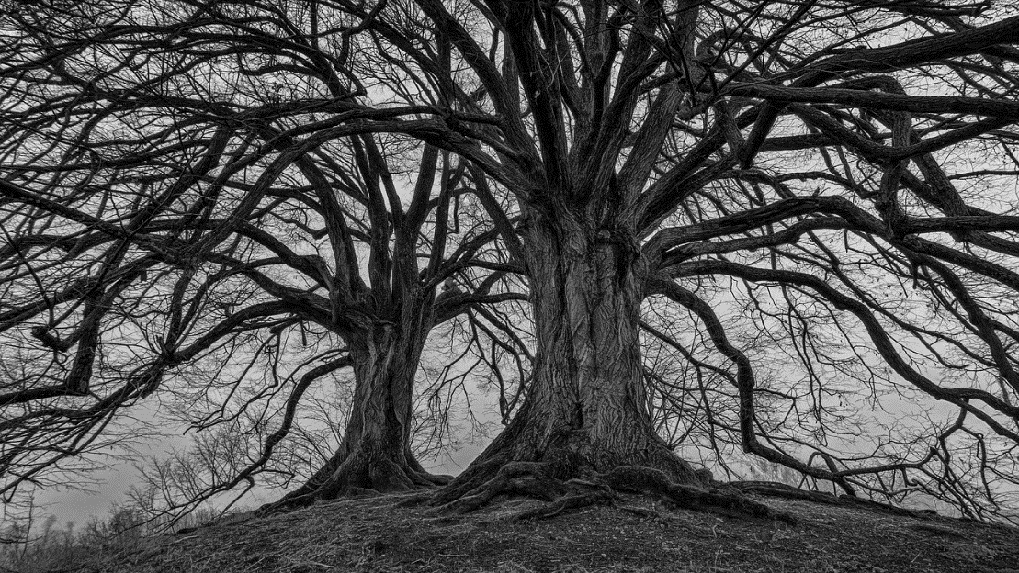**The 2-part relationship of content and form.**

Try describing this picture. Is your focus on its descriptive content: two barren trees in a country landscape?

Or is your focus on the literal form due to its spatial relations: a close up of two trees from a low angle, and a narrow field of view.

Either describes it correctly, but neither does it completely. Sense-making comes from both the content and the form of an image.