|  |
| --- |
| CASE- Coalition for Affordable Solar Energy |
| Solar Tariffs |
| Set up & policy paper |

|  |
| --- |
| ‏26/11/2018 |

**Introduction**

In 2011, following allegations of SolarWorld Company and The Coalition for American solar manufacturing against Chinese solar manufacturing about violation of the WTO GATT agreement and dumping solar panels product to the American market an Investigation was held according to section 301 of American trade act. Following the investigations, USA Found China guilty of dumping and decided to act with countervailing measures –antidumping tariffs The U.S administration committed in 2012 another investigation on China and has once again risen tariff rates.

Despite inefficiency of former tariffs, recently, president Trump decided to carry on with these deeds and posing more tariffs on the solar panel industry. The current administration declared in January 2018 on posing decreasing (5% decrease each year) tariff of 30 % on solar cells and modules in the next four years with an exception on 2.5-gigawatt cells. The tariffs were posed following a petition of solar manufactures Suvina and the Solar world. The two companies requested an investigation on solar panel prices and alleged injury from imports. Their allegations do not represent the greater share of US solar market.

**Dispute**

The decision on posing of tariff rates has a strong influence on the local American solar market. Tariffs are destined to help to flourish a local solar industry. However, they also have a negative influence on the market, which must be taken into consideration. Accusations of Asian companies and government in allegedly stilling American jobs has no base. America's solar industry has benefited from low global prices and free trade. The tariffs have a negative influence on the market share of the service of the American solar company and have caused damage to "downstream jobs" such as installers, sellers, harming a hidden side of the American economy and possible future.

**Position and Audience**

I am the head of Coalition for Affordable Solar Energy an American organization representing over 160 companies including all of the largest solar installers in 19 states, who employ more than 250,000 Americans. This policy paper is directed to Wilbur Ross, Secretary of Commerce in the hope to convince him to annul tariffs on solar panels. The department of commerce main mission is to promote job creation and economic growth by ensuring fair and reciprocal trade. I expect this policy paper will convince him that the tariff needs to be annulled or decrease significantly in order to stop the injury to the sector of solar panels,

**References**

* Hughes, L., & Meckling, J. (2017). The politics of renewable energy trade: The US-China solar dispute. *Energy Policy*, *105*(March), 256–262. <https://doi.org/10.1016/j.enpol.2017.02.044>
* Curran, L. (2015). The impact of trade policy on global production networks: the solar panel case. *Review of International Political Economy*, *22*(5), 1025–1054. <https://doi.org/10.1080/09692290.2015.1014927>
* Section 201 Cases: Imported Large Residential Washing Machines and Imported Solar Cells and Module (2018) executive office.<https://ustr.gov/sites/default/files/files/Press/fs/201%20FactSheet.pdf>

Jigar Shah

President

Coalition for Affordable Solar Energy

December 4, 2018

Wilbur Ross

Secretary of Commerce,

Department of Commerce

Dear Secretary Ross,

Following the recent developments in trade policy of USA regarding solar energy tariffs, the Coalition for Affordable Solar Energy (CASE) have noted it is important to address and inform the administration about the negative consequences of the new trade Tariffs on imported solar cells and modules. In this policy paper, I would like to present the severe implication on the American economy and employment that will cause by posing tariffs on imported solar cells and modules.

The solar sector in the U.S benefits from global integration. Thus, new tariffs will cause isolation of the sector from global supply chains and will prevent it is the ability to grow export. This will reduce the capacity of industry grow as in recent years and to provide new jobs. As a result of rising solar panel prices, investors are triggered to relocate their factories to other countries.

CASE opposes the tariff and the trade war it would trigger. As an American organization representing over 160 companies including all of the largest solar installers in 19 states, who employ more than 250,000 Americans, we carry the duty to forward this vital information. We share the same interest and see eye to eye the importance of having American jobs and a stable economy. In addition to the information about economic impact, we suggest a different option of tackling American trade deficit about the solar panel industry.

I genuinely hope this paper will have the power to convince the administration to change its position.

Best Regards,

Jigar Shah, president,

Coalition for Affordable Solar Energy

## Introduction

The Coalition for Affordable Solar Energy (CASE) was founded in 2011. CASE represents the majority of U.S. solar jobs and a diverse group of companies across the solar value chain, from local installers to project developers and equipment manufacturers. CASE began as a reaction to the Obama administration tariffs on the solar panel imports from China that were held due to petition request of SolarWorld and seven other companies.[1] A trade dispute that ended by a WTO assessment that American tariffs were not in coherence with WTO rules.[2]

On May 17, 2017, based on a petition from Suniva and later joined by SolarWorld, the International Trade Commission (ITC) instituted an investigation under Section 201 of the Trade Act of 1974 to determine whether increased imports were a substantial cause of serious injury to the domestic industry. Despite the non-effective tariff of former President Obama, the current administration declared in January 2018 on posing decreasing (5% decrease each year) tariff of 30 percent on solar cells and modules in the next four years with an exception on 2.5-gigawatt cells.[3]

Tariffs are a protectionist form of slowing growing trade deficit of the U.S. Unfortunately, experience has proven it to have almost no positive impact on the U.S market or employment rate. The opposite result occurred, cells and module prices continue to decrease worldwide, and investors and entrepreneurs choose to place their money in other countries which enables fair trade and build their factories in foreign countries. The American solar industry injuries will be due to rising prices of solar panels; investors flee and countertrade policy of other countries who chose to stop trading with U.S manufacturers and to prevent critical materials exports to the U.S industry such as steel and silicon.

Keeping its agenda from the previous conflict, CASE role is to inform everyday Americans, Congress, and the Administration about the profoundly destructive impact new tariffs will have on our booming industry. It is our duty once again to act in light of the new tariffs.

## The Debate

Tariffs are a well-known regulatory instrument, used to support specific industries in the local economy and develop protection against free trade violations such as dumping. Tariffs posed by the president ignore the reality in the US solar panel market by assisting a small share of companies, which filed a petition in order to better compete against foreign solar panel manufactures. Besides the effect the tariff will have on the global value chain, its potential of damaging investments and local jobs is catastrophic to the industry. Pushing thousands of American out of the employment market, leaving behind heavy taxation and shredded families. Estimations are that over the next five years the tariffs would reduce U.S. solar installation growth by 10 to 15 percent.[4]

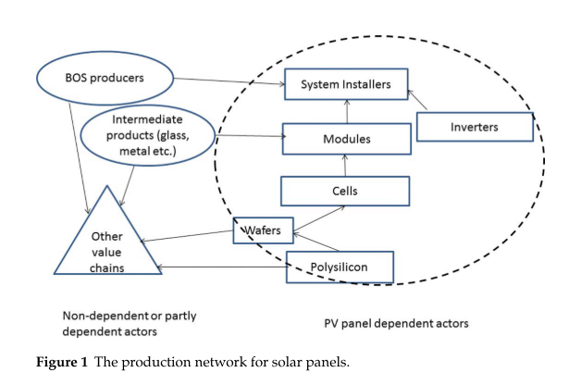[5]The solar industry has a unique and complex structure (fig 1), which makes it highly dependent on other countries production of raw materials and secondary products like wafers, silicon, etc.[6] These products are highly crucial to the production of solar panel in affordable, competitive prices that allows both export and domestic sells of panels.[7]

Figure 1- Solar PV value chain

Tariffs will injure thriving, investment and jobs in the industry, which has been expanding worldwide, from 2000 until 2010 from $2.5 billion to $71.2 billion. With a share of 5 billion dollars, approximately 7% of the US market. [8] In 2016, U.S solar energy industry had three times more employees than 2010.[9] The rate of “downstream jobs” grew dramatically as an overall share of the growth of jobs in the sector. This phenomenon explained by the sharp decline of solar panels prices since 2010. The decline contributed by massive global investment and production. The cost to install solar has dropped by more than 70% since 2010, leading the industry to expand into new markets and deploy thousands of systems nationwide making it even more dependent on global markets.

Price of PV modules has been declining progressively for many years, long before Chinese producers entered the PV market, and so does the employment rate in the sector. [10] Prices as of Q2 2018 are at or near their lowest historical level across all market segments. An average-sized residential system has dropped from more than $40,000 in 2010 to nearly $17,000 today. As seen in figure 2 the decreasing cost is with correlation to employment growth.

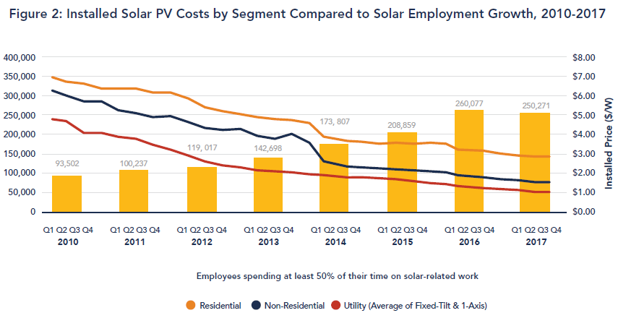

*Figure 2- Installed Solar Panel Costs by segment compared to solar Employment Growth 2010-2017*[11]

The solar market of America is local. The US solar energy companies, dealing with different parts of the product value chain of solar panels, declared that majority of their projects take place in the US market to US customers. According to reports 63% of installation projects, 60% of development projects, 55% of sales and distribution projects all take place in the states. The majority of solar installations in the United States—roughly 80 percent—[use imported panels](https://www.bloomberg.com/news/articles/2018-01-22/trump-taxes-solar-imports-in-biggest-blow-to-clean-energy-yet). Most come from Malaysia (36%) and South Korea (21 %), with China, Thailand, and Vietnam each contributing 8 to 9 percent. The raw materials sourced out from all over the world; a reflection of the industry has globalized supply chain. [12]

On the other hand, 61% of the manufacturing customers are outside the US. Recent numbers show 51% of the suppliers for solar energy firms are located out of the US. In the installation and project development, there is a high dependency on foreign markets—30% of firms have their primary suppliers located in-state, and 33% of sales and distribution establishments and 27% of manufacturers reported that their primary vendors are located overseas.[13]This data alludes that the tariff rates will influence significantly on the core part of the solar panel industry in the states.[14]

The price of an American solar panel is already considerably higher than the global price this will cause substantial unnecessary expenses this is the primary cause for America's high integration in global supply chains. The integration in the global market is an essential part of its success and growth in recent years. The tariffs posed by the government are not promising any bright future for the installation and sales sector. Their dependency on global prices will lead them to a crisis due to tariffs. The market will shrink jobs will be abolished without any future for supplying cheaper merchandise from American vendors.

## Jobs

The tariff imposed on solar panels are potentially harming the ability to produce at a decent price. As shown in the 2011 case despite supposedly protecting the local industry the main result was profound harm to the development of this industry. one of the forecasts has predicted a loss of 23,000 new jobs and a decrease in installed capacity. SEIA assumes that 9,000 jobs have been affected so far this year because of the tariffs, a figure mainly based on information that companies have provided confidentially. The calculation includes both layoffs and prospective jobs that were unfilled.[15] .Besides, it is predicted that if polysilicon export to China would decrease due to Chinese counter tariff on polysilicon another 11,000 American jobs at risk in the first year alone.[16]

According to National Solar Jobs Census 2017, the majority of the jobs in the solar industry are installation jobs (51.7%) while manufacturing is not even half (14.7%).[17] The meaning is that a rising price of solar panel will harm the majority of the solar industry employees since those are highly dependent on the sales and distribution of solar panel. If sales decrease due to prices, 129,423 people are at risk of losing their job. To show the dependency in a clear form see the following figure 3:

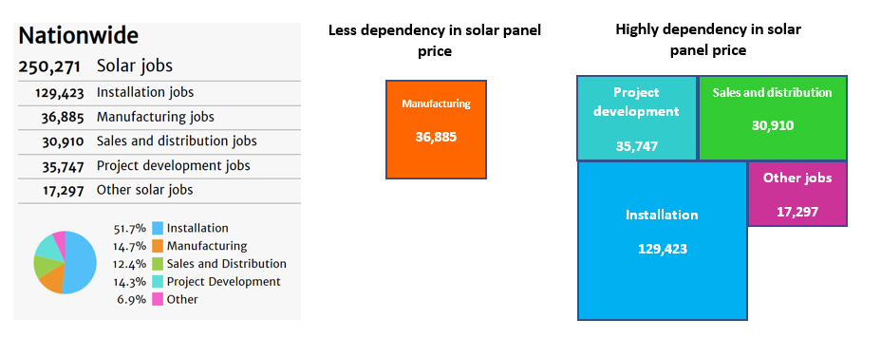

Figure 3-Solar Jobs in US [18]

Recent tariffs were set for four years. In the business world, opening a new manufacturing plant may take up to 2 years to build. Meaning no new vendors will possibly open plants in the market; this will lead to even higher prices on solar panels and will slow the growth of the market for the next years. In the short term, the act of tariff caused already notable uncertainty in the sector and slowed down activity rate, by slowing down investments.

A new study conducted in Colorado university predicts even more negative results of tariffs. According to the study, tariffs will not have a vital influence on the manufacturing jobs, but will mostly to annul thousands of installation jobs, As shown in figure 2 the ration between new manufacturing jobs and loss of installation jobs is predicted to be negative.

.

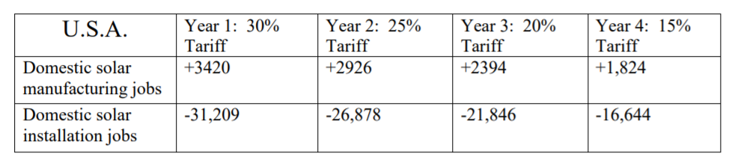

Figure 4- Implications predictions of tariff on the solar industry in U.S[19]

## Taxpayer toll

Adding to all other arguments, it is important to notice the toll of tariffs on the American people. The ruling pro-tariffs of ITC cost the American taxpayer 236 billion dollars over the past ten months. [20] That is because instead of decreasing prices the tariff will raise the current price[21].

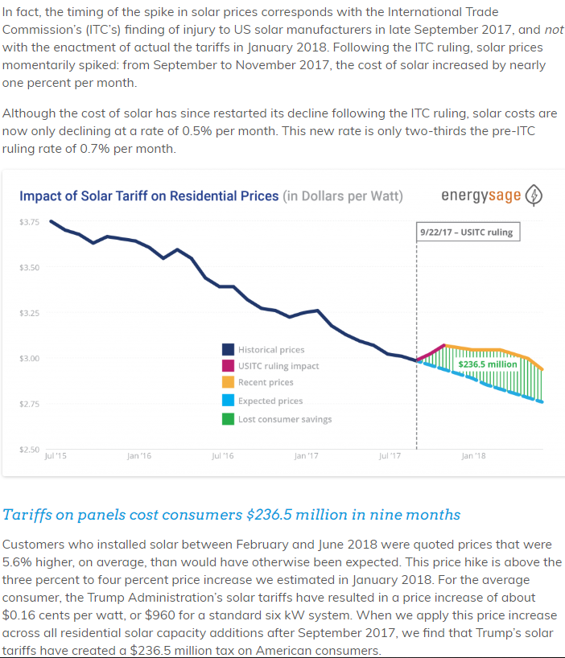

Figure 4-impact of solar tariff on residential price[22]

 Further, according to developers, tariffs on imported solar panels has led U.S. renewable energy companies to cancel or freeze investments of more than $2.5 billion in large installation projects, along with thousands of jobs[23]

## Alternatives

As mentioned four-year duration is not enough time to attract new manufacturers to build plants in the US. The declining tariffs are also not a great incentive for building a new plant due to non-profitability in the long run after tariffs cancellation. The conclusion must be that tariff will not support the solar manufacturing industry and not the other sector in the industry, mostly installation and sales. The need to incentivize job growth in the USA is a critical need to both the administration and the association.

Concerning the tackling the trade deficit issue by tariffs. We suggest the following measures:

1. Supporting demand for solar panels by loans to companies who will use local products.
2. Supporting manufacturers R&D centers in order to give a competitive advantage over outstate products.
3. A campaign to encourage buying American products – emphasizing the benefits of American product like the higher social standard for employees higher safety standard.
4. Attracting international companies to build new factories in the states by grants, tax relieves.

The four option is highly effective. In the long term, it can build a strong industry with more manufacturing job. Combined with option three this can lead to positive change without harming the growing sectors of installation and sales. CASE is definite that tariffs on PV imports would curb domestic demand for solar products, could erode profit margins across the PV value chain.[24]

## Conclusion

This paper purpose is to demonstrate that choosing tariffs to promote an economic agenda and creating more jobs in America is false. The tariff policy damages the fast evolution of a proud American industry wishing to keep growing with the help of the administration. The petition filed to ITC were of narrow interest and as shown will prevent the current positive progression of the industry. Tariffs eventually are taxation on the American taxpayer, which will lead to no more than higher costs on the consumers and producers. It will drive away foreign investments in the states, decrease expenditure on R&D, developing projects, installation, etc. with this in mind CASE as a representative of the majority of industry wish to stop the tariff continuation and provide alternatives to creating more jobs in America.

In order to keep this industry thriving in our country, we must make sure our country will have access to various suppliers of raw material and solar panels. As mentioned previously the US market is highly dependent on other countries in order to keep developing new factories, While supporting selling and marketing services for the industry.

## References

Abboushi, S. (2014). Solar trade tariffs. Competitiveness Review, 24(1), 59-65.

Brian. E, Ari. N, Chris. M," Trump's Tariffs on Solar Mark Biggest Blow to Renewables Yet"Retrieved 21 October 2018, from <https://www.bloomberg.com/news/articles/2018-01-22/trump-taxes-solar-imports-in-biggest-blow-to-clean-energy-yet>

Carbaugh, R. J., St Brown, M., & Carbaugh, B. (2012). Industrial Policy and Renewable Energy: Trade Conflicts. *Journal of International and Global Economic Studies Carbaugh and St. Brown Journal of International and Global Economic Studies*, *5*(51), 1–16. Retrieved from http://digitalcommons.cwu.edu/cobfac

Curran, L. (2015). The impact of trade policy on global production networks: the solar panel case. *Review of International Political Economy*, *22*(5), 1025–1054. https://doi.org/10.1080/09692290.2015.1014927

### Dan, G. *How Much Damage are Trump’s Solar Tariffs Doing to the U.S. Industry?*. (2018). *InsideClimate News*. Retrieved 21 October 2018, from https://insideclimatenews.org/news/20082018/trump-solar-panels-tariffs-clean-energy-economy-jobs-united-states-market

Executive office, Section 201 Cases: Imported Large Residential Washing Machines and Imported Solar Cells and Module (2018) executive office.<https://ustr.gov/sites/default/files/files/Press/fs/201%20FactSheet.pdf>

Elinor.C, (2018) "The price of solar panels just went up—here's what that means for you" ,Popular science, <https://www.popsci.com/solar-panel-tariff-effects#page-2>

Fields, S. (2018). Solar Power International 2018 Round-Up | EnergySage. [online] Solar News. Available at: https://news.energysage.com/solar-power-international-2018-round-up/ [Accessed 21 Oct. 2018].

Hughes, L., & Meckling, J. (2017). The politics of renewable energy trade: The US-China solar dispute. *Energy Policy*, *105*(March), 256–262. https://doi.org/10.1016/j.enpol.2017.02.044

Lewis, J. I. (2014) ‘The Rise of Renewable Energy Protectionism: Emerging Trade Conflicts and Implications for Low Carbon Development,’ Global Environmental Politics 14(4): 10-35.

National solar jobs census 2017, <https://www.thesolarfoundation.org/national/>

#### Nicloa, G. (2018). Billions in U.S. solar projects shelved after Trump panel tariff. [online] Available at: https://www.reuters.com/article/us-trump-effect-solar-insight/billions-in-u-s-solar-projects-shelved-after-trump-panel-tariff-idUSKCN1J30CT [Accessed 21 Oct. 2018].

Platzer, M. D. (2012). US solar photovoltaic manufacturing: Industry trends, global competition, federal support. *Washington, DC: Congressional Research Service*, *6*. Retrieved from <http://digital.library.unt.edu/ark:/67531/metadc86631/m1/1/high_res_d/R42509_2012May30.pdf>

#### Reuters, "Q&A: Winners, Losers Of Trump's Solar Panel Tariff." U.S.. N. p., 2018. Web. 21 Oct. 2018. <https://www.reuters.com/article/us-usa-trade-tariff-q-a/qa-winners-losers-of-trumps-solar-panel-tariff-idUSKBN1FC36N>

*Solarstates* "Solar Jobs Census 2017." Solarstates.org. N. p., 2018. Web. 21 Oct. 2018 <https://www.solarstates.org/#counties/solar-jobs/2017>

Solar Jobs Census infographics 2018 <http://www.thesolarfoundation.org/wp-content/uploads/2018/02/SolarJobsCensusInfographic.pdf>

The Brattle Group. 2012. The Employment Impacts of Proposed Tariffs on Chinese Manufactured Photovoltaic Cells and Modules. Cambridge, MA. January

Vaughn, J. (2018). Suniva Trade Case Implications for International Trade and the United States Solar Boom.

1. Lewis, J. I. (2014) ‘The Rise of Renewable Energy Protectionism: Emerging Trade Conflicts and Implications for Low Carbon Development,' Global Environmental Politics 14(4): 10-35.
2. Hughes, L., & Meckling, J. (2017). The politics of renewable energy trade: The US-China solar dispute. *Energy Policy*, *105*(March), 256–262. https://doi.org/10.1016/j.enpol.2017.02.044
3. Section 201 Cases: Imported Large Residential Washing Machines and Imported Solar Cells and Module (2018) executive office.<https://ustr.gov/sites/default/files/files/Press/fs/201%20FactSheet.pdf>
4. #### "Q&A: Winners, Losers Of Trump's Solar Panel Tariff." The U.S.. N. p., 2018. Web. 21 Oct. 2018.

   <https://www.reuters.com/article/us-usa-trade-tariff-q-a/qa-winners-losers-of-trumps-solar-panel-tariff-idUSKBN1FC36N>
5. Carbaugh, R. J., St Brown, M., & Carbaugh, B. (2012). Industrial Policy and Renewable Energy: Trade Conflicts. *Journal of International and Global Economic Studies Carbaugh and St. Brown Journal of International and Global Economic Studies*, *5*(51), 1–16. Retrieved from http://digitalcommons.cwu.edu/cobfac
6. Curran, L. (2015). The impact of trade policy on global production networks: the solar panel case. *Review of International Political Economy*, *22*(5), 1025–1054. https://doi.org/10.1080/09692290.2015.1014927
7. ibid
8. Platzer, M. D. (2012). US solar photovoltaic manufacturing: Industry trends, global competition, federal support. *Washington, DC: Congressional Research Service*, *6*. Retrieved from <http://digital.library.unt.edu/ark:/67531/metadc86631/m1/1/high_res_d/R42509_2012May30.pdf>
9. National solar jobs census 2017, <https://www.thesolarfoundation.org/national/>
10. Suhail Abboushi, (2014) "Solar trade tariffs", Competitiveness Review, Vol. 24 Issue: 1, pp.59-65, https://
11. National solar jobs census 2017, <https://www.thesolarfoundation.org/national/>
12. Elinor.C, (2018) "The price of solar panels just went up—here's what that means for you" , Popular science, <https://www.popsci.com/solar-panel-tariff-effects#page-2>
13. National solar jobs census 2017, <https://www.thesolarfoundation.org/national/>
14. ### Brian. E, Ari. N, Chris. M," Trump's Tariffs on Solar Mark Biggest Blow to Renewables Yet"

    #### Retrieved 21 October 2018, from <https://www.bloomberg.com/news/articles/2018-01-22/trump-taxes-solar-imports-in-biggest-blow-to-clean-energy-yet>

   
15. ### Dan, g.*How Much Damage are Trump’s Solar Tariffs Doing to the U.S. Industry?*. (2018). *InsideClimate News*. Retrieved 21 October 2018, from https://insideclimatenews.org/news/20082018/trump-solar-panels-tariffs-clean-energy-economy-jobs-united-states-market

   
16. The Brattle Group. 2012. The Employment Impacts of Proposed Tariffs on Chinese Manufactured Photovoltaic Cells and Modules. Cambridge, MA. January
17. #### "Solar Jobs Census 2017." Solarstates.org. N. p., 2018. Web. 21 Oct. 2018 <https://www.solarstates.org/#counties/solar-jobs/2017>

   
18. Solar Jobs Census infographics 2018 <http://www.thesolarfoundation.org/wp-content/uploads/2018/02/SolarJobsCensusInfographic.pdf>
19. Vaughn, J. (2018). Suniva Trade Case Implications for International Trade and the United States Solar Boom.
20. #### Fields, S. (2018). Solar Power International 2018 Round-Up | EnergySage. [online] Solar News. Available at: https://news.energysage.com/solar-power-international-2018-round-up/ [Accessed 21 Oct. 2018].

   
21. ibid
22. Ibid
23. #### Nicloa, g. (2018). Billions in U.S. solar projects shelved after Trump panel tariff. [online] Available at: https://www.reuters.com/article/us-trump-effect-solar-insight/billions-in-u-s-solar-projects-shelved-after-trump-panel-tariff-idUSKCN1J30CT [Accessed 21 Oct. 2018].

   
24. Platzer, M. D. (2012). US solar photovoltaic manufacturing: Industry trends, global competition, federal support. *Washington, DC: Congressional Research Service*, *6*.