[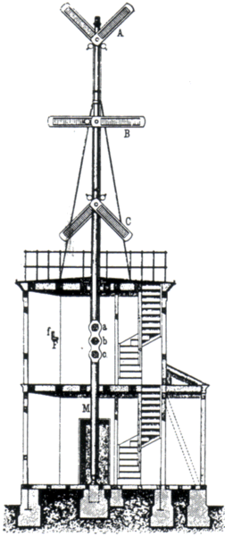](http://upload.wikimedia.org/wikipedia/commons/6/60/Construction-pruss-opt-tele.png)