[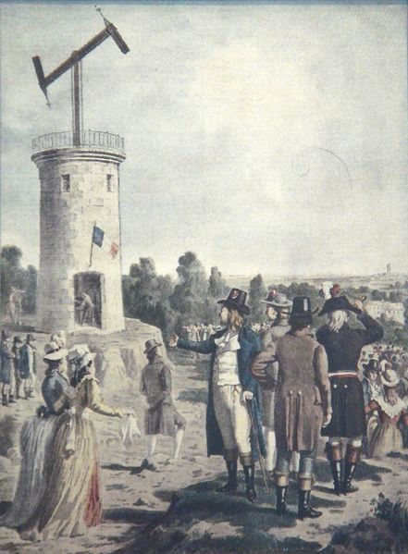](http://upload.wikimedia.org/wikipedia/commons/e/e7/Chappe_semaphore.jpg)