

**CONFERENCE SKILLS AUTUMN 2021**

**SESSION 1 (selected activities)**



**Mgr. Robert Helán, Ph.D.**

***Masaryk University, Faculty of Social Studies***

**1. INTRODUCTION TO THE COURSE**

**2. INTRODUCTION TO PRESENTING AND PUBLIC SPEAKING**

**3. CHARACTERISTICS OF ACADEMIC WRITING IN ENGLISH**

**In the session, the following areas will be covered:**

→ practicing free writing and free speaking as an integral part of writing and preparation for speaking

→ process of writing

→ discussions concerning academic writing and public speaking

**ACTIVITY 1:** *Discuss the following questions (concerning giving presentations) in pairs. Be prepared to summarize the most interesting/important information in 1 minute.*

1. Have you ever delivered a presentation? What was it about? Was it successful? How did you know the audience had liked it?
2. What’s the best presentation you have ever heard? Why did you like it?
3. What is the most challenging aspect of giving a presentation? What seems to be easy about it?
4. How can you stop being nervous when giving a presentation?
5. What presentation tools are you going to use when you prepare your poster? Powerpoint? Prezi? Can you use them effectively?
6. Whose presentation would you like to see (anyone in the world)? Why? Have you heard about TED Talks?
7. Do you think giving presentations might make you feel more confident? Why?
8. List your strengths and weaknesses when it comes to giving oral presentations? How are you going to overcome the weaknesses?

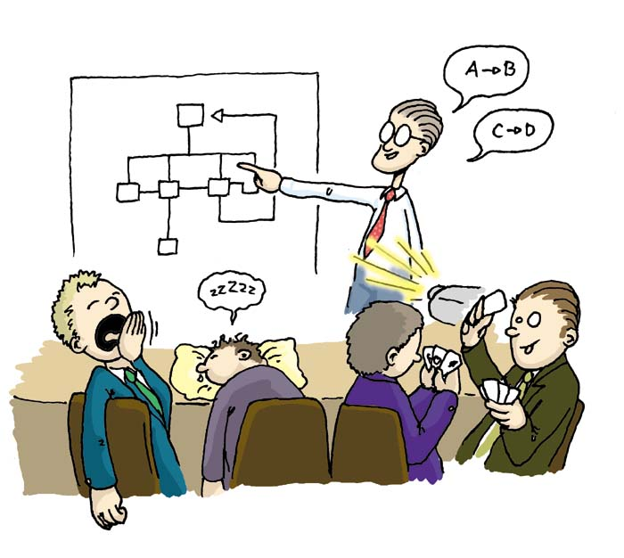

**ACTIVITY 2:** *How do you understand the process of writing depicted in this drawing?*

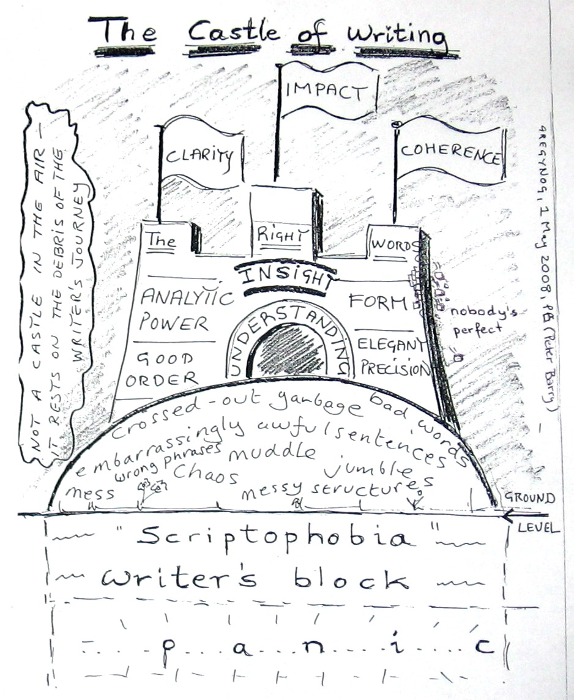

**ACTIVITY 3:** *Draw the process of your own writing - include any tips/strategies that work for you.*

**ACTIVITY 4:** *Discuss the following questions (concerning your attitude towards writing) in groups of three (each member will have a specific role in the discussion: leader, note taker, time keeper)*

1. Do you prefer writing or typing? Is there a difference between the two?

2. What are your biggest problems when writing?

3. What writing skills do you need to be able to write well?

4. How important is it to plan what you write?

5. How is your writing in English? Is writing in your language different from writing in English?

6. What advice would you give to a student who says he/she is no good at writing?

7. What questions would you like to ask a writing expert about writing?

8. Why/In what way is writing important for your future profession?

**ACTIVITY 5**: List and discuss the main characteristics of academic English (written and spoken). Consider the following levels of analysis and give examples:

MICRO LEVEL:

MEZZO LEVEL eg. grammatically correct sentences,

MACRO LEVEL

**ACTIVITY 6:** *Fill in either formal or informal synonyms of the following words.*

|  |  |  |  |  |
| --- | --- | --- | --- | --- |
| **formal** | **informal** |  | **formal** | **informal** |
|  | seem |  | enquire |  |
|  | climb |  |  | end |
|  | help |  |  | tell |
| cease |  |  | obtain |  |
| commence |  |  | preserve |  |
|  | use |  | reject |  |
| decrease |  |  |  | free |
| demonstrate |  |  |  | mend |
| depart |  |  | require |  |
|  | want |  |  | live |

|  |  |  |  |  |
| --- | --- | --- | --- | --- |
| **formal** | **informal** |  | **formal** | **informal** |
|  | understanding |  |  | childish |
| deficiency |  |  |  | wrong |
| opportunity |  |  | inferior |  |
| perspiration |  |  | inexpensive |  |
|  | house |  |  | dim |
|  | sight |  | insane |  |
| amiable |  |  |  | laid back |
|  | whole |  | responsible |  |
| energetic |  |  |  | enough |
| fortunate |  |  |  | empty |

**ACTIVITY 7:**

