**○ Nuclear and Solar Energy in the Energy and Climate politic of France**

The Energy and Climate Bill 1908 was introduced on 30 April 2019 in the National Assembly. An accelerated procedure on this text was initiated on the same day. This bill, presented on the name of Mr. Edouard Philippe, Prime Minister by Mr. François de Rugy, Minister of Ecological and Solidarity Transition, aims to change the objectives of French energy policy.

The unexpected change in Article L. 100-4 of the Energy Code has called us to attention and we allow ourselves, Mr. Minister, to support the idea of returning to the original article.

In fact, the legislative measure concerning this article aims to change the objectives on the proportion of nuclear energy in France: the words: “Reduce the proportion of nuclear energy in electricity production **to 50% by 2025”** have been replaced by the words “reduce the proportion of nuclear energy in electricity production **to 50% by 2035”[1]**.

The delay in this measure is due to the contradiction between this short deadline and our country's climate objectives. Indeed, according to this bill, in order to achieve the objective of reducing the proportion of nuclear energy in electricity production to 50% by 2025, it was considered necessary to build new thermal power stations, which is in contradiction with our country's climate objectives. However, we do not believe that the only way to achieve this objective in 2025 is through thermal power stations.

**○ The Region Reunion is concerned by this issue**

As a French territory, the Reunion Island Region would like to share with you its experience and expertise to demonstrate that solar energy is one of the solutions to meet the environmental and energy objectives to which France has committed itself at national, European and international level. Reunion Island is a French overseas territory according to Article 73 of the Constitution but also an outermost region of the European Union. We are therefore a territory fully concerned by French energy and environmental objectives. As an overseas department and region, we centralize the management of our energy policy for the whole of our territory.

Thus, as one of the only French territories independent of nuclear energy and aiming for energy independence, wishes to share its expertise in favour of solar energy.

**○ Remain coherent in French national policy**

The controversy and civil and scientific debate over the European Pressurized Reactor in Flamanville supports our position. The submission of the report "The construction of the Flamanville EPR"[2] to the Minister of Economy Bruno Le Maire and the head of EDF[3], Jean-Bernard Lévy, written by Jean-Martin Folz, proves that nuclear power is not the solution. The construction of the European Pressurized Reactor has already been a subject of debate since 2002, and as proof, it was only confirmed in 2006. Work began in 2007 and will be commissioned in 2012. Today, the starting of this reactor is scheduled for the end of 2022 with a budget of 12.4 billion instead of 3.3 billion. In our view, the Folz report is an opportunity to mark a rupture with French nuclear energy and to promote renewable energies, in particular solar energy. The delay and the exponential increase in the budget that this project has taken, shows that this money would have been used for better purposes such as investing in solar energy research (photovoltaic or thermal) or in the development of infrastructure.

Indeed, France has established ambitious objectives and the deadlines are approaching. According to the climate and energy policy plan for 2030, one of France's key objectives as a member of the European Union is to increase the share of renewable energies to at least 32% of final energy consumption. Today, according to EDF, Nuclear energy accounts for 71,6% (379,1 TWh) of French electricity production. This number shows France's dependence on nuclear energy. It would be advisable not to continue in nuclear energy but to look at other energy and renewable sectors. It is in this sense that the multi annual energy programme (MEP) provides for the closure of fourteen nuclear reactors and the significant development of solar and wind energy.

In addition, according to the Paris Agreement, France, together with other European countries, has committed itself to reducing Europe's emissions by 40% by 2030 compared to 1990.

France is now the most dependent country in the world on its nuclear fleet. In comparison, in the United States, only 20,05% (804,9 TWh) of electricity comes from nuclear power(EDF). The contradiction here is between the law adopted on climate and energy and the announcement by EDF's CEO declaring a project to build six new nuclear reactors in France[4]. This announcement, in which the government has not yet reacted, is not part of the desire to reduce the share of nuclear power in France. In addition, this includes significant investment in the nuclear sector for the construction of these reactors, while subsidies and assistance could be distributed to individuals, companies and regions to set up infrastructures for sustainable and renewable energies.

In this legislative and factual context, we do not understand the government's decision to postpone the date to reduce nuclear power in France.

= 1) The issue is not presented unequivocally. Is the problem in the timeframe of the nuclear phase-out? Or in what sources should replace nuclear?

= 2) Lobbying party is not identified properly. Reunion, yes, but who exactly and why?

= 3) Target entity is not identified at all. Who is the recipient of the paper and why?

*November 19th, 2019*

Dear Elisabeth Borne, Minister of Ecological and Solidarity Transition,

We are writing to you today as a French overseas territory concerned about achieving the ambitious objectives of French climate and energy policy. We know that you are aware of the urgency of the situation and we support most of your decisions, for example, the 40% reduction in fossil fuel consumption by 2030 compared to 30% previously(1). However, we want to come back to the Energy and Climate Law which decrees the ecological and climatic emergency promulgated in the Official Journal because we believe that we can act even better.

**○ Postponing the date of the nuclear reduction is not the answer.**

As explained previously, nuclear power is now the main source of electricity and energy in France. However, today nuclear energy is a controversial subject in our country.

First of all, nuclear power threatens the safety of citizens. A nuclear reactor consists of producing energy from the fission of heavy elements, mainly uranium [5]. In France, nuclear energy accounts for 71% of total electricity production.

On the one hand, the risk of accidents is not zero and this remains a problem in view of the history and consequences of nuclear accidents.

On the other hand, any type of installation can be threatening: by the age of reactors and nuclear power stations or by new installations. Indeed, on the second point, even if France has very strict standards, this has two effects: either the standards are not respected or, following the example of the Flamanville station, the project is years behind and is expensive.

This highlights the second problem of nuclear power in France, which is that it requires a significant amount of money.

The State is aware that it is not possible to completely stop nuclear power, as in Germany, where the rapid retirement of nuclear power has slowed its reduction in emissions and continues to buy electricity from France. The project to deploy new nuclear reactors at a time when the law advocates a reduction in the share of nuclear power contradicts itself.

Before, there was no alternative to meet the population's electricity demand. If research and investment focused on the energies included in the country's objectives, the profitability of this energy mix would be achieved very quickly. Conserving nuclear energy is not in question here, but investing in the energy mix and research into renewable energies is required.

In addition, in the long term, the issue of nuclear waste arises, and the government already knows that it will need to provide the necessary funds to learn how to manage and dispose of its waste.

**○ Solar Energy**

By contrast to nuclear power, which requires uranium, solar energy, particularly in relation to photovoltaic panels, only requires sustainable energy on a human scale, the sun. The safety of citizens is not threatened and the environmental impact remains low. This energy is thus in line with the European and global agreements signed by France by reducing man-made emissions.  
Today, solar energy covers 2% of the world's electricity and 1.9% of French electricity according to RTE's 2018 electricity report.

Solar energy is divided into two technologies: photovoltaic (which directly converts sunlight into electricity) and solar thermal. But it is a sector of the future, especially photovoltaic solar energy.

**○ Photovoltaic energy**

Photovoltaic allows electricity to be produced from sunlight by crystalline silicon solar cells. The process is explained by a solar cell that absorbs the solar energy that is converted into electrical energy. Solar energy produces both electrical energy (15 to 25%) and the other part is transformed into heat (Blakers, 2017)5.

In 2017, solar photovoltaic produced 8.6 TWh in France, or 1.8% of electricity consumption according to data from the Ministry of Ecological and Solidarity Transition. The photovoltaic energy produced is consumed instantly but the surplus can be used. The photovoltaic installation can be equipped with an energy storage system that allows the excess electricity to be used to increase the autonomy of a house. Lead-acid batteries are currently the most widely used because they are simple to use and their cost is low. Lithium batteries are increasingly present on the market because they are more efficient, less bulky and less polluting.

This energy is used to provide electricity and thermal energy to heat and cool buildings for private or private use. Decentralized installations are suitable for everyone: industrial sites and shops because they are active during the day, when the sunshine is high.

**○ Debates and arguments in favour of photovoltaic**

Solar energy is an energy that is sometimes contested as efficient energy. This was true at one time, but today the development of solar energy and in particular photovoltaic proves that solar energy is a sector of the future and that it can play a full part in the countries' energy mix.

*→ Prices*

One of the first obstacles, according to elected politicians, to increasing the share of solar panels concerns prices. The entry of solar energy is already facilitated by carbon pricing and the removal of fossil fuel subsidies, but the cost reduction of photovoltaic will continue to fall drastically.   
 Nevertheless, the progress made in terms of photovoltaic cell yields and the cost of manufacturing solar panels has changed significantly. China produces massively photovoltaic cells, which considerably reduces the cost of photovoltaic.

Thus, in a few years, the costs of solar energy have considerably reduced, which today makes this energy competitive with fossil and nuclear energy. According to the International Energy Agency, costs could fall between 15% and 35% by 2024, soon making the solar sector more profitable than thermal power plants.

*→ Photovoltaic energy and land conflicts*

Land conflicts no longer concern photovoltaic energy because it can be installed on almost any surface. The case of Reunion Island by its small area shows that it is possible to set up solar panels on a small area. Indeed, solar collectors are mainly on the roofs of buildings (private, public) and even now there are floating solar panels. The case of Lake Vaucluse and the 47,000 photovoltaic panels installed by Akuo Energy show that it is possible to reuse old unused quarry sites. With a power of 17 megawatts, it is one of the most powerful installations in Europe, corresponding to a small group of ten nuclear power plants under the condition of optimal sunshine. In addition, the government, through the implementation of the “Sun Plan” in June 2018 to help free up space for the installation of solar panels, should not have any problems installing solar panels.

*→ Sun exposition is sufficient in France*

For many years France has been behind in photovoltaic energy, countries like England had a more efficient and a larger part in solar energy even if they are more exposed to the North.(Annexe 1&2)

In 2016, China is the leading producer of electricity from solar photovoltaic energy with 75.25 TWh (22.9% of world production). France has a production of 8.16 TWh, or 2.5% of the world's production according to EDF Data.

However, the village of Langouët in the Brittany Region near the city of Rennes is now almost independent in terms of energy and food production. A large part of their energy independence is due to the installation of solar panels. However, Brittany is one of the regions in France with the least sunshine all year round (Annexe 1). Photovoltaic energy is thus sufficient for the self-consumption of private individuals.

*→ The materials used for photovoltaic panels are abundant*

Solar energy uses common materials. The majority of the solar cells in a solar panel use silicon (Blakers, 2017), about 90% of the solar cells in the global photovoltaic market are made of crystalline silicon. It is a non-toxic, profitable, stable element. It is also the second most numerous element in the earth's crust(annex 3). Thus, unlike nuclear energy, by the profusion of this element, the possibility of conflict over photovoltaic energy materials is much less than for nuclear energy.

→ Job creation in correlation with declining unemployment

The development of solar energy has had a great impact on job creation in Reunion Island. Unemployment on Reunion Island is much higher than in France and Europe. According to INSEE in 2018, the unemployment rate in Reunion Island was 24% compared to 8.5% in metropolitan France. The development of solar energy is not only about energy, it has created jobs. In 2017 alone, 613 jobs were created in production(annex 4), and solar energy accounted for more than half of these jobs in production (among biogas, wind, bagasse, hydro and fuel).

*→ Public opinion is in favour of increasing photovoltaic energy*

Solar energy is largely and easily accepted by citizens. Decreasing the proportion of nuclear energy and at the same time increasing the proportion of solar energy will be fully accepted. Indeed, reducing the part of nuclear power means reducing the risk of accidents, developing solar energy means creating jobs.

**○ Problems persist and require investment in research and development**

The growth of the solar sector is encouraging but not sufficient to comply with the Paris Agreement. According to the IEA, 1200 gigawatts of renewable capacity would have to be installed between 2019 and 2024, 50% more than the actual capacity[6]. To remedy its weaknesses, it is necessary for politicians, scientists and companies to cooperate to achieve the planned objectives.

*→ Intermittence and storage*

The problem of metrological intermittency remains the major problem concerning photovoltaic energy. Indeed, solar energy production varies greatly depending on climatic conditions. During the night and winter, electricity production remains very limited. Nevertheless, the low attitude territories of which France is more favoured than other countries such as New Zealand, Iceland or Argentina.

Faced with this intermittency, it would be necessary to invest in energy storage facilities or use secondary energy. Thus, the great challenge of solar energy remains storage. For a continuous power supply, additional equipment (inverters) and storage batteries are required. Today, even if there are batteries and other elements to store electrical energy but there is no system to store large quantities of energy. The storage of this energy must be improved if the solar sector is to develop.

*→ Installation price*

The installation of solar panels is expensive, particularly because of the need to pay for additional equipment (*see section on intermittence*). Thus, the profitability of the installation is only visible after several years. Due to the high cost of installation, a social inequality between households, modest companies compared to those with more resources, is emerging.

*→ Life expectancy*

For optimal performance, solar panels have a more limited lifetime. After 25 to 30 years the efficiency is reduced and the materials need to be changed. However, no maintenance or cleaning costs are required during the 25 years. Besides, looking for a way to build solar panels with a longer lifespan would be promising.

**○ Alternative without nuclear power: the case of the Reunion Island**

The Reunion Island Region is today in the Indian Ocean region a precursor of sustainable energies. As a leader in climate, air and energy policy planning, the meeting region co-developed with the State on the island's multi annual energy programming (MEP).

By the results obtained for our MEP we wish to show that even according to the different territories of our two territories alternatives exist.

It is a fact that we are a territory too dependent on fossil fuels and not interconnected to a continental electricity grid: it is because we had no choice that we had to change our model. However, we are well aware that solar energy will not be enough, which is why we are talking about an energy mix. Solar energy is the most promising in France (unlike biomass or wave power on Reunion Island) and by being combined with 50% of nuclear energy's proportion of total electricity production it is possible to have a sufficient energy yield.

Energy efficiency is one of our priorities and the regional sustainable energy forums bringing together professionals, researchers and companies make it possible to place energy in a virtuous model. The ENERGIES programme funded by Europe allows us to be advanced in the field of solar energy.

Through our progress in this area, we propose that the continent focus on developing the share of renewable energies in its energy mix and allocate funding to the Reunion Island Region to enable research on energy efficiency.

**○ Recommendations for actions**

According to the International Energy Agency, global renewable energy capacity is expected to grow by 50% by 2024, an additional 1,200 gigawatts, *the equivalent of about 1000 nuclear power stations[7]*. Until now, the introduction of photovoltaic into electricity systems has been achieved through massive public subsidies. The role of municipalities and regions is essential for this sector. The government can provide the impulse for this assistance.

Energy efficiency, “doing better with less” that the Reunion adopted, can also be applied to France, it is possible to do more energy with less in non-renewable energy. The Reunion Island Region has set up projects and subsidies to address the climate emergency, reduce gas emissions and, in our case, reduce the import of fossil fuels. Knowing that France is targeting 35.6 to 44.5 GW in 2028 in the PPE, the government must take action to help solar power.

We would like to make several recommendations based on our experience:

1/ In order to increase the number of homes equipped with solar water heaters, it is possible to set up a photovoltaic cheque-system similar to the one on Reunion Island. This involves creating a regional subsidy for individuals (residents and farmers) without income conditions, to be accessible to all. In Reunion Island, 1174 photovoltaic vouchers were distributed and 4324 solar water heaters were installed.

2/ The “eco-solidarity” system: the social aspect is also very important. In France, 14.4% of the population was estimated in 2012 to be in fuel poverty. Setting up such a system helps families and homes with modest incomes to equip their homes with a solar water heater. This would cover the cost of the installation. By combining the creation of such a system in France with the existing SLIME (Local Intervention Service for Energy Management), fuel poverty would decrease while developing the solar sector.

3/ Regulation and implementation of city’s infrastructure: The municipalities could equip their properties (buildings and land) with photovoltaic panels to produce electricity. This would make it possible to supply isolated sites such as waste collection centres or public lighting installations. In this case, local production will be less expensive than connecting to the electricity system.

4/ Requiring municipalities to support calls for proposals from the "Energy Commission and Regulation" and company innovations. It is also the responsibility of local authorities to support project leaders and companies in this field.

5/ Lower the tax on photovoltaic installations, so as not to penalize workers in the photovoltaic sector.

6/ Concerning the formation of the citizens, the photovoltaic solar energy sector requires different types of professionals: scientists, engineers, workers, technicians, sales representatives. Establish an education and formation is required first and foremost to develop the solar energy sector.

= recommendations are interesting. More detailed information would be appreciated here.

**○ Conclusion**

If the French government wishes to remain coherent in its policies and actions in relation to its national and international objectives and commitments, the share of solar energy must be increased in the French energy mix.

Continental France is very independent of nuclear energy, as Reunion Island is dependent on fossil fuels. However, transition is possible, but in the long term, that is why postponing the objective of reducing nuclear power by 50% in 2050 may not be the best solution, out of the risk of thinking that we have more time to start this transition. Efforts to develop solar energy and particularly photovoltaic energy must start today.

This energy is a sector of the future in terms of safety, abundance of materials, social acceptance and non-pollution (greenhouse gas emissions, noise pollution, health). It is an energy that concerns the public, commercial, industrial or private domain and can be centralised or decentralised.

We call for cooperation between scientists, municipalities, regions, companies to share our knowledge and know-how and move solar energy forward more quickly. For several years now, the Reunion Island region has been committed and working to significantly develop the solar sector, our knowledge is diverse and varied. The Standing Committee of the Regional Council met on Tuesday 10 September 2019 under the chairmanship of Didier Robert in Saint-Denis, Reunion Island. We regularly review the amounts we allocate[8] from the region's budget in the solar sector and we believe that we can make even greater progress by strengthening cooperation and increasing the amount allocated to research in solar and photovoltaic energy.

Investing in the solar and photovoltaic energy sector will accelerate the decarbonisation of France, Europe and the world, and ensure a sustainable and carbon-free energy future.

= Some interesting insights were provided, however, some significant drawbacks need to be mentioned.

1. The aim of the lobbying paper is not clear. In the set-up part of the text you have emphazised the importance of Energy Code and its Art. 100-4 and the fact that deadline for partial nuclear phase out was postponed. But you are not getting back to this issue in the paper itself.
2. The text itself is more a discussion on the advantages of solar PV technology than focused analysis trying to alter some processes in France. This is not a seminal paper, this is a lobbying paper.
3. The arguments are quite often shallow and unsubstantiated with precise data. It would be better to present a fewer issues but in detail and fitted to the actual situation in France.
4. Structure of the paper could be improved, also references are missing in the text. 17 points.

**ANNEX**

**Annex 1**

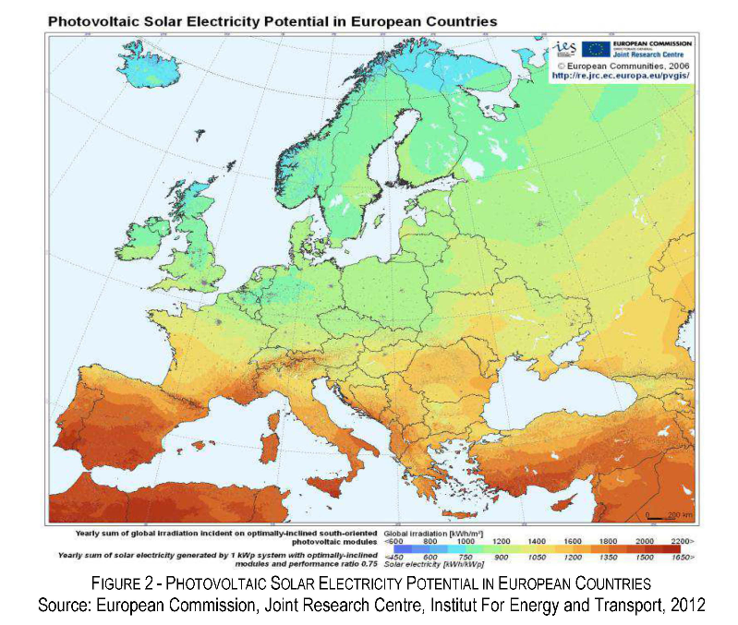**Annex 2: Installed solar photovoltaic capacity, gigawatts (source: Our World in Data)**

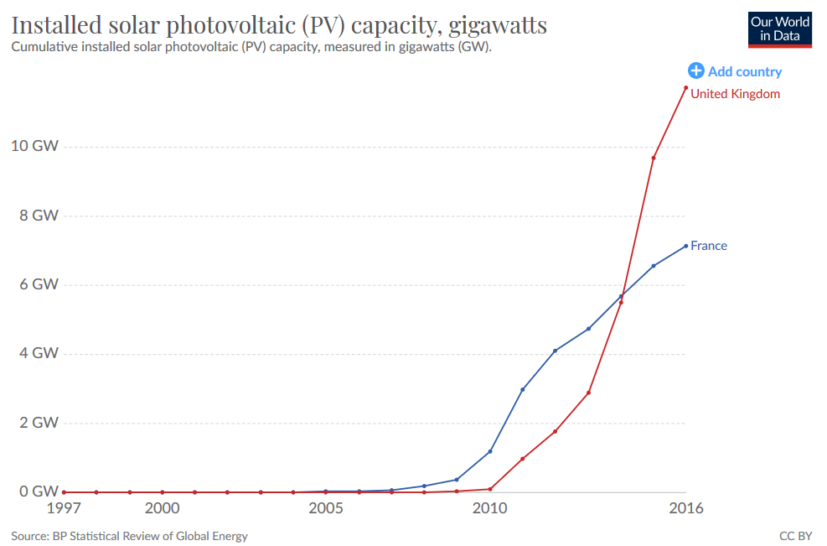

**Annex 3**

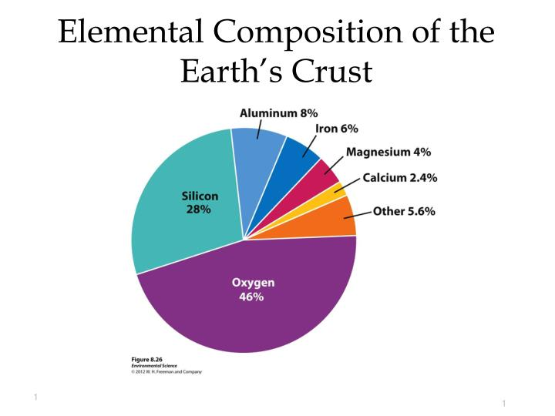**Annex 4: Employment in Energy Sector- 2017 (source: Official Journal of the Reunion Region)**

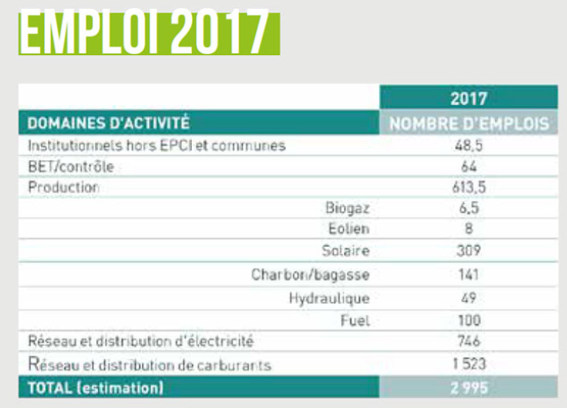

**BIBLIOGRAPHY**

First Part:

-(1) Bill, adopted by the National Assembly after initiation of the accelerated procedure, on energy and climate on 28 June 2019, T.A. No. 301: <http://www.assemblee-nationale.fr/15/ta/ta0301.asp>

-(2) Rapport of Jean-Martin Folz, The Construction of the Flamanville EPR:

<https://minefi.hosting.augure.com/Augure_Minefi/r/ContenuEnLigne/Download?id=104AF2DA-FA4D-4BED-B666-4D582E2C7A8A&filename=1505%20-Rapport%20Flamanville%20pdf.pdf>

-(4) Article of Simon Soubieux, France Bleu: “EDF's CEO announces a project to build six new nuclear reactors in France” <https://www.francebleu.fr/infos/environnement/le-pdg-d-edf-annonce-le-projet-de-construction-de-six-nouveaux-reacteurs-nucleaires-en-france-1571372320>

- Official Data of EDF (literraly: Electricity of France) on nuclear power: <https://www.edf.fr/groupe-edf/espaces-dedies/l-energie-de-a-a-z/tout-sur-l-energie/produire-de-l-electricite/le-nucleaire-en-chiffres>

Second Part:

- Official Journal of the Reunion Region “La Réunion Eco-positive”, May 2019

- The Multiannual Energy Plan , Ministery <https://www.ecologique-solidaire.gouv.fr/sites/default/files/4pages_PPE_GB_DEF_Web.pdf>

- The Multiannual Energy Plan French version <https://www.ecologique-solidaire.gouv.fr/programmations-pluriannuelles-lenergie-ppe>

- Mihaela Pacesila, Solar Energy Policy Developments in Europe, Theoretical and Empirical Researches in Urban Management, Vol.10, No1 (February 2015), pp.13-24 <https://www.jstor.org/stable/pdf/24873518.pdf?ab_segments=0%252Fbasic_SYC-4802%252Ftest2&refreqid=excelsior%3A41adbc71023a79bd401c1066fd0a0b22>

- (5)Andrew Blakers, Learning from Fukushima, Sustainable energy options, 2017  
<https://www.jstor.org/stable/pdf/j.ctt1ws7wjm.19.pdf?ab_segments=0%252Fbasic_SYC-4802%252Ftest2&refreqid=excelsior%3Af414c6b18a0e329e0704d48ade179c6a>

- The International Energy Agency Website <https://www.iea.org/>

- Electricity Review 2018 by RTE (Electricity Transmission network)

<https://www.rte-france.com/sites/default/files/be_pdf_2018v3.pdf>

- Press file of the Minister of Ecological and Solidarity Transition, on the "Place au Soleil" project

<https://www.ecologique-solidaire.gouv.fr/sites/default/files/2018.06.28_DP_Mobilisation_PlaceAuSoleil.pdf>

- Official Website of European Union <https://ec.europa.eu/regional_policy/fr/projects/france/running-reunion-on-solar-power>

- Insee Data about unemployment <https://www.insee.fr/fr/statistiques/3973442>

- Article of Gérard Julien, AFP, The Conversation, L’avenir du solaire est-il dans le flottant ?

- The Wold Bank, Where sun Meets Water: Floating Solar Market Report:

<https://www.worldbank.org/en/topic/energy/publication/where-sun-meets-water>

- Article of Ute Dubois about Energy Poverty

<https://www.energypoverty.eu/news/fuel-poverty-france>

- Gérard Julien, « Why solar energy is expected to explode in the coming years » <https://www.lci.fr/planete/electricite-pourquoi-l-energie-solaire-devrait-exploser-durant-les-prochaines-annees-2135607.html>

1. Extract from the bill, adopted by the National Assembly on energy and climate on 28 June 2019
2. Rapport of Jean-Martin Folz, The Construction of the Flamanville EPR
3. EDF : « Electricité de France » : French company that supplies and produces electricity and is majority owned by the government
4. Article of Simon Soubieux, France Bleu: “EDF's CEO announces a project to build six new nuclear reactors in France”
5. Andrew Blakers, “Learning from Fukushima, Sustainable energy options”, 2017
6. IEA Official Website https://www.iea.org/renewables2019/
7. Gérard Julien, « Why solar energy is expected to explode in the coming years » https://www.lci.fr/planete/electricite-pourquoi-l-energie-solaire-devrait-exploser-durant-les-prochaines-annees-2135607.html
8. Standing Committee of the Regional Council of Reunion Island <http://www.regionreunion.com/actualite/toute-l-actualite/article/commission-permanente-du-10-septembre-2019>