MASARYK UNIVERSITY FACULTY OF LAW

Public Health Emergency Law:
Domestic and International

Offered in the Spring Semester 2010

Judith W. Munson
Visiting Adjunct Professor from
John Marshall Law School
Jwmunson2@yahoo.com

Outline for Class #1

Tuesday, March 16, 2010
Computer Lab

NOTE: ALL STUDENTS ARE REQUIRED TO BRING A LAPTOP COMPUTER TO CLASS OR MAKE ARRANGEMENTS TO PARTNER WITH ANOTHER STUDENT WITH A LAPTOP

All Students: Sign-up to receive email alerts from the following two entities:
- EU Commission on Health and Consumer Protection: sanco-news@ec.europa.eu
(Note: the Commission has relaunched its website and the rss feeds are no longer available—unless you can locate the place where you are to sign up)
- US Centers for Disease Control and Prevention, Public Health Law Program News: http://www2a.cdc.gov/phlp/cphln.asp (Since this class was offered last, the CDC Public Health Law News is now only published once a month.)
Both subscriptions are FREE.

- Overview—Introductions—Public Health + Threats + Security Topics Monitoring—Student Sign Up

- International Quiz—ppt by Instructor
- Please come to class having read the following article: Goodman, R.A., et. al, “Law and Public Health,” MMWR, Dec 22, 2006 (55 SUP02; 29-33) http://www.cdc.gov/mmwr/preview/mmwrhtml/su5502a11.htm?s_cid=su5502a3_3

ANTHRAX AND THE REVOLUTION
IN PUBLIC HEALTH LAW

- CDC Bioterrorism Video
http://www.bt.cdc.gov/training/historyofbt/01overview.asp
http://www.bt.cdc.gov/training/historyofbt/02anthrax.asp
http://www.bt.cdc.gov/training/historyofbt/03plague.asp
http://www.bt.cdc.gov/training/historyofbt/04smallpox.asp
http://www.bt.cdc.gov/training/historyofbt/05botulism.asp
http://www.bt.cdc.gov/training/historyofbt/06vhf.asp
http://www.bt.cdc.gov/training/historyofbt/07tularemia.asp

- ANTHRAX—Reformation of PH Law in US and the Model Act

- PPT presentation by the Instructor—Anthrax + the Model Act

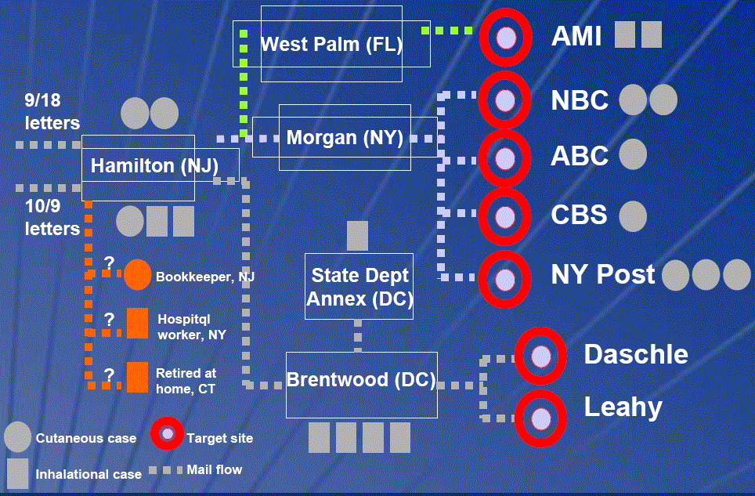

- The Model State Emergency Health Powers Act as of December 21, 2001 can be found at: http://www.publichealthlaw.net/MSEHPA/MSEHPA2.pdf

For a description of the Model State Emergency Health Powers Act
Go to: http://en.wikipedia.org/wiki/Model_State_Emergency_Health_Powers_Act

- The Anthrax case (Amerithrax Case File) was just recently closed by the FBI. See http://en.wikipedia.org/wiki/2001_anthrax_attacks#Overview

If time permits . . .

- Viewing of the first 20 minutes of the 1950’s film, “Panic in the Streets”—Elia Kazan, Director.

- Forensic Epidemiology – the importance of joint training—Public Health + Law Enforcement

- PDD-39: http://www.fas.org/irp/offdocs/pdd39.htm

