JOHN MARSHALL LAW SCHOOL STUDENTS
Public Health Emergency Law: Domestic and International
Skype Assignment, Spring 2010

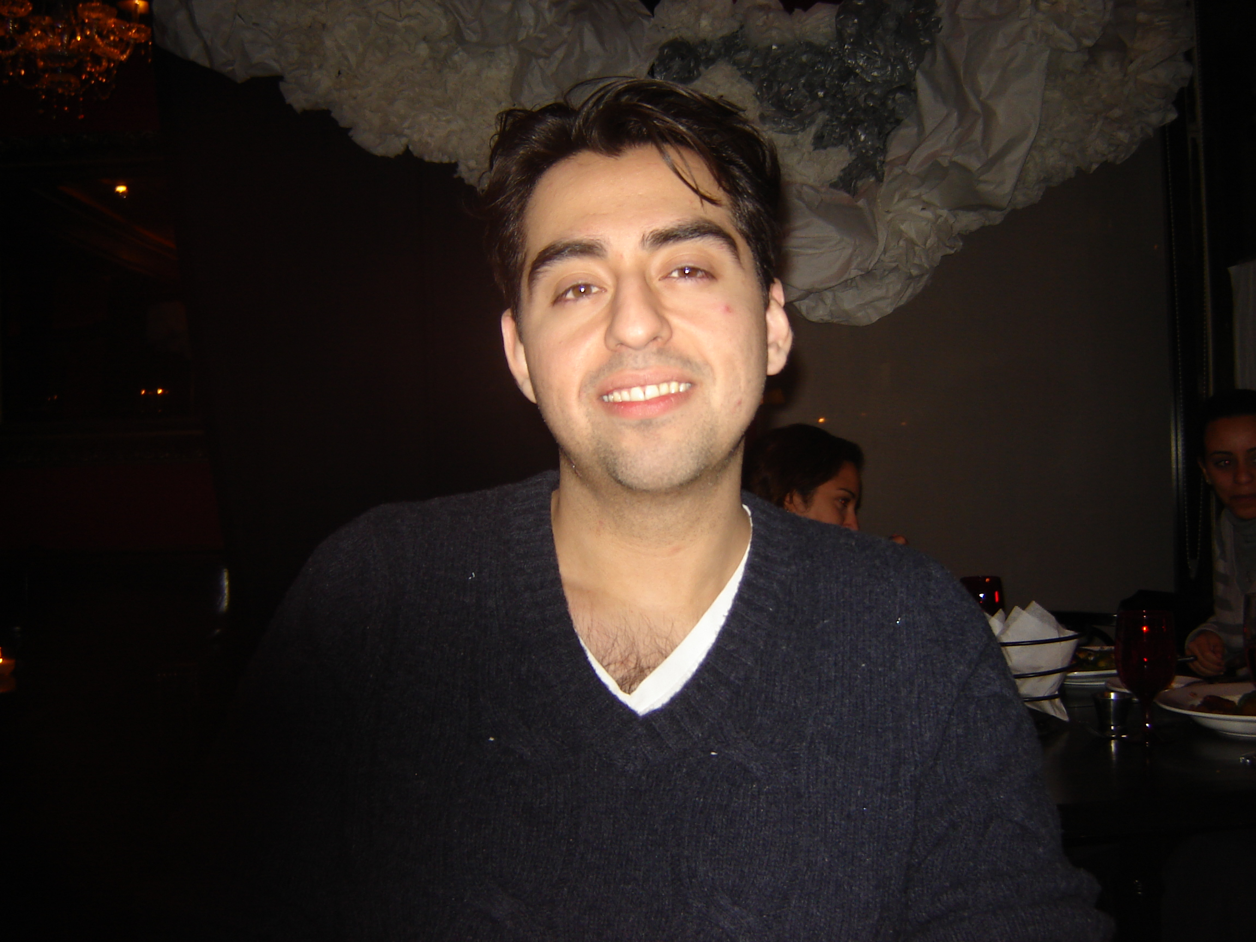
Luis Melero
jlmelero@gmail.com
jmelero@law.jmls.edu
skype name: jlmelero1


Bradley John Schaufenbuel
5schaufenbuelb@law.jmls.edu
bschaufe@hotmail.com
Skype name: bschaufe


Yoon Kim
5kimy@law.jmls.edu
ytkim0918@yahoo.com
Skype name: ytkim0918


Betty Anna Donoval
bdonova@law.jmls.edu
lopta151@gmail.com
skype: lopta151



Carol Comrie
skype name: carol.comrie
carol.comrie@gmail.com
ccomrie@law.jmls.edu

Felicia Ganther
5ganther@law.jmls.edu
fganther@clcillinois.edu
fganther



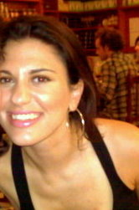
Name: Eleni Giannakopoulos
Email: egianna@law.jmls.edu
Eleni.giannakopoulos@gmail.com
Skype Name: lenieog

Andrew (Drew) McClarity
E-mail: Drewmc@ameritech.net
Amcclar@law.jmls.edu
Skype: andrew.mcclarity

Full Name: Katrina S. Forrest
JMLS Email: kforres@law.jmls.edu
Other Email: kforrest2@gmail.com
Skype Name: k4rest

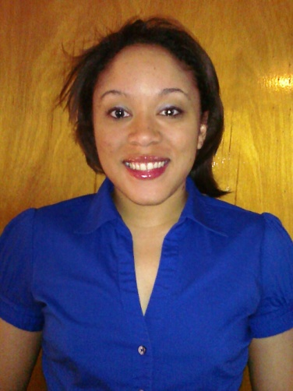
Name: Quiana Marie Mays
Email addresses: 5maysq@law.jmls.edu and quianamays@comcast.net
Skype name: quianamays1

Lauren N. Prihoda5prihodal@law.jmls.edu
laurennicole@ameritech.net
Skype name: lnpriho




Joe Chekouras
Communications Specialist
Lake County, IL Government
847.377.2155
Skype name: joe.chek
joe.chek@gmail.com
5chekour@law.jmls.edu

