MASARYK UNIVERSITY FACULTY OF LAW

Public Health Emergency Law:
Domestic and International

Offered in the Spring Semester 2011

Judith W. Munson
Visiting Adjunct Professor from
John Marshall Law School
Jwmunson2@yahoo.com

Outline for Class #1

Tuesday, March 15, 2011
Computer Lab

NOTE: This course is based on the availability of documents, videos, breaking news, etc., available on the Internet. As a result, this course is scheduled to take place in the Computer Lab.

All Students: Please read this Case Study Prepared by an International Meta-Leadership Team at the 2009-2010 Leadership Institute at the University of Illinois, School of Public Health: A TALE OF TWO FLOODS: Applying Multi-Sector Cooperation to Emergency Preparedness and Response in Illinois and the Czech Republic, March 12, 2010. The Case Study is available at: http://www.midamericacphp.com/wp-content/uploads/2010/09/A-Tale-of-Two-Floods-MARPHLI-Case-Study-by-the-Meta-Balconeers-final.pdf

- Overview—Introductions—Public Health + Threats + Security Topics Monitoring—Student Sign Up
- International Quiz—powerpoint by Instructor
- Please come to class having read the following article: Goodman, R.A., et. al, “Law and Public Health,” MMWR, Dec 22, 2006 (55 SUP02; 29-33) http://www.cdc.gov/mmwr/preview/mmwrhtml/su5502a11.htm?s_cid=su5502a3_3
Please also read Title XIV PUBLIC HEALTH Article 168 of the Treaty on the Functions of the EU (Consolidated Version) and,
- Please access and review the EU Commission on Health and Consumer Protection Preparedness and Response documents: http://ec.europa.eu/health/preparedness_response/consultations/preparedness_cons_02_en.htm
- Read the Introductory Paper http://ec.europa.eu/health/preparedness_response/docs/cons_introduction_en.pdf, and
- The STAFF WORKING DOCUMENT on lessons learnt from the H1N1 pandemic and on health security in the European Union: http://ec.europa.eu/health/preparedness_response/docs/commission_staff_lessonsh1n1_en.pdf

ANTHRAX AND THE REVOLUTION
IN PUBLIC HEALTH LAW
- CDC Bioterrorism Video
http://www.bt.cdc.gov/training/historyofbt/01overview.asp
http://www.bt.cdc.gov/training/historyofbt/02anthrax.asp

(For Viewing On Your Own):
http://www.bt.cdc.gov/training/historyofbt/03plague.asp
http://www.bt.cdc.gov/training/historyofbt/04smallpox.asp
http://www.bt.cdc.gov/training/historyofbt/05botulism.asp
http://www.bt.cdc.gov/training/historyofbt/06vhf.asp
http://www.bt.cdc.gov/training/historyofbt/07tularemia.asp

- ANTHRAX—Reformation of PH Law in US and the Model Act

- PPT presentation by the Instructor—Anthrax + the Model Act
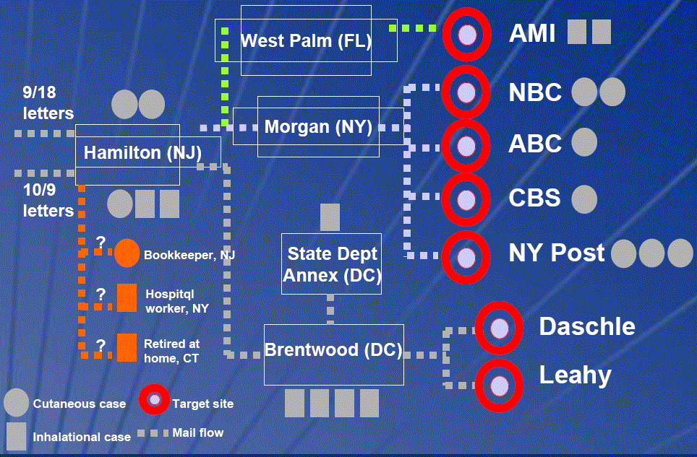

- The Model State Emergency Health Powers Act as of December 21, 2001 can be found at: http://www.publichealthlaw.net/MSEHPA/MSEHPA2.pdf

For a description of the Model State Emergency Health Powers Act
Go to: http://en.wikipedia.org/wiki/Model_State_Emergency_Health_Powers_Act

- The Anthrax case (Amerithrax Case File) was closed by the FBI only a year ago. See http://en.wikipedia.org/wiki/2001_anthrax_attacks#Overview

If time permits . . .

- Viewing of the first 20 minutes of the 1950’s film, “Panic in the Streets”—Elia Kazan, Director.

- Forensic Epidemiology – the importance of joint training—Public Health + Law Enforcement

- PDD-39: http://www.fas.org/irp/offdocs/pdd39.htm

