**International Law in**

**Contemporary Society**

**Faculty of Law, Masaryk University,**

**23-25 April 2012**

**Prof. Ryszard Piotrowicz, Aberystwyth University;**

**Member, European Commission’s Group of Experts on Trafficking in Human Beings**

<http://www.aber.ac.uk/en/law-criminology/staffdirectory/ryp/>

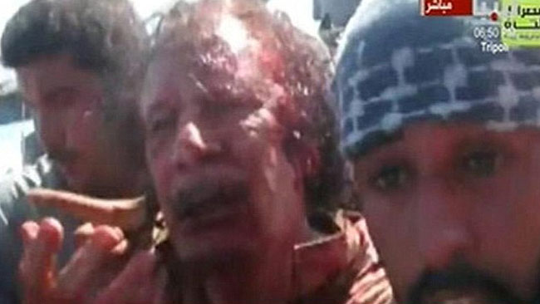

Gaddaffi shortly before being shot dead.

Where is International law

* When the Syrian government attacks its own people and the world just watches?
* When Colonel Gaddaffi is murdered on YouTube but nobody is prosecuted?
* When thousands of women are raped every year in war?
* When young women are trafficked for sex?
* When the UK and France attack Libya?
* When Kosovo and Northern Cyprus claim to be States?
* When more than half of the countries in the world torture their citizens?

**Structure of the course**

This is an intensive course: there will be six sessions over three days; each session devoted to a separate topic. Each session will last 90 minutes. I will give an introductory lecture on the topic.

There will be plenty of opportunities for you to ask questions and I hope that you will take advantage of this. It helps me to see what needs to be explained more and also gives me ideas on how best to present the issues.

**Assessment**

Assessment will be by essay. The essay must be no longer than 1500 words. At the end of your essay you must give a word count. The essay must be submitted to can you insert the name/location of the person and submission date?

**1. Fundamental Principles of International Law**

The class will consider how these principles have emerged and particular problems that arise with regard to their application in the contemporary international community.

international law, like international relations, is not static. After the collapse of communism in 1989-91, people started to talk about “the end of history” – as if the end of the cold war had settled the major divisions confronting the world.

In fact, we simply entered another phase of history, with the spectre of the cold war replaced by new challenges posed by international terrorism, emerging democratic movements and failed States. How does international law work twenty years on?

**United Nations**

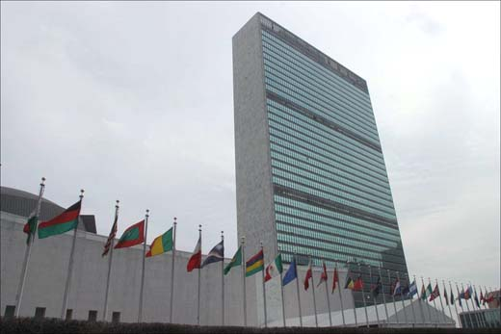

**United Nations Charter** (1945)

http://www.un.org/en/documents/charter/index.shtml

* Sovereign equality of States
* Non-intervention
* Prohibition on threat or use of force
* Peaceful settlement of disputes
* Respect for human rights
* Self-determination of peoples

**Purposes of UN: Art 1**

* Maintain international peace and security
* Develop friendly relations among nations
* Achieve international cooperation in solving international problems
* Co-ordinate and harmonise actions to achieve these ends

**Principles of UN: Art 2**

* Sovereign equality of all members
* Disputes to be settled by peaceful means
* Prohibition on threat or use of force against territorial integrity or political independence of other States

**Questions**

1. What is meant by the notion of ‘sovereign equality of States’? Is it absolute or limited? Think of examples to justify your view.

2. If you could make one major reform to the United Nations, what would it be, and why?

3. Does the Security Council function effectively? From the perspective of international law, consider the principal reasons for the difficulties encountered by the Security Council.

4. How do you evaluate the response of the Security Council with regard to Libya and Syria?

**2. Challenges to International Personality**

This class will consider what actually is a subject of international law: who has rights and duties to act at the international level?

We will consider the extent to which human beings now have international capacity and the ramifications of having such personality.

Who are the subjects of International Law?

* States

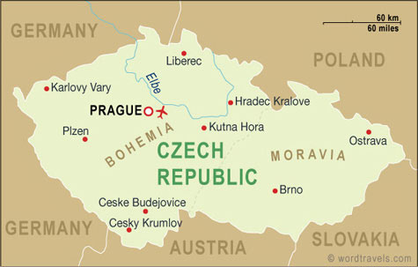

* International organisations

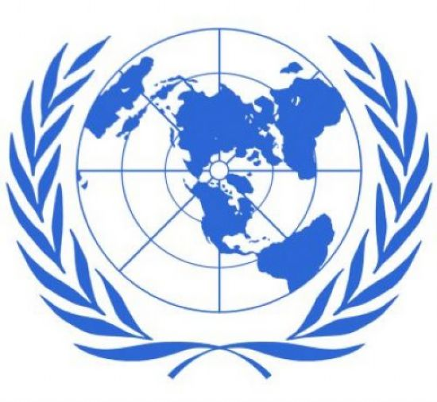

* Human beings



* NGOs

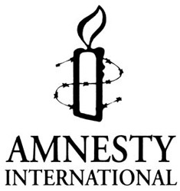

* Corporations



What is a State?

*Montevideo Convention on Rights and Duties of States 1933*

Article 1: a State should posses the following qualifications:

1. a permanent population; (b) a defined territory; (c) government; (d) capacity to enter into relations with other States

*Arbitration Commission of the European Conference on Yugoslavia*

Opinion No.1: “the state is commonly defined as a community which consists of a territory and a population subject to an organised political authority”

What about:

* Wales
* Transnistria
* Somalia – failed States
* Republika Srbska
* Chechnya
* Southern Ossetia and Abkhazia
* Turkish Republic of Northern Cyprus
* Holy See/Vatican City
* McDonalds – Human Rights Council, “Promotion and Protection of all Human Rights, Civil, Political, Economic, Social and Cultural Rights, Including the Right to Development.”, 7 April 2008. (Subtitle: Protect, Respect and Remedy: A Framework for Business and Human Rights). The Report was written by Prof. John Ruggie, the Special Representative of the Secretary-General on the issue of human rights and transnational corporations and other business enterprises.
* Human rights and international criminal responsibility

**Kosovo: is it a State?**

**Kosovo**

|  |
| --- |
| http://img.timeinc.net/time/daily/special/kosovo/maps/kosovomap.gif |

Kosovo declares independence – 17 February 2008

Czech Republic recognises Kosovo – 21 May 2008; altogether 90 States have recognised Kosovo (March 2012; in March 2011, 76 States had recognised it).

**Legal issues**

* right of territorial integrity/ duty to respect territorial integrity
* right of self-determination/secession

**The legal context**

* Security Council Resolution 1244, 10 June 1999
* Statement by the Chairman on the conclusion of the G-8 meeting of Foreign Ministers, Petersberg Centre, 6 May 1999
* Paper presented to, and accepted by, the Yugoslavian Government, Belgrade, 2 June 1999

**SC Res. 1244**

Preamble:

Reaffirming the commitment of all Member States to the sovereignty and territorial integrity of the Federal Republic of Yugoslavia…

Reaffirming the call in previous resolutions for substantial autonomy and meaningful self-administration for Kosovo…

5. Decides on the deployment in Kosovo, under United Nations auspices, of international civil and security presences… and welcomes the agreement of … Yugoslavia to such presences;

10. Authorizes the Secretary-General… to establish an international civil presence in Kosovo in order to provide an interim administration for Kosovo under which the people of Kosovo can enjoy substantial autonomy within… Yugoslavia, and which will provide transitional administration while establishing and overseeing the development of provisional democratic self-governing institutions to ensure conditions for a peaceful and normal life for all inhabitants of Kosovo;

11. Decides that the main responsibilities of the international civil presence will include:

(a) Promoting the establishment, pending a final settlement, of substantial autonomy and self-government for Kosovo…

(c) Organizing and overseeing the development of provisional institutions for democratic and autonomous self-government pending a political settlement…

**Annex 1**

G-8 Statement, 6 May 1999

- adopted several general principles on a political solution to the Kosovo crisis, including:

A political process towards the establishment of an interim political framework agreement providing for a substantial self-government for Kosovo, taking full account of the Rambouillet accords and the principles of sovereignty and territorial integrity of… Yugoslavia…

**Annex 2**

Paper presented to, and accepted by, the Yugoslavian Government, Belgrade, 2 June 1999

- requires agreement to be reached on certain principles to move towards a resolution of the Kosovo crisis:

5. Establishment of an interim administration for Kosovo as part of the international civil presence under which the people of Kosovo can enjoy substantial autonomy within… Yugoslavia…

8. A political process towards the establishment of an interim political framework agreement providing for substantial self-government for Kosovo, taking full account of the Rambouillet accords and the principles of sovereignty and territorial integrity of… Yugoslavia…

*Accordance with International law of the Unilateral Declaration of Independence in Respect of Kosovo*, Advisory Opinion, International Court of Justice, 22 July 2010:

<http://www.icj-cij.org/docket/files/141/16010.pdf>

Please read this summary of the Opinion before the lecture.

**Questions**

1. Is Kosovo a State? What happens next?
2. What will happen to Syria and what role will international law play?
3. Do human beings owe human rights obligations?
4. How should the international community deal with “failed States”?

**3. The Use of Force: Lessons from the Middle East**

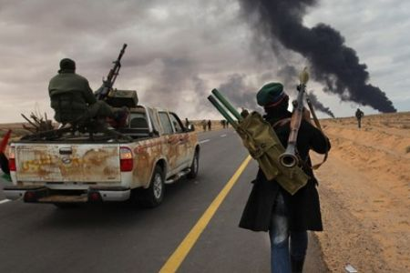

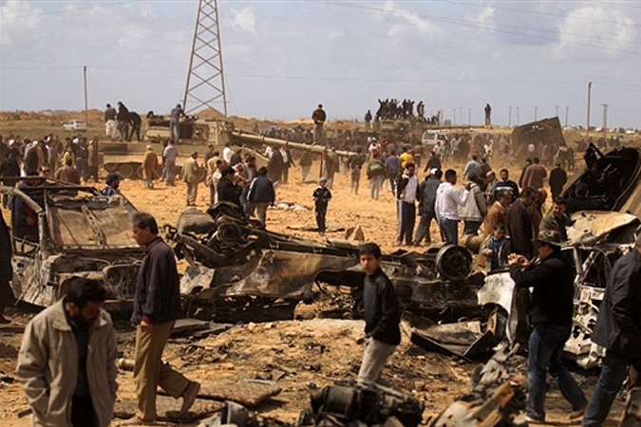

The legitimacy of the use of force, and the circumstances in which force may be used, are currently amongst the most keenly debated issues in International Law. The threat or use of force is prohibited except in self-defence and/or under the authority of the UN Security Council. Nevertheless there are many examples of apparently unlawful use of force in recent years by one State against another.

International law is also confronted by new challenges to States’ security:

* how may States respond to repeated attacks on their civilian shipping, by pirates in a territory where the State is unable or unwilling to take effective action to address the threat?
* may a State intervene in another State by force to prevent that other State perpetrating serious human rights abuses against its own people? Do the events in Libya and Syria clarify this?
* does the international community have a responsibility to intervene – a so-called *responsibility to protect* – when a State commits serious attacks on its own citizens, and if so, how far may such intervention go.

**UN Charter**

*Article 2(4)*: All Members shall refrain in their international relations from the threat or use of force against the territorial integrity or political independence of any state, or in any other manner inconsistent with the Purposes of the United Nations.

*Article 51*: Nothing in the present Charter shall impair the inherent right of individual or collective self-defence if an armed attack occurs against a Member of the United Nations, until the Security Council has taken measures necessary to maintain international peace and security. Measures taken by members in the exercise of this right of self-defence shall be immediately reported to the Security Council and shall not in any way affect the authority and responsibility of the Security Council under the present Charter to take at any time such action as it deems necessary to maintain or restore international peace and security.

*Article 42*: Should the Security Council consider that measures provided for in Article 41 would be inadequate or have proved to be inadequate, it may tale such action by air, sea, or land forces as may be necessary to maintain or restore international peace and security. Such action may include demonstrations, blockade, and other operations by air, sea, or land forces of Members of the United Nations.

*Nicaragua Case* (1986)

*Corfu Channel Case* (1949)

*Declaration on Friendly Relations Between States* 1970, GA Res 2625 (XXV)

Definition of Aggression - GA Res 3314

*Nuclear Weapons Advisory Opinion* (1996), paras 37-50, 97

*Caroline Case* (1837)

*Legal Consequences of the Construction of a Wall in the Occupied Palestinian* *Territory* Advisory Opinion (2004), paras 138-139

*Oil Platforms Case* (2003), paras 31-78, esp. paras 76-77

*Congo v Uganda* (2005), paras 106-166

Report of the International Commission on Intervention and State Sovereignty, *The Responsibility to Protect* (2001):

http://www.iciss.ca/report2-en.asp

**Prohibition on the use of force**

**Right of self defence – individual and collective**

**Use of force to rescue nationals**

**Humanitarian intervention: a responsibility to protect?**

**The Iraq Conflict (2003)**

Security Council Resolution 1441 (2002)

Acting under Chapter VII of the UN Charter, the SC

Para 1

“Decides that Iraq has been and remains *in material breach* of its obligations under relevant resolutions, including resolution 687 (1991), in particular through Iraq’s failure to cooperate with United Nations inspectors and the IAEA, and to complete the actions required under paragraphs 8 to 13 of resolution 687 (1991)…”

Para 13

“Recalls…that the Council has repeatedly warned Iraq that it will face *serious consequences* as a result of its continued violations of its obligations…”

**The Libya Conflict (2011)**

Security Council Resolution 1970 (2011), 26 February 2011

http://daccess-dds-ny.un.org/doc/UNDOC/GEN/N11/245/58/PDF/N1124558.pdf?OpenElement

*Preamble*

* + referred to “serious violations of human rights and international humanitarian law” being committed in Libya
  + “Considering that the widespread and systematic attacks currently taking place in ...[Libya] may amount to crimes against humanity”

“Acting under Chapter VI of the Charter ..., and taking measures under its Article 41”

Introduced various measures:

* Referral to ICC
* Arms embargo
* Travel ban
* Asset freeze
* Sanctions Committee

Security Council Resolution 1973 (2011), 217 March 2011

<http://daccess-dds-ny.un.org/doc/UNDOC/GEN/N11/268/39/PDF/N1126839.pdf?OpenElement>

*Preamble*

*Reiterating* the responsibility of the Libyan authorities to protect the Libyan population and reaffirming that parties to armed conflicts bear the primary responsibility to take all feasible steps to ensure the protection of civilians...

*Reaffirming* its strong commitment to the sovereignty, independence, territorial

integrity and national unity of the Libyan Arab Jamahiriya...

*Determining* that the situation in the Libyan Arab Jamahiriya continues to constitute a threat to international peace and security,

*Acting* under Chapter VII of the Charter of the United Nations...

3. *Demands* that the Libyan authorities comply with their obligations under international law, including international humanitarian law, human rights and refugee law and take all measures to protect civilians and meet their basic needs, and to ensure the rapid and unimpeded passage of humanitarian assistance;

**Protection of civilians**

4. *Authorizes* Member States that have notified the Secretary-General, acting nationally or through regional organizations or arrangements, and acting in cooperation with the Secretary-General, to take **all necessary measures**, notwithstanding paragraph 9 of resolution 1970 (2011), to protect civilians and civilian populated areas under threat of attack in the Libyan Arab Jamahiriya, including Benghazi, while excluding a foreign occupation force of any form on any part of Libyan territory, and *requests* the Member States concerned to inform the Secretary-General immediately of the measures they take pursuant to the authorization conferred by this paragraph which shall be immediately reported to

the Security Council...

Security Council Resolution 2036 (2012), 22 February 2012

http://daccess-dds-ny.un.org/doc/UNDOC/GEN/N12/238/47/PDF/N1223847.pdf?OpenElement

**Questions**

1. Did the attacks on the USA on 11 September 2001 trigger a right to use force in self-defence?

2. What are the principal restrictions on the use of force by a State in self-defence?

3. Should a State be entitled to use nuclear weapons in self-defence?

4. What is the legal basis for collective security action through the United Nations?

5. Is the ICJ correct to state, as it did in *The Wall* Advisory Opinion, that Israel had no right of self-defence with regard to the attacks made upon it because they had not been made by a State?

6. May a State attack pirates based in Somalia in response to pirate attacks on ships that fly its flag?

7. Did SC Resolution 1973 (2011) justify the use of force to remove the Libyan government from power?

8. Has the Security Council authorised the use of force against Somalia? And Syria?

**4. Challenges to Human Rights during Armed Conflicts and the Role of International Humanitarian Law**

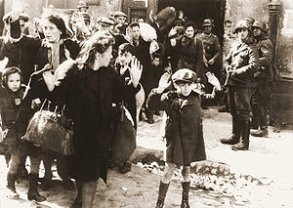

Warsaw

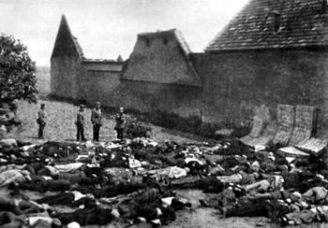

Lidice

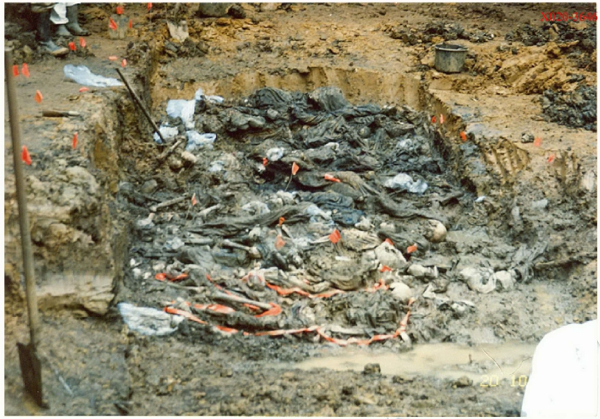

Srebrenica

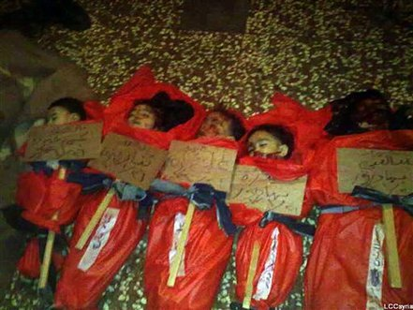

Homs

International humanitarian law (IHL) seeks to protect human rights during armed conflict. The body of law is substantial, yet the essence of IHL may be distilled into a few principles.

Can we say that IHL is adequate given the extreme violations that occur in modern armed conflicts, such as mass rape and sexual violence in the Democratic Republic of Congo?

What has been the impact of the emerging international criminal law, which now denies immunity to Heads of State?

For a superb resource with primary and secondary sources (in particular, the *International Review of the Red Cross*), please refer to the website of the International Committee of the Red Cross: http://www.icrc.org/eng

**Definition of IHL**

* principles and rules that limit the use of violence during armed conflicts:
  + to spare those not directly involved in hostilities
  + limit the effects of violence to the amount necessary for the purpose of war

**Origins of IHL**

* Henry Dunant, Battle of Solferino (1959)
* Lieber Code (Instructions for the Government of Armies of the United States in the Field (1863)
* Foundation of ICRC and first National Red Cross Societies (1963)
* First Geneva Convention (1864)
* St Petersburg Declaration Renouncing the Use, in Time of War, of Certain Explosive Projectiles (1868)
* Oxford Manual on the Laws of War on Land (1880)

**Sources**

* Hague Law
  + Conventions of 1899 and 1907 dealing with the actual conduct of hostilities – regulating the means and methods of warfare
* Geneva Law
  + Four conventions (1949) and three protocols (1977, 2005) relating to the protection of persons hors de combat or not taking part in hostilities – sick and wounded, prisoners of war, civilians
* more specific treaties
  + conventions prohibiting or regulating the use of specific types of weapons, eg anti-personnel landmines, or establishing specialised protection regimes, eg for cultural property
* customary international law
  + *Nuclear Weapons Advisory Opinion* (1996 ICJ Reports)
  + ICRC study on Customary International Humanitarian Law (2005)
* humanitarian law principles
  + basic principles underlying IHL

**IHL and Public International law**

* IHL protects human rights during armed conflicts – how does it differ from human rights law?
* *jus in bello* v *jus ad bellum*

**When does IHL apply?**

* international armed conflicts (IACs)
* non-international armed conflicts (NIACs)
  + IACs –
    - * Geneva Conventions (1949), common Art 2:
        + all cases of declared war or of any other armed conflict which may arise between two or more Parties, even if they do not recognise the state of war
        + all cases of partial or total occupation of the territory of a Party, even where there is no resistance to the occupation
      * Additional Protocol I (1977), Art 1.4
        + Armed conflicts where people are fighting against colonial domination and alien occupation and against racist regimes in exercise of their right to self-determination
  + NIACs-
    - * Geneva Conventions (1949), common Art 3:
        + “armed conflicts not of an international character”
      * Additional Protocol II (1977)
        + NIACs taking place in territory of a party, between its armed forces and dissident armed forces or other organised armed groups which, under responsible command, exercise such control over a part of its territory as to enable them to carry out sustained military operations and to implement the Protocol
        + Note threshold – it does **NOT** apply to situations of internal disturbances and tensions, such as riots, isolated and sporadic acts of violence and similar acts.

**Fundamental principles of IHL**

*Martens clause* – in cases not covered by treaties, civilians and combatants remain under the protection and authority of the principles of international law derived from custom, from the principles of humanity and from the dictates of public conscience (1899)

*Humanity* – this aims to restrict activities that might otherwise be justified as not contrary to specific treaties and allowed by military necessity

*Necessity* – those measures indispensable for securing the aims of the conflict, and which are not contrary to laws of armed conflict

*Distinction*

* parties to a conflict must at all times distinguish between the civilian population and combatants in order to spare civilian population and property.
* Neither the civilian population as such nor civilian persons shall be the object of attack
* Attacks shall be directed solely against military objectives

*Proportionality*

* Parties to a conflict and members of their armed forces do not have an unlimited choice of methods and means of warfare: it is prohibited to employ weapons or methods of warfare of a nature to cause unnecessary losses or excessive suffering

|  |
| --- |
|  |

|  |  |  |
| --- | --- | --- |
|  | International humanitarian law: the essential rules  **These rules, drawn up by the ICRC, summarize the essence of international humanitarian law. They do not have the authority of a legal instrument and in no way seek to replace the treaties in force. They were drafted with a view to facilitating the promotion of the law.**   * The parties to a conflict must at all times distinguish between the civilian population and combatants in order to spare the civilian population and civilian property. Neither the civilian population as a whole nor individual civilians may be attacked. * Attacks may be made solely against military objectives. People who do not or can no longer take part in the hostilities are entitled to respect for their lives and for their physical and mental integrity. Such people must in all circumstances be protected and treated with humanity, without any unfavourable distinction whatever. * It is forbidden to kill or wound an adversary who surrenders or who can no longer take part in the fighting. * Neither the parties to the conflict nor members of their armed forces have an unlimited right to choose methods and means of warfare. It is forbidden to use weapons or methods of warfare that are likely to cause unnecessary losses or excessive suffering. * The wounded and sick must be collected and cared for by the party to the conflict which has them in its power. Medical personnel and medical establishments, transports and equipment must be spared. * The red cross, red crescent or red crystal on a white background is the distinctive sign indicating that such persons and objects must be respected. * Captured combatants and civilians who find themselves under the authority of the adverse party are entitled to respect for their lives, their dignity, their personal rights and their political, religious and other convictions. They must be protected against all acts of violence or reprisal. They are entitled to exchange news with their families and receive aid. They must enjoy basic judicial guarantees.  |  | | --- | |  | |

**Questions**

1. Was the conflict in Libya international or non-international? Syria?

2. “…if international law is, in some ways, at the vanishing point of law, the law of war is, perhaps even more conspicuously, at the vanishing point of international law.” (H.Lauterpacht, 1952)

*What do you think Lauterpacht meant when he wrote this statement?*

3. **IHL and the soldier’s dilemma**

In the early morning, a column of tanks and personnel carriers made their way down the road of the heavily populated outskirts of the city. We were hemmed in by the wire fence of an air base on our left and a long narrow hamlet of buildings on our right. We stopped to assess the situation. My mate ducked inside the turret of the tank, saying: “I don’t like the look of this”. Our radio operator turned to me and said that he’d just heard reports of lots of guerilla soldiers hiding out in the area.

From where I rode, as tank gunner, I had a pretty clear view. Sure enough, through the dust and overcast morning weather, I could see silhouettes darting into positions among the cluster of village houses opposite our platoon of men in the personnel carriers up the road. I could see that the figures were clearly armed. Someone shouted to open fire.

*You are the tank gunner. What do you do?*

4. Could the use of nuclear weapons ever be in conformity with international humanitarian law?

5. A soldier is attacked by a boy who looks about twelve years old. The boy fires a gun at him, misses, then turns round to run away. At this point the soldier returns fire, hitting the boy in the back and killing him.

What issues of international humanitarian law arise?

**5. Trafficking in Human Beings**

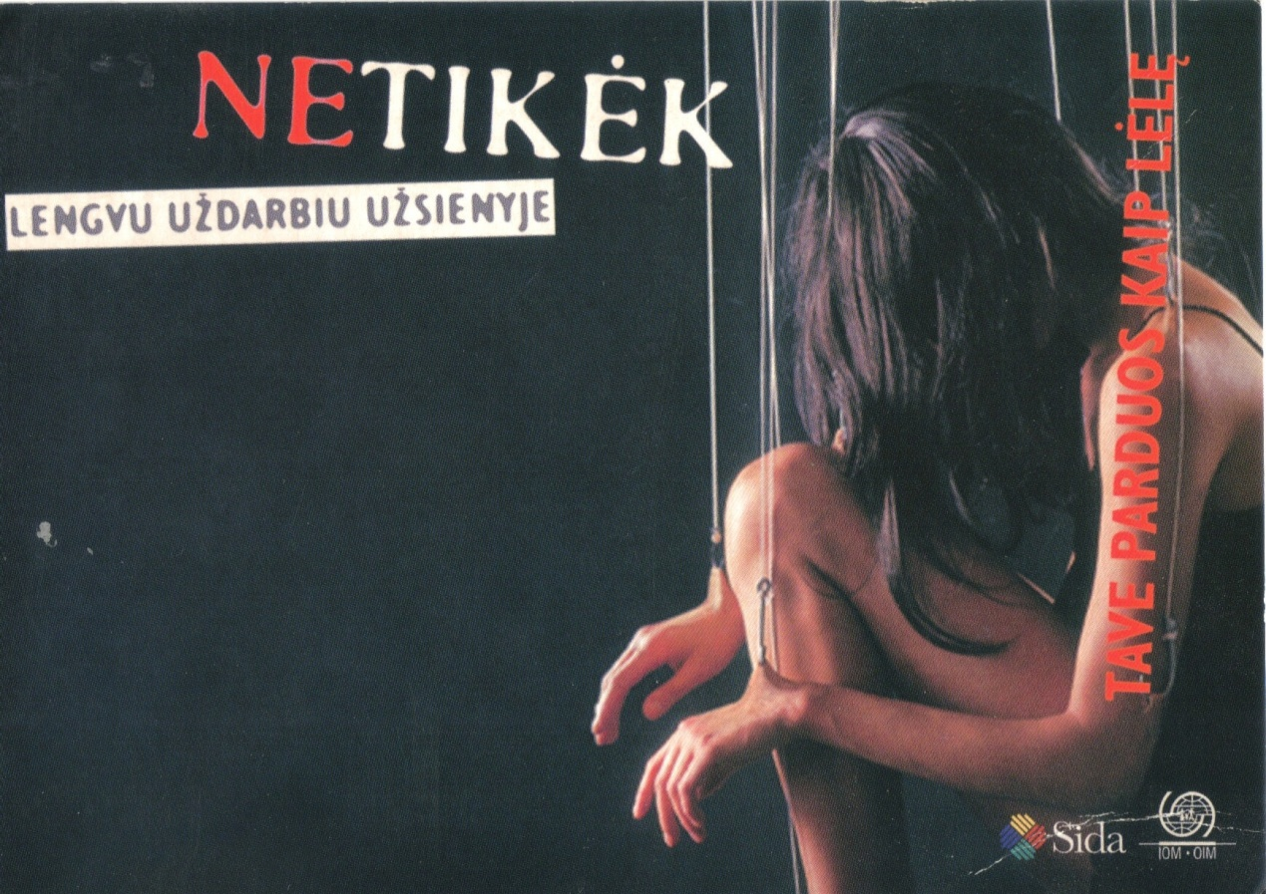

*No one shall be held in slavery or servitude; slavery and the slave trade shall be prohibited in all their forms.*

(Universal Declaration of Human Rights, Article 4)

One of the most serious long-term effects of armed conflicts is to cause mass displacement of people. This can persist for years after a conflict has ended. This poses real problems for countries where people seek refuge, such as Tunisia and Libya having to take care of thousands of people, fleeing the conflict in Libya. Significant migratory pressures are created.

These pressures expose vulnerable people, especially women and children, to the risks of people smuggling and people trafficking. This class addresses these issues.

European Union, Fight against Trafficking in Human Beings

http://ec.europa.eu/anti-trafficking/

UNODC, Global Report on Trafficking in Human Beings

<http://www.unodc.org/unodc/en/human-trafficking/global-report-on-trafficking-in-persons.html>

UNODC, Human Trafficking and Migrant Smuggling

http://www.unodc.org/unodc/en/human-trafficking/index.html?ref=menuside

Council of Europe, Action against Trafficking in Human Beings

http://www.coe.int/t/dghl/monitoring/trafficking/default_en.asp

US Department of State. Office to Monitor and Combat Trafficking in Persons:

<http://www.state.gov/g/tip/>

Anti-Slavery: http://www.antislavery.org/

**I. Examples of trafficking in human beings (THB)**

* Prostitution
* Sweat shops
* Domestic labour
* Forced marriage
* Agricultural labour
* Sport (eg camel jockeys)
* Adoption
* Organ transplants
* Begging

**Trafficking and smuggling distinguished**

**II. Concepts**

* THB
* Deception, coercion, violence
* Exploitative end purpose: slavery, forced labour
* Violation of victim’s rights
* May involve illegal crossing of border

# Principal legal issues

* Human rights of those trafficked or smuggled
* Criminal law (international and national)
* Immigration law
* Employment law
* Laws on prostitution

**THB as Slavery**

*Prosecutor v Kunarac, Kovac and Vukovic*, Trial Chamber, Judgment, Case No. IT-96-23-T and 23/1, especially par.542:

Indications of enslavement include elements of control and ownership; the restriction or control of an individual’s autonomy, freedom of choice or freedom of movement; and, often, the accruing of some gain to the perpetrator. The consent or free will of the victim is absent. It is often rendered impossible or irrelevant by, for example, the threat or use of force or other forms of coercion; the fear of violence, deception or false promises; the abuse of power; the victim’s position of vulnerability; detention or captivity, psychological oppression or socio-econom ic conditions... The ‘acquisition ‘ or ‘disposal’ of someone for monetary or other compensation, is not a requirement for enslavement.

ICC Statute, Art 7.2.c – “Enslavement” means the exercise of any or all of the powers attaching to the right of ownership over a person and includes the exercise of such power in the course of the trafficking in persons, in particular women and children…

*Hadijatou Mani Koraou v Niger*, ECOWAS Court of Justice, Judgment No. ECW/CCJ/JUD/06/08

**THB and Human Rights**

*Rantsev v Cyprus and Russia*, Application no. 25965/04, European Court of Human Rights, Judgment of 7 January 2010

#### III. THB under International Law

# UN Convention Against Transnational Organised Crime 2000

**Trafficking**

**Protocol to Prevent, Suppress and Punish Trafficking in Persons, in Particular Women and Children (Palermo Protocol)**

* Entered into force December 2003
* 147 parties (March 2012). Czech Republic has signed but not ratified; Slovakia ratified in 2004

Article 3

1. “Trafficking in persons” shall mean the recruitment, transportation, transfer, harbouring or receipt of persons, by means of the threat or use of force or other forms of coercion, of abduction, of fraud, of deception, of the abuse of power or of a position of vulnerability or of the giving or receiving of payments or benefits to achieve the consent of a person having control over another person, for the purpose of exploitation. Exploitation shall include, at a minimum, the exploitation of the prostitution of others or other forms of sexual exploitation, forced labour or services, slavery or practices similar to slavery, servitude or the removal of organs…

Three elements:

* + the act
  + the method
  + the motivation
  + Consent of victim not relevant where any of above methods are employed
  + Where victim is a minor (under 18) it is THB even if none of above methods are used

Limitations

* Deals only with transnational THB
* Focus primarily on prevention of crime rather than protection of human rights
* Limited measures addressing rights of victims
* Article 6 – limited obligations of assistance to victims
* Council of Europe Convention on Action Against Trafficking in Human Beings (2005)
  + Needed 10 ratifications to enter into force; has 34 (March 2012. Czech Republic has neither signed nor ratified; Slovakia has ratified)
  + Stresses victims’ rights and protection of victims equally with action to combat THB
  + Same definition as Palermo Protocol, except:
    - THB does not have to be transnational (Art.2)
    - Defines “victim”: “any natural person who is subject to trafficking in human beings [as defined in Art.4]”
  + Obligation to promote “a Human Rights-based approach” (Art.5(3))
  + Minimum standards set for provision of assistance to victims to promote physical, psychological and social recovery

Soft Law

* UN High Commissioner for Human Rights: Recommended Principles and Guidelines on Human Rights and Human Trafficking (2002)
  + Human rights of victims of THB to be *at the centre* of all anti-THB efforts
  + States’ obligations to act against THB and help victims
  + Anti-THB measures must not adversely affect rights of individuals, especially victims of THB, migrants, IDPs and refugees
* UNHCR: Guidelines on application of Refugees Convention to victims of THB (2006)

**International Protection Regime**

*Victims of THB have no special entitlement to remain in the destination State.*

*Under the law of international protection, destination States may have an obligation to permit victims of THB to remain on their territory.*

* Victims of THB in a foreign country frequently wish to return to their home country once they are no longer under the control of their traffickers; destination States generally want them to return
* Some victims may fear returning because of danger or threats to which they might be exposed at home
  + Risk of retrafficking
  + Shame/embarrassment
  + Ostracism
  + Victimisation by national authorities
* Some victims may have given evidence against their traffickers

The principle of *non-refoulement* obliges States not to return anyone to a territory where they will be killed or at risk of a serious breach of their basic human rights

* Applies to threats posed by the State, or by non-state actors where the State is unable or unwilling to offer effective protection
* Convention Relating to the Status of Refugees 1951, Article 33 – *non-refoulement*

**Convention Relating to the Status of Refugees 1951**

Article 1A

For the purposes of the present Convention, the term ‘refugee’ apply to any person who…(2)…owing to a well-founded fear of being persecuted for reasons of race, religion, nationality, membership of a particular social group or political opinion, is outside the country of his nationality and is unable or, owing to such fear, is unwilling to avail himself of the protection of that country…

**Council Directive 2004/83/EC of 29 April 2004 (“Qualification Directive”) - on minimum standards for the qualification and status of third country nationals and stateless persons as refugees or as persons who otherwise need international protection**

* Article 6: Persecution can be by
  + the State
  + parties or organizations controlling the State or a substantial part of its territory
  + non-state actors, where the State or those in control are unable or unwilling to provide protection against persecution or serious harm
* Article 15: Entitlement to subsidiary protection based on following threats:
  + Death penalty or execution
  + Torture or inhuman or degrading treatment or punishment in the country of origin
  + Serious and individual threat to a civilian’s life or person by reason of indiscriminate violence in situations of armed conflict

Where a victim of THB can show a reasonable likelihood that her basic human rights are at serious risk should she be repatriated, the State of destination may have to permit her to remain, although the general view is that repatriation is the preferable option

International Criminal Law

**THB Protocol**

Art 2 – purposes

* Prevent and combat THB, especially of women and children
* Protect and assist victims of THB
* Promote cooperation amongst states to meet these objectives

Art 5 – obligation to criminalise THB (including attempting or participating as an accomplice, organising or directing others to do so

Art 9 – obligation to establish comprehensive policies and programmes “to prevent and combat” THB

**Convention on the Rights of the Child, Optional Protocol on the Sale of Children, Child Prostitution and Child Pornography**

Art 3 – obligation to criminalise

**Case Study**

**A case of modern day slavery in the suburbs**

Mwanamisi Mruke was hired by Saeeda Khan in Tanzania to work at her home in London. Khan organised a domestic service visa for Ms Mruke and agreed to pay her 120,000 shillings (£21) monthly into her Tanzanian bank account and £10 monthly pocket money in London.

Ms Mruke suffered severe abuse at the hands of her employer, who confiscated her passport, forced her to sleep on the kitchen floor and gave her meagre amounts of food. She was required to be available to work from 6am to midnight daily. Her employer would summon her by ringing a bell when she was required to assist her or her two adult children. She was sometimes obliged to work at night. She worked for four years without a day off. Ms Mruke was detained in Ms Khan’s house and threatened by her, to the extent that she was cowed into submission.

Ms Mruke spoke only Swahili with her employer, who deliberately failed to teach her English, further increasing her isolation. Eventually her employer ceased paying her altogether. She refused to let her return to Tanzania after her parents died; nor was she allowed to go there for the wedding of her daughter.

At Ms Khan’s trial, the prosecutor said: "From the moment of her arrival in England Mwanamisi was made to sleep, work and live in conditions that fall by any understanding into that of slavery."

Ms Mruke was released after an interpreter who went wither to see a doctor contacted a charity, Kalayaan, which assists people trafficked into domestic servitude. Kalayaan informed the police, who eventually went to Khan's home and removed Ms Mruke to a place of refuge.

Khan was charged with trafficking a person for exploitation. Police found a letter in Swahili, addressed to Ms Mruke and intended to intimidate her. It warned her not to complain about her conditions in London and told her that she had to obey Khan all the time. It said her life could be in danger if she complained, but that she would receive her reward in heaven.

Khan was convicted of trafficking for domestic servitude, given a nine-month prison sentence, suspended for two years and ordered to pay £25,000 in compensation to Ms Mruke plus £15,000 in costs.

A police spokesman said it was the first time someone had been prosecuted for trafficking a "slave" for domestic servitude. He said the Metropolitan Police were currently investigating another 15 cases of trafficking for forced labour, and had worked with other forces on similar cases. The cases under investigation involved individuals from Saudi Arabia, India, Bangladesh, Tanzania, Uganda and Vietnam.

About Ms Mruke, the spokesan added: "She may want to go back to Tanzania, because she has a family there. But if she can't go back for fear of reprisals I'm sure that would be looked upon positively by the UK Border Agency."

**Questions**

1. What is the difference between smuggling and trafficking of human beings? Give examples to illustrate this.

2. Discuss the legal nature of trafficking in human beings. In particular, is it:

a) a crime?

b) a violation of human rights?

c) both a crime and a violation of human rights?

3. Outline and discuss the significance of the *Kunarac* case (*Prosecutor v Kunarac, Kovac and Vukovic*, IT-96-23-T and IT-96-23/1-T) for the development of international criminal law with regard to trafficking in human beings.

4. A, aged 16, has been brought from Vietnam to the Czech Republic by a distant male relative on the pretext that she could have an extended holiday. However after her arrival in Brno the man made it clear that she would be working for him and that he intended to force her into prostitution. She gave evidence that the man had already bought her the clothes she was to wear while working as a prostitute. He had also told her where she was going to work, confiscated her passport and threatened her with violence if she attempted to escape. He had also said that if she returned to Vietnam then other members of his gang would “take revenge” on her. The evidence gathered by the police when they arrested the man supports Ms A’s statement. Ms A has said that she is afraid to return to Vietnam.

Has Ms A been trafficked? What, if any, are the Czech Republic’s obligations towards Ms A?

**6. Human Rights: the Prohibition of Torture**

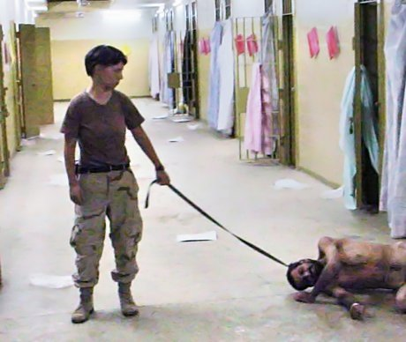

**The prohibition on torture and inhuman and degrading treatment**

What is torture?

Human rights treaties tend to contain derogable rights and non-derogable rights. This reflects the recognition that there may be situations where a State may legitimately derogate from some of its obligations because of other threats, for instance an armed attack by other States.

However, some rights are deemed so fundamental that derogation is never permitted. These include the right to life; the prohibition of slavery, forced labour and involuntary servitude; the principle of legality (no one can be convicted of an offence where the act was not an offence at the time it was committed).

The other right from which no derogation is permitted is contained in Article 3 ECHR:

**Convention for the Protection of Human Rights and Fundamental Freedoms 1950**

Art 3: “No one shall be subjected to torture or to inhuman or degrading treatment or punishment”.

An obligation of ***the State***; not of individuals towards one another.

**UN Human Rights Committee, General Comment No.20 on Article 7 ICCPR** [equivalent to Art 3 ECHR]: Freedom from Torture etc.

The obligation is not only not to torture but to avoid placing others in a situation where they are likely to be exposed to torture or inhuman and degrading treatment or punishment.

**United Nations Convention Against Torture and Other Cruel, Inhuman Or Degrading Treatment or Punishment 1984**

Art 1.1: For the purposes of this Convention, torture means any act by which severe pain or suffering, whether physical or mental, is intentionally inflicted on a person for such purposes as obtaining from him or a third person information or a confession, punishing him for an act he or a third person committed or is suspected of having committed, or intimidating or coercing him or a third person, or for any reason based on discrimination of any kind, when such pain or suffering is inflicted by or at the instigation or with the consent or acquiescence of a public official or other person acting in an official capacity. It does not include pain or suffering arising from, inherent in or incidental to lawful sanctions.

A minimum level of severity required – depends on all circumstances of the case, such as duration of treatment, its physical or mental effects and, sometimes, the sex, age and state of health of the victim

*Ireland v UK* (1978), (No.25), 2 EHRR 25, para 162

Techniques complained of:

* Wall – standing (stressing hands and feet)
* Hooding
* Subjection to noise
* Deprivation of sleep
* Deprivation of food and drink

Torture or inhuman/degrading treatment?

Distinction between torture and inhuman/degrading treatment/punishment

* Derives from a difference in intensity of the suffering inflicted (para 167)

Inhuman treatment – premeditation, long duration, intense physical and mental suffering, acute psychiatric distress (focus more on physical pain)

Degrading treatment - feelings of fear, anguish and inferiority, humiliating and debasing, breaking physical/moral resistance (focus more on emotional or dignitary injury)

*Aksoy v Turkey* (18 December 1996), 23 EHRR 553

Complaint:

* Applicant stripped naked
* Hung by his arms tied behind his back
* Soaked then given electric shocks to his genitals
* Regularly beaten over subsequent two days

Torture or not?

* Abuse was “of such a serious and cruel nature that it can only be described as torture” (para 64)
* “to allow the special stigma of “torture” requires a showing of “deliberate inhuman treatment causing very serious and cruel suffering” “ (para 63)

*Aydin v Turkey* (25 September 1997), 25 EHRR 251

Complaint:

* Seventeen year old woman detained for three days, raped and beaten

Torture or not?

*Tyrer v UK* (25 April 1978), 2 EHRR 1

Complaint:

* Applicant sentenced to birching (beating three times on his bare buttocks with a birch stick) as a judicial corporal punishment
* Caused pain for ten days but did not break the skin (no bleeding)

Torture or not?

* Suffering insufficient to amount to torture (para 29)
* Also insufficient to be inhuman treatment (para 29)
* Punishment could be degrading: “the humiliation or debasement involved must attain a particular level” and go beyond the mere humiliation associated with conviction of an offence (para 30)
* The punishment was humiliating as understood by the term “degrading treatment” (para 35)

Torture, inhuman treatment or degrading treatment?

* Tickling
* Forcing someone to listen to Britney Spears
* Electric shocks
* Imagine something you hate – and you are forced to endure it
* Seeing a close family member being given electric shocks
* Being made to drink English beer

**Obligation to take positive steps**

Art 3 is not only about the prohibition of torture etc. It also entails an obligation to take certain positive steps to ensure compliance with the duty.

*MC v Bulgaria* (2005) 40 EHRR 20

* Violation of Art 3 because of failure by Bulgaria to implement and apply sufficiently protective anti-rape laws

*Sevtap Veznedaroglu v Turkey* (2001) 33 EHRR 1142

* Where individual alleges breach of Art 3, there is a positive duty, in combination with Art 1, to mount an effective investigation capable of leading to identification and punishment of those responsible.

*M.S.S. v Belgium and Greece,* Application No. 30696/09, 21 January 2011

* “... the existence of domestic laws and accession to international treaties guaranteeing respect for fundamental rights in principle are not in themselves sufficient to ensure adequate protection against the risk of ill-treatment where ... reliable sources have reported practices resorted to *or tolerated by* the authorities which are manifestly contrary to the principles of the Convention” (Para 353, emphasis added).

**Obligation not to expel, deport or extradite someone to a State where they might be a victim of a breach of Article 3**

**Convention Relating to the Status of Refugees 1951**

Art 33.1: No Contracting State shall expel or return (‘refouler’) a refugee in any manner whatsoever to the frontiers of territories where his life or freedom would be threatened on account of his race, religion, nationality, membership of a particular social group or political opinion.

*Soering v UK* (7 July 1989), 11 EHRR 439

* Responsibility of the State for a breach of Art 3 ECHR where it sends a person to a territory where they are at real risk of being the victim of actions that would breach Art 3 (para 91)

*D v UK* (2May 1997), 24 EHRR 423

* Liability for returning someone to a territory where they would not receive adequate medical treatment

*N v United Kingdom* (27 May 2008), Application No. 26565/05

* Restricts scope of *D v UK*: Ugandan citizen with AIDS/HIV
* Expulsion would violate Article 3 only in "very exceptional cases".
* Three considerations relevant:
  + the seriousness and stage of the illness;
  + the availability of adequate treatment in the country of destination;
  + the availability of support by one's relatives.

*M.S.S. v Belgium and Greece,* Application No. 30696/09, 21 January 2011

**Questions**

1. Why is torture subject to a complete prohibition?
2. Should torture be completely prohibited? Think of circumstances in which torture might be justified.
3. Why is the freedom from torture apparently better protected than the right to life?
4. Should corporal punishment of children by their parents be permitted? Does it breach Article 3?
5. Does Article 3 ECHR go too far in the prohibition of degrading treatment?
6. How do you evaluate the alleged rendition by the UK to Libya of political opponents of the Gaddafi government?

**7. The Practical Application of International Law**

**Working in international law**

This class will look at what international law can actually mean for those of you who wish to pursue a career in the field. There are in fact many more options than you might have expected; some people are active in several fields:

* Academia
* International organisations
* Non-governmental organisations
* Private law firms
* Legal aid
* Training programmes
* Government: Ministries of Justice, Interior, Foreign Affairs, Immigration
* Armed forces

**Recapping the course**

The course is very intensive. For this reason, and in order to help your learning, we will use some of the time to discuss any issues at all that you wish to raise arising out of the topics we have studied during the week.

It is **your** chance to set the agenda: you are free to raise any issue at all with regard to the subjects we have studied.