Unit 5 and 6 Types of Courts

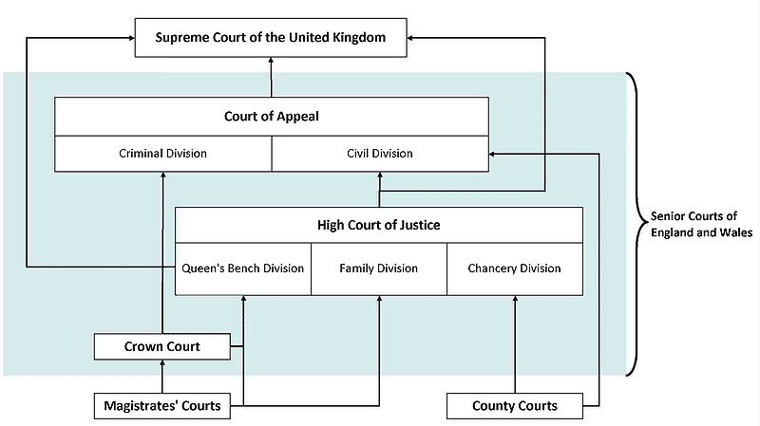

The Supreme Court has been established to achieve a complete separation between the United Kingdom’s senior Judges and the Upper House of Parliament, emphasising the independence of the Law Lords and increasing the transparency between Parliament and the courts.
In August 2009 the Justices moved out of the House of Lords (where they sat as the Appellate Committee of the House of Lords) into their own building on the opposite side of Parliament Square. They will sit for the first time as a Supreme Court in October 2009.
The impact of Supreme Court decisions will extend far beyond the parties involved in any given case, shaping our society, and directly affecting our everyday lives.
For instance, in their previous role as the Appellate Committee of the House of Lords, the Justices gave landmark rulings on the legality of the Hunting Act 2004 under European law, and whether or not a schoolgirl could be prevented from wearing traditional cultural dress.
The Supreme Court, as well as being the final court of appeal, plays an important role in the development of United Kingdom law. As an appeal court, The Supreme Court cannot consider a case unless a relevant order has been made in a lower court. The Supreme Court:
- is the final court of appeal for all United Kingdom civil cases, and criminal cases from England, Wales and Northern Ireland
- hears appeals on arguable points of law of general public importance
- concentrates on cases of the greatest public and constitutional importance
- maintains and develops the role of the highest court in the United Kingdom as a leader in the common law world
The Supreme Court hears appeals from the following courts in each jurisdiction:
England and Wales
- The Court of Appeal, Civil Division
- The Court of Appeal, Criminal Division
- (in some limited cases) the High Court
Scotland
- The Court of Session
Northern Ireland
- The Court of Appeal in Northern Ireland
- (in some limited cases) the High Court
As the highest court of appeal in the United Kingdom, The Supreme Court acts as the final arbiter on cases. Occasionally, The Court will be called upon to interpret European law and the European Convention on Human Rights as they relate to our domestic laws.
Under European law, member states’ courts should always make their rulings according to principles laid down in relevant decisions by the European Court of Justice (ECJ).
If The Supreme Court is considering a case where interpretation of an ECJ decision is unclear, the Justices can refer the question to the ECJ for clarification. They will then base their own decision on this answer. In cases relating to the European Convention on Human Rights, it is accepted that no national court should “without strong reason dilute or weaken the effect of the Strasbourg case law” (Lord Bingham of Cornhill in R (Ullah) v Special Adjudicator (2004)).
If human rights principles seem to have been breached, it may be possible to appeal to the European Court after all avenues of appeal in the United Kingdom have been exhausted, or The Supreme Court has no jurisdiction in this particular case.
[cit. 26.10.2009] dostupný z <http://www.supremecourt.gov.uk>

