Introduction to Cyberlaw
domain names

.COM | generic | .CAT | sponsored
.INFO | generic | .COOP | 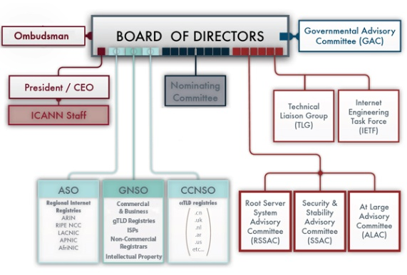  sponsored
.NET | generic | .EDU | sponsored
.ORG | generic | .GOV | sponsored
.BIZ | generic-restricted | .INT | sponsored
.NAME | generic-restricted | .JOBS | sponsored
.PRO | generic-restricted | .MIL | sponsored
.ARPA | infrastructure | .MOBI | sponsored
.AERO | sponsored | .MUSEUM | sponsored
.ASIA | sponsored | .TEL | sponsored
 |  | .TRAVEL | sponsored

Uniform Domain Name Dispute Resolution Policy

4. Mandatory Administrative Proceeding.

This Paragraph sets forth the type of disputes for which you are required to submit to a mandatory administrative proceeding. These proceedings will be conducted before one of the administrative-dispute-resolution service providers listed at www.icann.org/en/dndr/udrp/approved-providers.htm (each, a "Provider").
a. Applicable Disputes. You are required to submit to a mandatory administrative proceeding in the event that a third party (a "complainant") asserts to the applicable Provider, in compliance with the Rules of Procedure, that

(i) your domain name is identical or confusingly similar to a trademark or service mark in which the complainant has rights; and
(ii) you have no rights or legitimate interests in respect of the domain name; and
(iii) your domain name has been registered and is being used in bad faith.
In the administrative proceeding, the complainant must prove that each of these three elements are present.

b. Evidence of Registration and Use in Bad Faith. For the purposes of Paragraph 4(a)(iii), the following circumstances, in particular but without limitation, if found by the Panel to be present, shall be evidence of the registration and use of a domain name in bad faith:
(i) circumstances indicating that you have registered or you have acquired the domain name primarily for the purpose of selling, renting, or otherwise transferring the domain name registration to the complainant who is the owner of the trademark or service mark or to a competitor of that complainant, for valuable consideration in excess of your documented out-of-pocket costs directly related to the domain name; or
(ii) you have registered the domain name in order to prevent the owner of the trademark or service mark from reflecting the mark in a corresponding domain name, provided that you have engaged in a pattern of such conduct; or
(iii) you have registered the domain name primarily for the purpose of disrupting the business of a competitor; or
(iv) by using the domain name, you have intentionally attempted to attract, for commercial gain, Internet users to your web site or other on-line location, by creating a likelihood of confusion with the complainant's mark as to the source, sponsorship, affiliation, or endorsement of your web site or location or of a product or service on your web site or location.
c. How to Demonstrate Your Rights to and Legitimate Interests in the Domain Name in Responding to a Complaint. When you receive a complaint, you should refer to Paragraph 5 of the Rules of Procedure in determining how your response should be prepared. Any of the following circumstances, in particular but without limitation, if found by the Panel to be proved based on its evaluation of all evidence presented, shall demonstrate your rights or legitimate interests to the domain name for purposes of Paragraph 4(a)(ii):
(i) before any notice to you of the dispute, your use of, or demonstrable preparations to use, the domain name or a name corresponding to the domain name in connection with a bona fide offering of goods or services; or
(ii) you (as an individual, business, or other organization) have been commonly known by the domain name, even if you have acquired no trademark or service mark rights; or
(iii) you are making a legitimate noncommercial or fair use of the domain name, without intent for commercial gain to misleadingly divert consumers or to tarnish the trademark or service mark at issue.

Commission Regulation (EC) No 874/2004 of 28 April 2004 laying down public policy rules concerning the implementation and functions of the .eu Top Level Domain and the principles governing registration

Article 21
Speculative and abusive registrations
1. A registered domain name shall be subject to revocation, using an appropriate extra-judicial or judicial procedure, where that name is identical or confusingly similar to a name in respect of which a right is recognised or established by national and/or Community law, such as the rights mentioned in Article 10(1), and where it:

(a) has been registered by its holder without rights or legitimate interest in the name; or
(b) has been registered or is being used in bad faith.

2. A legitimate interest within the meaning of point (a) of paragraph 1 may be demonstrated where:
(a) prior to any notice of an alternative dispute resolution (ADR) procedure, the holder of a domain name has used the domain name or a name corresponding to the domain name in connection with the offering of goods or services or has made demonstrable preparation to do so;
(b) the holder of a domain name, being an undertaking, organisation or natural person, has been commonly known by the domain name, even in the absence of a right recognised or established by national and/or Community law;
(c) the holder of a domain name is making a legitimate and non-commercial or fair use of the domain name, without intent to mislead consumers or harm the reputation of a name on which a right is recognised or established by national and/or Community law.
3. Bad faith, within the meaning of point (b) of paragraph 1 may be demonstrated, where:
(a) circumstances indicate that the domain name was registered or acquired primarily for the purpose of selling, renting, or otherwise transferring the domain name to the holder of a name in respect of which a right is recognised or established by national and/or Community law or to a public body; or
(b) the domain name has been registered in order to prevent the holder of such a name in respect of which a right is recognised or established by national and/or Community law, or a public body, from reflecting this name in a corresponding domain name, provided that:
(i) a pattern of such conduct by the registrant can be demonstrated; or
(ii) the domain name has not been used in a relevant way for at least two years from the date of registration; or
(iii) in circumstances where, at the time the ADR procedure was initiated, the holder of a domain name in respect of which a right is recognised or established by national and/or Community law or the holder of a domain name of a public body has declared his/its intention to use the domain name in a relevant way but fails to do so within six months of the day on which the ADR procedure was initiated;
(c) the domain name was registered primarily for the purpose of disrupting the professional activities of a competitor; or
(d) the domain name was intentionally used to attract Internet users, for commercial gain, to the holder of a domain name website or other on-line location, by creating a likelihood of confusion with a name on which a right is recognised or established by national and/or Community law or a name of a public body, such likelihood arising as to the source, sponsorship, affiliation or endorsement of the website or location or of a product or service on the website or location of the holder of a domain name; or
(e) the domain name registered is a personal name for which no demonstrable link exists between the domain name holder and the domain name registered.
4. The provisions in paragraphs 1, 2 and 3 may not be invoked so as to obstruct claims under national law.

