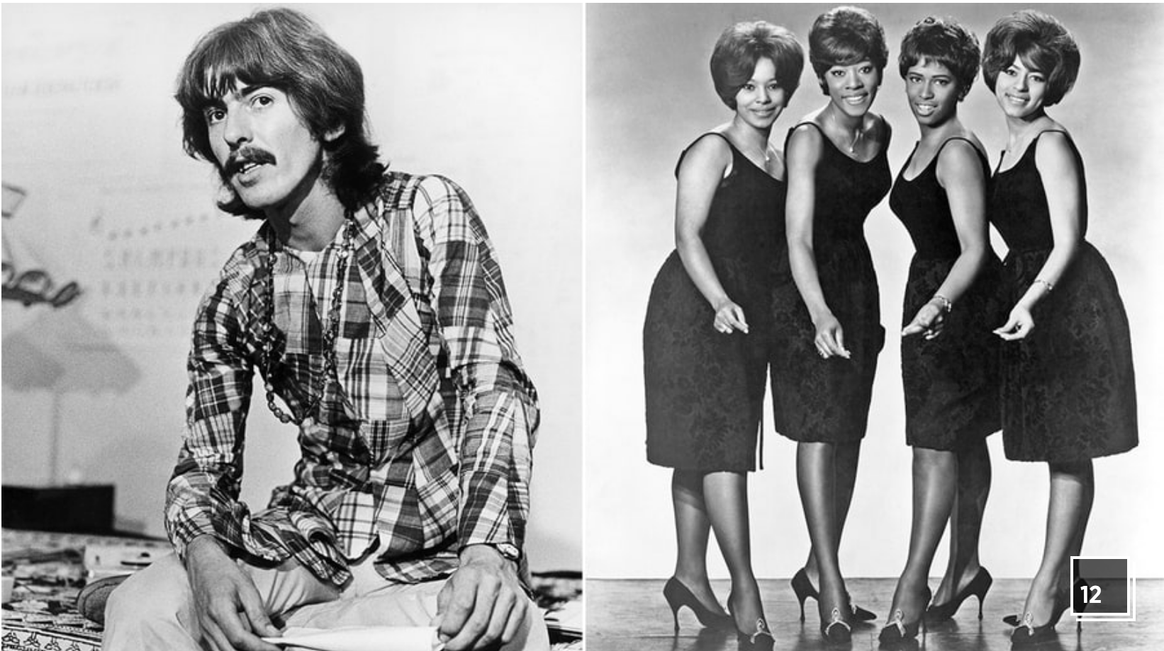

George Harrison vs. The Chiffons (1976)

"My Sweet Lord," by George Harrison (1970) vs. "He's So Fine," by the Chiffons (written by Ronnie Mack) (1962)

**The Case:** Harrison became the first Beatle to have a solo Number One on the Billboard charts with his ode to piety "My Sweet Lord." The subject matter was as far from early-Sixties Brill Building pop as one could get, but musically the verses bear a strong resemblance to the Chiffons' 1962 hit "He's So Fine," written by Ronnie Mack. Mack's publisher, Bright Tunes Music Corporation, filed a plagiarism suit in February 1971, but the case wouldn't go to trial until 1976. In the intervening years, the Chiffons themselves would record a version of "My Sweet Lord" to draw attention to the upcoming trial. Harrison claimed that he actually based the melody of the song on the public-domain hymn "Oh Happy Day," but admitted the similarity to "He's So Fine" in his autobiography, *I Me Mine*.

**The Verdict:** The judge ruled that Harrison was guilty of "subconscious plagiarism." The penalty phase was delayed until February 1981. He was initially ordered to pay $1,599,987, but this was lowered to $587,000 when his former manager Allen Klein purchased Bright Tunes Music and negotiated the sale of the song to Harrison. Litigation continued until March 1998, making it one of the longest legal skirmishes in American history. "I don't feel guilty or bad about it," he continued in his autobiography. "In fact it saved many a heroin addict's life. I know the motive behind writing the song in the first place and its effect far exceeded the legal hassle."

**Why It Matters**: In addition to introducing the phrase "subconscious plagiarism" into the popular lexicon, the ruling set a precedent of harsher copyright standards and ushered in a wave infringement suits.