# Cases (moot court)

### CASE 1:

Domain name: 2021.com (domain name is fictional)

**Complainants (3): Tereza Polachová, Matěj Sekret**

**Respondents (2): Václav Škapa, Adam Janeček**

**Respondent:**

Star Travel LLC. Berkshire House, 252-256 Kings Road, Reading RG1 (fictional company)

Owner of the company: Sergei Popov, UK national (abstracted from WHOIS)

Travel agent, specializing in “event tourism”, cooperates with foreign travel agents to organize trips to sports and cultural events in Sochi, Moscow, Petersburg, especially concerts and event tourism games.

* The Star travel company has purchased a domain name 2021.com
* Currently uses subdomains tokyo.2021.com, japan.2021, sog.2021 among other subdomains such as olympicgames.2021.com, travel.2021.com and hotels.2021.com,
* He has previously registered 2012.com domain to offer event tourism at London SOG and domains 2014.com where he used subdomains sochi.2014.com, among other subdomains such as wog.2014.com
* On the website it offers tourist information about Tokyo and locations for sporting events
* The agency has invested 20.000 USD for web-design and contracts with sports journalists to create a website providing extensive coverage of the championship. The preparations of this project have started but the website has not been finished yet.
* The website under the domain name contains basic tourist information about Japan, together with on-line applications that enable visitors to book hotels near the places of matches, links to taxi and car-rental companies and plenty of advertisement.
* The defendant offers some space for contextual advertising, as a result, some users are displayed contextual advertisements for escort and sexual services.
* The website contains also several video-commercials with sports themes sponsored by Pepsi ltd.

**Complainant:**

International Olympic Committee, Basel, Switzerland

* the committee is furious with the activities of the defendant and is under strong pressure of main commercial partner Coca Cola to do something about the use of a domain name.
* The complainant wants to have the domain 2021.com transferred as soon as possible to pursue its own commercial activities.
* The complainant feels, that the significant amount of internet users is attracted by the website of the defendant. The IOC website traffic is 30 percent below the expectation and they believe that this is caused by the activities of the defendant.

## CASE 2

Domain name: **just-dont-do-it.com** (the case is partly fictional, as to the actual domain name, but based on several similar websites).

**Complainants (3): Šárka Chytrová, Jakub Novanský, Jan Brablík**

**Respondents (2): Josef Doleček, Dominik Jakeš, Tereza Němcová**

Consumers -- "***Just don't do it***."   
 

**Respondent**:

Human rights group Amnesty International (AI), London

* AI claims that the Nike knowingly uses suppliers from Asia who exploits child labor
* As a part of their campaign, they register a domain name **just-dont-do-it.com**
* On the website, they inform about their claims against the company and provide photographic and video evidence
* Discourages consumers to purchase Nike products

One of the examples of the displayed text: *“The basic truth about Nike is that its only real strength is its good name. Nike rules because of all the good things people associate with the company: sharp ads, Michael Jordan, Tiger Woods, little Penny, and Michael Jordan again. If "beaten workers" and "child labor" get added to that list, then Nike's greatest asset will be lost.”*

* The site operates small e-shop which sells small gift products like mugs, T-shirts, umbrellas with motives against child labor to finance AI campaigns.
* The company has led several environmental and human-rights campaigns before.

**Comlplainant:**

Nike, Beaverton, Oregon, USA

* Is unhappy with the website and wants to shut it down as quickly as possible.
* Believes that it strongly influences their target consumers in western Europe.
* Wants to have domain name transferred or blocked.

## CASE 3

**Domain name: volvoforum.com (the website is real)**

**Complainants (3): Jana Krčmová, Martin Pecuch**

**Respondents (2): David Pelán, Petr Novotný, Lukáš Bílek**

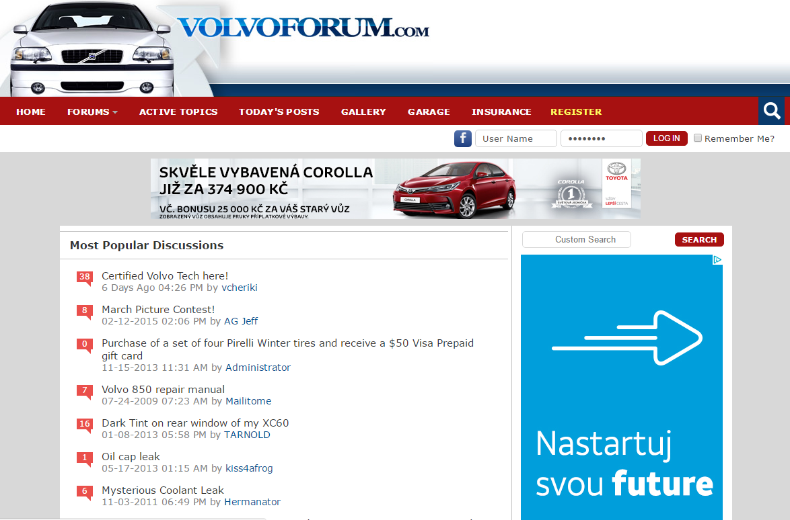

**Respondent:** Richard Scott; Las Vegas, Nevada (the factual circumstances are more complicated, but for this case, lets presume the domain is operated by an individual)

* Civil person, operates a website forum for Volvo users
* Occasionally writes articles and reviews particular Volvo models
* Is an active member of tuning community and annually organizes meetings of Volvo tuning group
* The content of a website and forum is not moderated
* The users of forum occasionally advertise for non-original (or possibly even stolen) spare parts or tuning parts
* The forum has a buy/sell section where users offer their cars for sale. This forum is frequently used by non-authorized vendors
* The defendant uses several google AdWords banners to generate small revenue. He uses part of this revenue for hosting fees, and he keeps the rest.
* The defendant promotes services of certain insurance providers

**Complainant : Volvo cars**

* Has been tolerant to the website for several years, but wants to introduce new marketing campaign and launch its official forum with customer support
* Feels that the existence of parallel forum could be confusing for their customers
* Wanted to buy the domain name, but Richard Scott refused to sell it for the offered price of 1.000 USD
* Volvo wants to acquire the domain name through UDRP complaint

## Instructions to file a complaint:

Instructions:

Visit website: udrp.expert4me.com *** Don’t be scared that the certificate is not recognized, the website is safe to use. You will just then after granting you access data login in the system and can start to fill in the form. More instructions on how to proceed are in the presentation downloaded in the information system. Information about response will be sent to respondents later in the semester.

## Deadlines

**7th April**UDRP Case-Law, preparation for moot court - PL

**14th April**Procedural elements of alternative dispute resolution, beginning of the moot court (seminar) 1st round of moot court – PL (next week – until 21st April – fill in the complaint)

**5th May**New forms of alternative resolution, 2nd round of moot court – PL (next week – until 12th May – fill in the response)

**26th May Final seminar - awarding colloquia, moot court feedback - PL, MK**