Written assignment

Deadline December 7, 2020

Odevzdávárna in IS

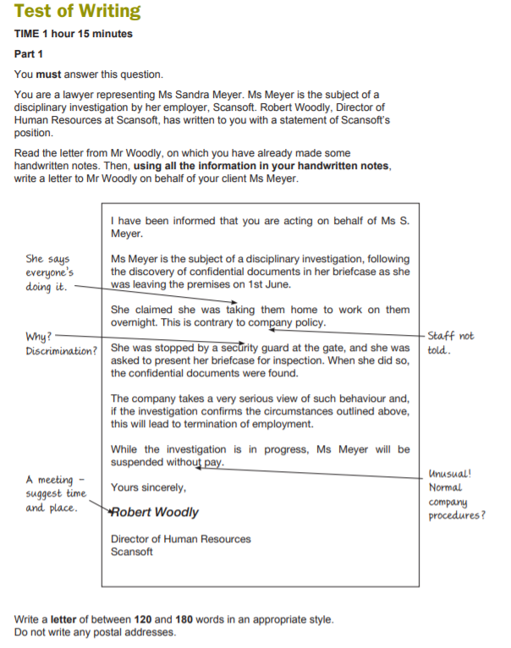

For a clearer view, see page 12 in this document:

<file:///C:/Users/1583/Downloads/international-legal-english2-upper-intermediate-ilec-practice-test%20(2).pdf>