NERVOUS SYSTEM
1. a) What are the two parts that the nervous system is composed of?
b) What do they consist of?

2. a) What are the two principal types of nerve cells?
b) What are their functions?

3. Describe the picture of the neuron.
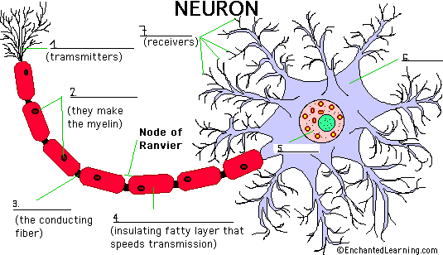

4. What is myelin? What is a synapse?

5. Match.
Cerebellum | a. The lowest section of the brainstem (at the top end of the spinal cord); it controls automatic functions including heartbeat, breathing, etc.
Parietal Lobe of the Cerebrum | b. A large bundle of nerve fibers that connect the left and right cerebral hemispheres. In the lateral section, it looks a bit like a "C" on its side.
Temporal Lobe of the Cerebrum | c. A gland attached to the base of the brain (located between the Pons and the Corpus Callosum) that secretes hormones.
Corpus Callosum | d. The part of the brainstem that joins the hemispheres of the cerebellum and connects the cerebrum with the cerebellum. It is located just above the Medulla Oblongata.
Occipital Lobe of the Cerebrum | e. The top, front regions of each of the cerebral hemispheres - they are used for reasoning, emotions, judgment, and voluntary movement.
Pituitary Gland | f. A thick bundle of nerve fibers that runs from the base of the brain to the hip area, running through the spine (vertebrae).
Medulla Oblongata | g. The region at the lower side of each cerebral hemisphere; contains centers of hearing and memory (located at the sides of the head).
Spinal Cord | h. The part of the brain below the back of the cerebrum. It regulates balance, posture, movement, and muscle coordination.
Frontal Lobe of the Cerebrum | i. The region at the back of each cerebral hemisphere that contains the centers of vision and reading ability (located at the back of the head).
Pons | j. The middle lobe of each cerebral hemisphere between the frontal and occipital lobes; it contains important sensory centers (located at the upper rear of the head).

6. Describe the picture of the brain.
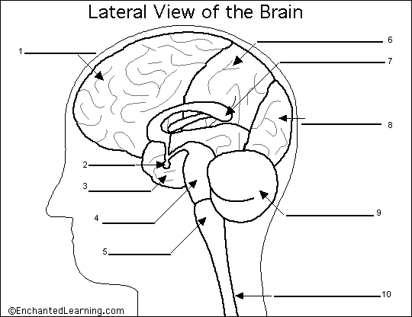

7. a) Name the four sections of the brain.
b) What are gyri?
c) What is the cerebral cortex?
d) What are the main functions of the forebrain?
e) Name the major functions of the cerebellum.
f) What are the 2 main parts of the interbrain? Name them and describe them.
g) Name the 3 parts of the brain stem.
h) What main bodily activities does the brain stem control?

8. Complete the short paragraph about the spinal cord with the following numbers.
70 31(2x) 35 13,500,000 43-45
The spinal cord is a bundle of nerves that connects the brain to other parts of the body. It is protected by a series of bones called vertebrae, which surround the spinal cord. The human spinal cord is about ............... cm long and approximately as wide as a human finger. There are ............... neurons that transmit electro-chemical signals in the spinal cord. The cord weighs approximately ............... grams. The vertebral column (bones) that supports it is about ............... cm long and has ............... segments and ............... pairs of spinal nerves.
9. a) What are the meninges? Name the 3 layers.
b) What is the cerebrospinal fluid?

10. Name some illnesses and diseases connected with the nervous system.

