Organs of Sense
I. EAR
a. Describe the ear.
Malleus Semicircular canals Cochlea Incus
External auditory canal Eustachian tube Eardrum
Pinna Vestibular cochlear nerve Stapes Lobule

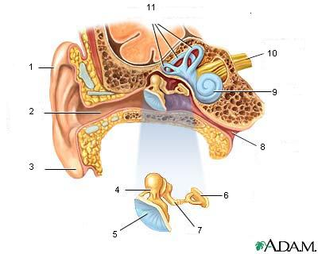
b. Complete the sentences with the words from the list.
subsides transmitted pus via impair relieve
mastoiditis rare susceptible myringotomy

Infection in the throat is often ............................. to the middle ear ............................. Eustachian tube. The oedema caused by inflammation may ............................. hearing until the inflammation ............................. . Children are more ............................. to otitis media because the Eustachian tube is shorter. A ............................. complication of otitis media is ............................. . Sometimes ............................. must be performed to ............................. pressure of the ............................. on the eardrum.

c. Match.

1. anacusis | a. abnormal growth of bone of the middle ear – this bone prevents structures within the ear from working properly and causes hearing loss
2. vertigo | b. inflammation of the eardrum
3. perforated eardrum | c. feeling of dizziness or spinning in space
4. otosclerosis | d. an inflammation of the middle ear
5. otitis media | e. total hearing loss, deafness
6. tympanitis | f. known as swimmer’s ear – an infection of the ear canal caused by many different types of bacteria or fungi
7. otitis externa | g. a hole or rupture in the tympanic membrane

