Organs of Sense
EYE
I. Describe the eye.
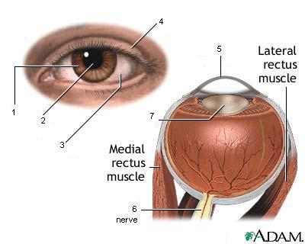
II. Match.

1. daltonism | a. inability to focus close up as a result of aging
2. myopia | b. clouding of the lens that affects the vision
3. presbyopia | c. distortion of the cornea or the lens causing blurred vision
4. hyperopia | d. inflammation of the conjunctiva, also known as pink eye
5. astigmatism | e. also called lazy eye – it means that the eye did not develop normal sight during childhood – usually one eye is strong and one eye is weak (lazy)
6. glaucoma | f. colour blindness
7. cataract | g. condition in which the eyeballs point in different directions
8. conjunctivitis | h. nearsightedness - clear vision close up but blurry in the distance
9. strabismus | i. damage to the eye’s optic nerve by the fluid pressure inside the eye – it is a leading cause of blindness
10. amblyopia | j. farsightedness – clear vision in the distance but blurry close up

III. Complete the sentences.

1. The _____________ is the coloured ring of the eye.
2. The _____________ is a part of the eyeball, between the sclera and the retina.
3. This part of the eye, which focuses so that things can be seen clearly, is called the _____________
4. Optic nerve is the _____________ that carries visual information to the brain.
5. This part of the eye is a small black round area in the centre of the iris through which light enters eye. It's called the _____________.
6. The _____________ is the hard white covering of the eyeball.
7. The transparent part of the front of the eyeball is called _____________.

