INTEGUMENTARY SYSTEM

I. Work in pairs to answer the following questions:

1. What does the integumentary system consist of?
2. What are the general functions of the skin?
3. The skin contains two layers. What are they?
4. Describe the epidermis.
5. What is another name for the dermis?
6. Describe the dermis.
7. What is the difference between the hair shaft and the hair root?
8. Why is most of the nail body pink?
9. What is sebum? What is its function?
10. What is the function of the sweat glands?
11. What is another name for breasts?

II. Describe the picture of the skin:

HAIR SHAFT MELANOCYTE SEBACEOUS GLAND DERMIS

HAIR FOLLICLE SWEAT PORE EPIDERMIS HAIR ERECTOR MUSCLE

BLOOD VESSELS SWEAT GLAND SUBCUTANEOUS TISSUE

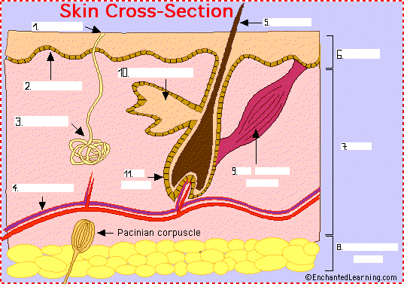

III. Complete the definitions:
a. ______________ - tubes that carry blood as it circulates. Arteries bring oxygenated blood from the heart and lungs; veins return oxygen-depleted blood back to the heart and lungs.
b. ______________ - (also called the cutis) the layer of the skin just beneath the epidermis.
c. ______________ - the outer layer of the skin.
d. ______________ - a tube-shaped sheath that surrounds the part of the hair that is under the skin. It is located in the epidermis and the dermis.
e. ______________ - the part of the hair that is above the skin.
f. ______________ - a muscle is connected to each hair follicle and the skin - it contracts (in response to cold, fear, etc.), resulting in an erect hair and a "goosebump" on the skin.
g. ______________ - a cell in the epidermis that produces melanin (a dark-colored pigment that protects the skin from sunlight).
h. ______________ - nerve receptors that respond to pressure and vibration; they are oval capsules of sensory nerve fibers located in the subcutaneous fatty tissue.
i. ______________ - a small, sack-shaped gland that releases oily (fatty) liquids onto the hair follicle (the oil lubricats and softens the skin). These glands are located in the dermis, usually next to hair follicles.
j. ______________ - a tube-shaped gland that produces perspiration. The gland is located in the epidermis.
k. ______________ - fatty tissue located under the dermis.

IV. Work in pairs. A will define 5 of the following terms regarding the skin. B will try to guess which term was defined. Then change roles.

frostbite swelling scar burn ulcer tumour blister bruise
birthmark herpes hives bedsores wart itching dermatitis
scratch laceration necrosis eczema graze acne ingrown toenails

V. Match.
a. TUMOUR | 1. Verruca; a small hard dry growth on the skin
b. BLISTER | 2. Acute or chronic inflammation of the skin from any cause
c. DERMATITIS | 3. Decubitus ulcer; it is caused by lying in bed for a long time, e.g. when ill
d. BIRTHMARK | 4. Another name for oedema
e. WART | 5. Abnormal tissue that grows more rapidly then normal
f. SHINGLES | 6. Mole or nevus; a mark on the skin from a person’s birth
g. BEDSORES | 7. Bubble of fluid below the skin
h. ULCER | 8. Generally spots on the skin
i. SWELLING | 9. Herpes zoster; band of painful spots on the skin
j. RASH | 10. It can appear on the skin or on the surface of an internal organ

