URINARY SYSTEM
1. What does the urinary system consist of? Name the organs.

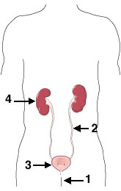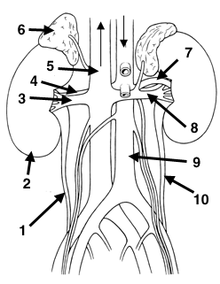

2. Complete the text with the words from the box.
travels carried removes back containing stores excrete forms tighten consists emptied swells

The urinary system works with the lungs, skin, and intestines — all of which also __________¹ wastes — to keep the chemicals and water in your body balanced.
The urinary system __________² a type of waste called urea from your blood. Urea is produced when foods __________³ protein, such as meat, poultry, and certain vegetables, are broken down in the body. Urea is __________⁴ in the bloodstream to the kidneys.
The kidneys are bean-shaped organs about the size of your fists. They remove urea from the blood through tiny filtering units called nephrons. Each nephron __________⁵ of a ball formed of small blood capillaries, called a glomerulus, and a small tube called a renal tubule. Urea, together with water and other waste substances, __________⁶ the urine as it passes through the nephrons and down the renal tubules of the kidney.
From the kidneys, urine __________⁷ down two thin tubes called ureters to the bladder. Muscles in the ureter walls constantly __________⁸ and relax to force urine downward away from the kidneys. If urine is allowed to stand still, or __________⁹ up, a kidney infection can develop. Small amounts of urine are __________¹⁰ into the bladder from the ureters about every 10 to 15 seconds.
The bladder is a hollow muscular organ shaped like a balloon. The bladder __________¹¹ urine until you are ready to go to the bathroom to empty it. It __________¹² into a round shape when it is full and gets smaller when empty.
3. Match the diseases of the urinary system with their description.
1. Kidney stones | a. This term refers to the bladder-emptying problems - abnormal holding of urine in the bladder. Causes can include an obstruction in the urinary system, stress, or neurologic problems.
2. Pyelonephritis | b. It is the presence of abnormal amounts of protein in the urine. Healthy kidneys take wastes out of the blood but leave in protein. Protein in the urine does not cause a problem by itself. But it may be a sign that your kidneys are not working properly.
3. Urinary tract infections (UTIs) | c. It refers to painful urination. This is typically described to be a burning or stinging sensation. It is most often a result of an infection of the urinary tract. It may also be due to an STD, bladder stones, bladder tumors, and virtually any condition of the prostate.
4. Renal (kidney) failure | d. This is an infection in one or both of the kidneys. It can cause serious damage to the kidneys if it is not adequately treated.
5. Urinary retention | e. This is an infection in the urinary bladder.
6. Prostatitis | f. This is a loss of bladder control - the involuntary passage of urine. There are many causes and types, and many treatment options. Treatments range from simple exercises to surgery. Women are affected more often than men.
7. Proteinuria | g. The term is commonly used to refer to calculi in the urinary system. They form in the kidneys and may be found anywhere in the urinary system. They vary in size. The aim of treatment is to remove them, prevent infection and recurrence.
8. Cystitis | h. These are caused by bacteria in the urinary tract. Women get this disease more often than men. It is treated with antibiotics. Drinking lots of fluids also helps by flushing out the bacteria.
9. Urinary incontinence | i. It is the inflammation of the prostate gland that results in urinary frequency and urgency, a condition called dysuria, and pain in the lower back and genital area, among other symptoms.
10. Dysuria | j. This results when the kidneys are not able to regulate water and chemicals in the body or remove waste products from your blood.

