**THE EYE**

***EXERCISE I.: Describe the picture of the eye.***

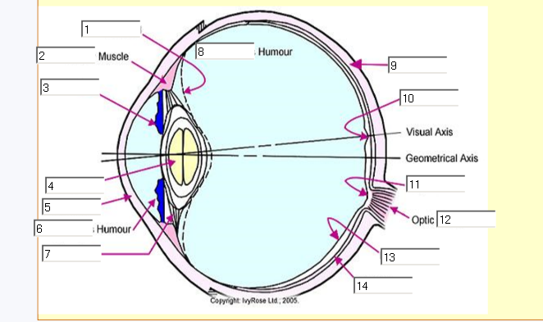

***EXERCISE II.: Which part of the eye is being described in the following definitions?***

1. It is the nerve layer that lines the back of the eye, senses light, and creates impulses that travel through the optic nerve to the brain. There is a small area, called the macula, there that contains special light-sensitive cells. The macula allows us to see fine details clearly.

2. It is the tough white outer coat over the eyeball that covers approximately the posterior five-sixths of its surface. It is continuous in the front of the eye with the cornea and in the back of the eye with the external sheath of the optic nerve.

3. It is a clear, jelly-like substance that fills the middle of the eye.

4. It is a thin vascular layer between the sclera and the retina. It supplies blood to the retina and conducts arteries and nerves to other structures in the eye.

5. It is the clear front window of the eye that transmits and focuses light into the eye.

6. It is the circular, coloured curtain of the eye. Its opening forms the pupil. It helps regulate the amount of light that enters the eye.

7. It is the transparent structure inside the eye that focuses light rays onto the retina. It was named after the lentil bean because it resembled it in shape and size.

8. It connects the eye to the brain. It carries the impulses formed by the retina to the brain, which interprets them as images. Using an ophthalmoscope, its head can be easily seen. It can be viewed as the only visible part of the brain (or extension of it).

9. It is the opening of the iris. The iris opens (dilates) and closes (constricts) it. This part determines how much light is let into the eye.

10. It is the fluid normally present in the front and rear chambers of the eye. It is a clear, watery fluid that flows between and nourishes the lens and the cornea; it is secreted by the ciliary processes.

***EXERCISE III.: Watch the following video. Decide whether the sentences below are true or false.***

1. Karen suffers from a disease that affects the retina.   
2. The disease is serious but it does not lead to blindness.   
3. Cornea protects the eye from the dust.   
4. The shape of the lens never changes.   
5. We can see the various colours because of the cone cells.   
6. In retinitis pigmentosa, the rods cells die away.   
7. When the retinal cells are damaged, the optic nerve is affected as well.   
8. Scientists believe that a silicon chip will substitute the function of damaged retinal cells.

***EXERCISE IV.: Listen to the video sequence again. Complete the transcription.***HOW THE HUMAN EYE WORKS  
As you watch this segment, think about how the eye, nerves, and brain all work together to focus, transport, and identify images. Karen Christianson lives what should be an ideal life in the wooded valleys of British Columbia. But Karen suffers from an eye disease – retinitis pigmentosa – that is slowly 1._______ her of her sight. As its name suggests, this disease affects the retina, the part of the eye that contains cells that turn light into impulses that are sent to the brain. “While most people have about 170 degrees of vision around their head, I have about 3.” Karen 2._______ out about her disease at a very young age. “My family started noticing I was having difficulties picking up all my toys so they took me into the family ophthalmologist and he 3._______ it right away.” Although doctors prescribed glasses for her condition, they realized that they were fighting a loosing battle to save Karen’s sight. Over time everyone who suffers from retinitis pigmentosa will become 4._______. The images that Karen sees look as though they are at the bottom of a long narrow tunnel. The images are so blurry that they can hardly be identified. To understand Karen’s disease, it’s helpful to know how the eye works, which is something like a 5._______. Light passes through the camera’s curved lens which focuses the image. The image forms behind the lens and is recorded on a film or the digital sensor. In a similar way light passes through the lens of a human eye. It first passes through the cornea. This 6._______ membrane protects the eye from dust. It also bends the light passing through the eye slightly so that the resulting image will be focused. Light then enters the eye through the pupil – the opening of the eye and passes through the iris – 7._______ of smooth muscle that expand and contract to regulate how much light enters the inside of the eye. In bright light the iris contracts or shrinks around the pupil – this keeps too much light from entering. But when it is dark, the iris expands to let as much light as possible into the eye ensuring that we can see even when little light is 8._______. Then light reaches the lens – the shape of the lens changes constantly to focus an image. Muscles surrounding the lens expand and contract focusing the light as it travels to the retina located at the back of the eye. The retina functions in a similar way to the film or digital sensor of a camera. Once an image has been brought into 9._______, thousands of receptors cells called rods and cones react to light that strikes the retina. Rod cells let us see black, white and shades of gray while cone cells let us distinguish among more than 200 different colors. Each cell 10._______ a nerve impulse. Nerves that lie on the retina create an electrical signal. This signal is carried to the brain through a connection called the optic nerve. It is only in the brain that these electrical signals are interpreted as objects. But for people like Karen who suffer from retinitis pigmentosa, the rod cells die away leaving a series of blind 11._______ throughout the retina. Information that should be traveling to the brain never gets there. Luckily, Karen’s children will probably not suffer from retinitis pigmentosa. For her, however, there are only a few options. Scientists are considering new 12._______ that may give hope to people with retinitis pigmentosa. One such tool is called a bionic eye. “The good news is that where people have damaged retinal cells the optic nerve is still in working order. And if you can tap into the optic nerve, you could still send electrical signals to the visual centers of the brain. And that’s exactly what these bionic13._______ do.” Scientists are exploring two methods of creating a bionic eye. In the first, a tiny video camera set in a pair of glasses transmits an image directly to a chip implanted on the retina. This chip will then deliver an electrical signal of an object directly to the optic nerve and from there to the brain. Another method bypasses the use of video 14._______ altogether. Scientists hope that the use of a silicon chip containing 5 thousand light sensitive cells will transmit images that damaged rod cells cannot once it is inserted under a flap of tissue just beneath the retina. These new techniques offer some hope for the future to people who are visually 15._______. How does the iris control the amount of light that enters the eye?