URINARY SYSTEM
1. What does the urinary system consist of? Name the organs.

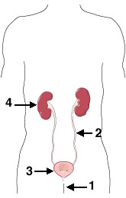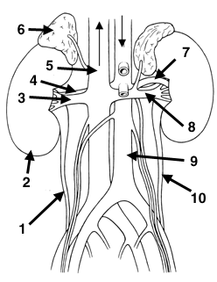

2. Complete the text with the words from the box.
travels carried removes back containing stores excrete forms tighten consists emptied swells

The urinary system works with the lungs, skin, and intestines — all of which also __________¹ wastes — to keep the chemicals and water in your body balanced.
The urinary system __________² a type of waste called urea from your blood. Urea is produced when foods __________³ protein, such as meat, poultry, and certain vegetables, are broken down in the body. Urea is __________⁴ in the bloodstream to the kidneys.
The kidneys are bean-shaped organs about the size of your fists. They remove urea from the blood through tiny filtering units called nephrons. Each nephron __________⁵ of a ball formed of small blood capillaries, called a glomerulus, and a small tube called a renal tubule. Urea, together with water and other waste substances, __________⁶ the urine as it passes through the nephrons and down the renal tubules of the kidney.
From the kidneys, urine __________⁷ down two thin tubes called ureters to the bladder. Muscles in the ureter walls constantly __________⁸ and relax to force urine downward away from the kidneys. If urine is allowed to stand still, or __________⁹ up, a kidney infection can develop. Small amounts of urine are __________¹⁰ into the bladder from the ureters about every 10 to 15 seconds.
The bladder is a hollow muscular organ shaped like a balloon. The bladder __________¹¹ urine until you are ready to go to the bathroom to empty it. It __________¹² into a round shape when it is full and gets smaller when empty.
3. Which part of the urinary system is being described?
1. Bean-shaped organs of excretion, each about the size of a fist; they filter the blood and form urine.
2. Microscopic functional units of the kidney; by working with blood vessels, they filter the blood and balance the composition of urine.
3. The expanded upper end of the ureter that receives urine from the kidney.
4. The tube that carries urine from the bladder to the outside of the body.
5. The fluid excreted by the kidneys. It consists of water, electrolytes, urea, other metabolic waste, and pigment. A variety of other substances may appear in it in cases of disease.
6. The main nitrogen-containing waste product in the urine.
7. The organ that stores and eliminates urine excreted by the kidneys.
8. The tube that carries urine from the kidney to the bladder.

