**What do we test?**

Picture description tests fluency, vocabulary, stress, pronunciation and rhythms of speech, ability to communicate, grammatical accuracy and interactive communication.

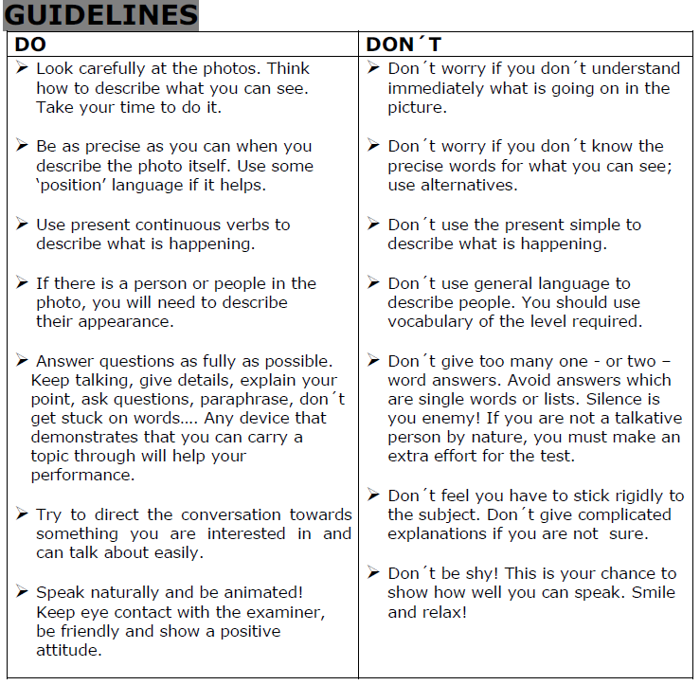

**1. Describe where things are in the picture**

1. **Preparation**

Have a close look at the picture and decide on how to structure your picture description. What is important or special? What should the viewer pay attention to?

1. **Structure and Content**

It's not easy to follow a picture description if the writer jumps randomly from one point to another. Therefore, make sure that your picture description is logically structured, for example:

* from left to right (or from right to left)
* from the background to the foreground (or from the foreground to the background)
* from the middle to the sides (or from the sides to the middle)
* from details to general impressions (or from general impressions to details)

Which structure you finally choose depends on your taste and the picture you want to describe.

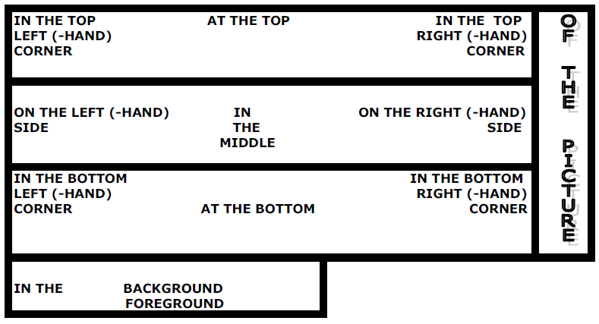

**2. Don´t be too certain**

Try to use your imagination to **make assumptions**.

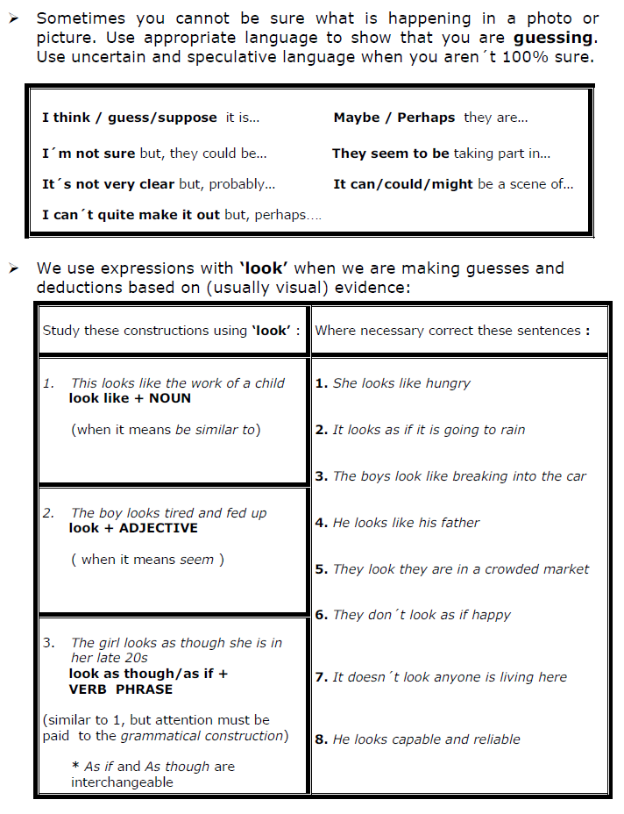

**3. Paraphrase if you don´t know the word**

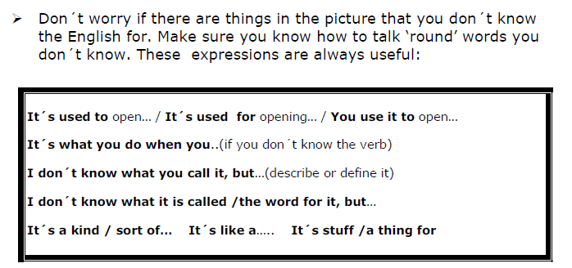

**4.Give your opinion & Use hesitation words**

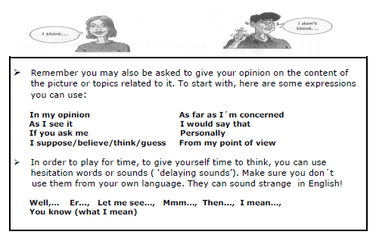

**5. Ask for clarification & Correct yourself**

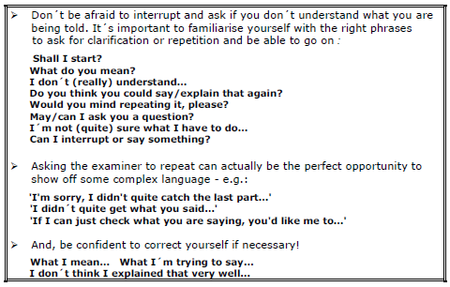

**6. What to include**

It is best to think about the WHO WHAT WHERE WHEN WHY HOW of each picture.

Think about the subject, environment, time of day, weather, location, culture...this will give you ideas to keep you talking.

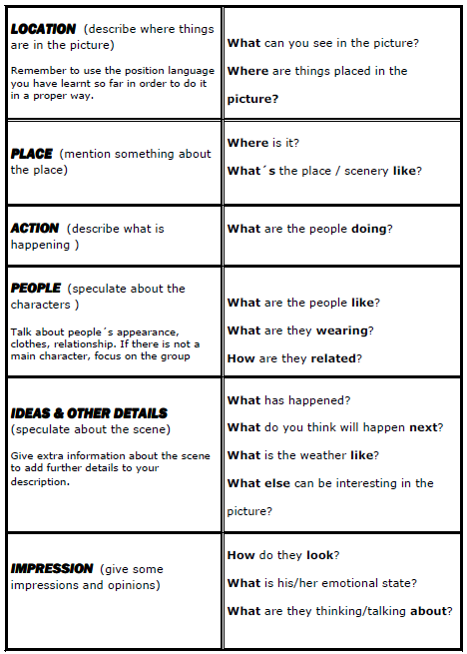

**Pictures in General**

* short description of the scene (e. g. place, event)
* details (who / what can you see)
* background information (if necessary) on place, important persons or event

**Structure**

foreground

background

in the upper/lower part

in the left/right part

in the central part

in front of

behind

next to …

on the right/left

in the middle

from front/behind/above/below

the second from left/right

This picture / drawing / cartoon / photo shows a …

In this picture …

This is a picture of…

There’s /There’re…

I can see…

The … is / are …-ing

In the foreground / background…

In the middle…

On the right (hand side of the picture)…

At the top / bottom…

In the top / bottom left hand corner…

Near; next to; beside; above; under; behind; in front of; opposite; across from; between…etc.

I think they are /may be …(-ing)

I’m not sure / I can’t say for sure /certain, but it may be…/ it could be…/ it might be…

I can see a …, so it must be…

I think this photo was taken…

It looks like a…

I’m absolutely sure / certain…

There’s no doubt that…

It seems…

It’s difficult to make it out because…

It looks as if / though they are…

I (can still) remember…-ing…

I’ve already been in a situation like this.

That reminds me of…

If I were in a situation like this…, I would…

If such a thing happened to me…, I would…

I think /guess…

In my opinion / view…

As far as I’m concerned…

The way I see it…

From my point of view…

It seems to me that…

I’d say…

If you ask me…

To my mind…

Well, to be honest, I don’t think…

Under / In no circumstances, would I ever…

No way would I…

I wouldn’t do it for anything.

No, thank you, …is not for me.

…is not my cup of tea

I’d rather not (do something)

I don’t feel I could…

I’m not sure I’d be capable of…-ing

The issue of…has now become the focus of national / worldwide media attention, and…

…has focused public attention on…

I think people / the government should…

Generally speaking,…

Thank God…

Unfortunately,…

It is in everyone’s best interest to…

You may have to pay very dearly for…

It is crucial / extremely important that… should…

There has been a lot of progress made in…

The issue has been hotly debated for some time, and…

There has been a lot of (heated / fierce / intense) public debate on this issue, and…

There are a number of things we could do about this problem…

The only way out of this situation seems to be…-ing…

The only solution to this problem seems to be…-ing…

We are left with no choice, but to…

…before it’s too late

Adapted from :

http://www.ego4u.com/en/cram-up/writing/picture-description

http://kolmanv.blogspot.cz/2009/09/picture-description-useful-phrases.html

http://www.cristinacabal.com/pre-intermediate/description.pdf

http://elenec.files.wordpress.com/2012/05/picture-description.pdf

**Practical exercises:**

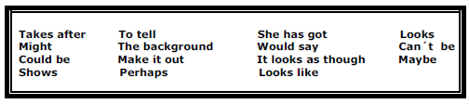

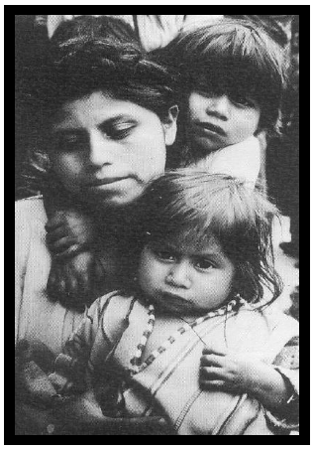This photo _____________ 1 a young mother and her two kids. I _________ 2 they must be from somewhere in South America. ___________ 3 they are in a crowded market, although it is difficult _______________ 4 because you can’t see much of _____________ 5.

The mother has her hair up in a bun and a roundish face. She ___________ 6 fed up, but this ____________ 7 because she’s tired. _____________ 8 she’s had a busy day shopping.

The child with its arm around her neck ____________ 9 a little boy. It seems he’s aware of the camera.

The little girl __________ 10 more than three. She’s a little plump, but you can see that she really ____________ 11 her mother. _______________ 12 her mother’s mouth and the most beautiful almond-shaped eyes. She’s holding something in her hand.

I can’t really ____________ 13. It ________________ 14 be a charm or ______________ 15 it’s a crucifix.

Key: shows, 2. would say, 3. It looks as though, 4. to tell, 5. the background, 6. looks 7. could be 8.maybe/perhaps, 9. looks like, 10. can’t be, 11. takes after, 12. She has got, 13. make it out, 14. might, 15. perhaps/maybe

1. Describe the pictures.

2. What physical function does the skin perform in each of them?

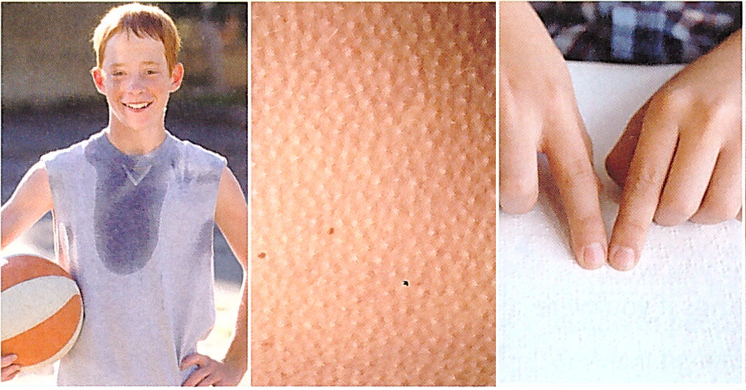

1. Look at the pictures below and describe them?

2. Why people do these artificial things to their skin?

3. Is there any such practice in your culture?

