NAME ALL THE BASIC PLANES OF THE BODY AND EXPLAIN HOW THEY DIVIDE IT. | NAME ALL THE BASIC CAVITIES IN THE HUMAN BODY AND NAME THE ORGANS WHICH THEY CONTAIN.
NAME AND EXPLAIN AT LEAST FOUR DIRECTIONAL TERMS AND GIVE EXAMPLES USING ORGANS OR PARTS OF THE BODY. | Describe the picture:  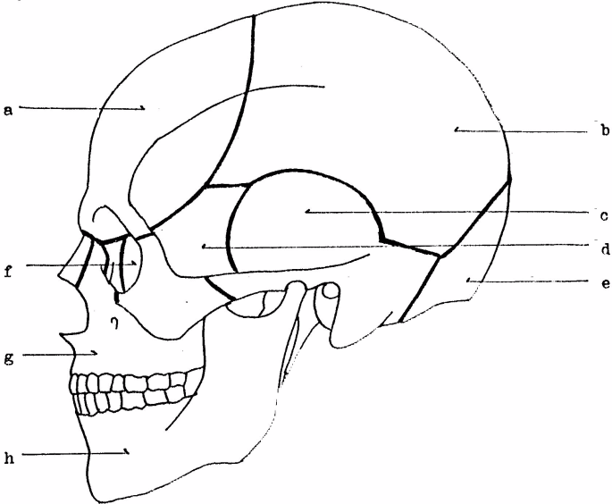
DESCRIBE THE MOST SERIOUS INJURY THAT YOU (OR SOMEBODY YOU KNOW) HAVE EVER SUFFERED FROM. INCLUDE DETAILS (HOW, WHEN, WHERE, TREATMENT, ETC.) | DESCRIBE THE MOST SERIOUS DISEASE THAT YOU (OR SOMEBODY YOU KNOW) HAVE HAD. INCLUDE DETAILS (TREATMENT, MEDICINE, ETC.)
EXPLAIN WHY YOU DECIDED TO STUDY AT THE MEDICAL FACULTY, WHAT SPECIALIZATION YOU WANT TO HAVE, WHERE YOU WOULD LIKE TO WORK, ETC. | EXPLAIN IN DETAIL WHAT HAPPENS WHEN YOU ARE AT THE DOCTOR’S, what is a REFERRAL? What EXAMINATIONS are likely to happen?
DESCRIBE HOW YOUR STUDY PROGRAMME IS STRUCTURED. ARE THERE ANY ADVANTAGES? ANY DISADVANTAGES? | EXPLAIN THE DIFFERENCE: • BETWEEN ARTERIES, VEINS AND CAPILLARIES;  • BETWEEN PULMONARY AND SYSTEMIC CIRCULATIONS
ARE PLANNING ON IMPROVING YOUR ENGLISH IN THE FUTURE?  HOW?  WHERE? | EXPLAIN THE DIFFERENCE BETWEEN:  • HYPERTENSION AND HYPOTENSION
WHAT DO THESE NUMBERS REFER TO IN MUSCULAR AND SKELETAL SYSTEM:  206  33-34  7  12  5 | EXPLAIN THE DIFFERENCE BETWEEN:  • A SPLINT AND A SPLINTER  • PLASTER AND A PLASTER  • DIARRHOEA AND CONSTIPATION
EXPLAIN THE DIFFERENCE BETWEEN:  • TACHYCARDIA AND BRADYCARDIA  • THROMBUS AND EMBOLISM | WHAT DO THE FOLLOWING SUFFIXES MEAN?  (give examples)  • -ITIS  • - ECTOMY  • - PATHY
DESCRIBE YOUR TYPICAL DAY AT SCHOOL | WHAT ARE THE MOST COMM ON DISEASES AFFECTING THE HUMAN ORAL CAVITY?
WHAT ARE THE SEGMENTS OF THE SPINE CALLED?  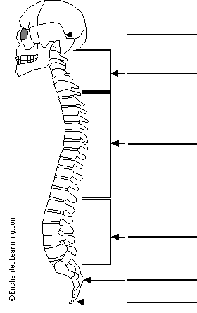 | IS THERE ANY GUIDANCE AS TO THE CORRECT WAY OF TOOTHBRUSHING?
DESCRIBE BLOOD CIRCULATION BETWEEN THE HEART AND THE LUNGS. | NAME THE BASIC COMPONENTS OF HUMAN BLOOD.
.

