**1. Listening**

*Watch the video and complete the missing words.* https://www.youtube.com/watch?v=hiNEShg6JTI

The kidneys lie outside the **____________________**, they function as the main **_________________**and eliminate the body’s metabolic waste products which are then **_________________**through the urethra. The kidneys adjust blood composition and so maintain blood **_________________**. In the place called **_________________**, blood vessels, nerves and ureter connect to the kidney. They consist of up to 18 **_________________** (each lobe is divided into lobules) which are composed of **_________________.** The nephron is made up of **_________________**and a system of tubules.

Plasma like fluid which is filtered through a membrane in kidneys is called filtrate and forms the **_________________**. The filtrate then enters the tubule system of the nephron where some substances **_________________** to it and some substances are reabsorbed into the blood.

The nephron tubule is divided intofour segments: proximal **_________________** tubule, **_________________**of Henle, **_________________**tubule and **_________________**

One **_________________** supplies blood to each kidney. The artery is divided into segmental arteries which then **_________________**several lobular arteries within the kidney. The afferent and **_________________**arterioles regulate glomerular capillary pressure by selectively dilating or **_________________**. Blood from the kidney empties into the **_________________**.

By reabsorption the **_________________**of the internal environment is maintained. After filtration and reabsorption, the filtrate concentrates in **_________________**and then goes to renal **_________________**from where it passes to the ureter, bladder and urethra.

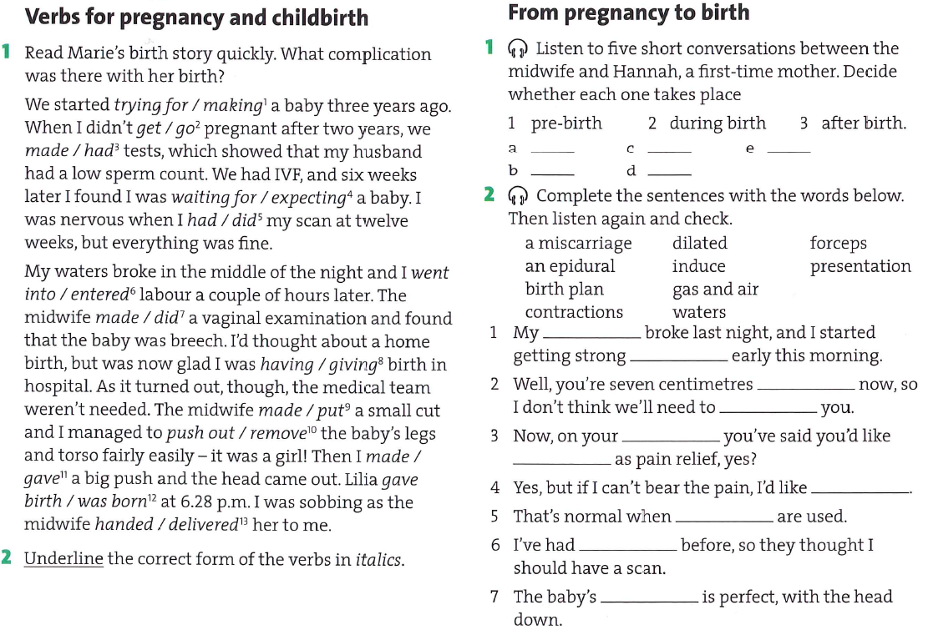The kidneys perform an **_________________**: the blood is filtered and some materials are **_________________**reabsorbedinto the blood so that a stable internal environment is **_________________.** The nephron is made up of glomerulus, which **_________________** and the tubular component where substances are either reabsorbed or **_________________** the tubular filtrate for elimination.