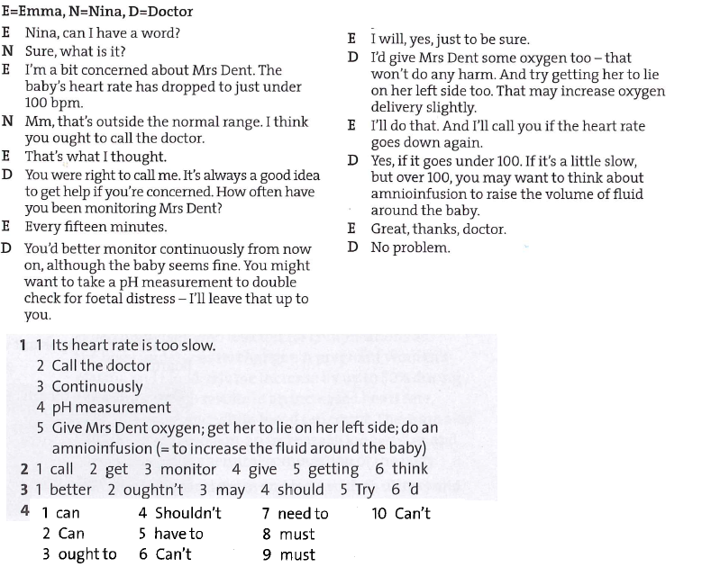

**2. Read the text on STD’s up to breast cancer and find the words which are described in the definitions below:**

1. A substance that is excreted from an organ. ____discharge__________

2. To acquire or catch an infection/disease ________contract_________

3. Any physical contact between two individuals involving stimulation of the genital organs of at least one ______sexual intercourse_______

4. The occurrence of infection with a particular disease/ a sudden start of a disease ______outbreak____

5. Perceptible to the eye, can be seen _______visible________

6. synonym for “clap” ______gonnorhea______

7. The part of an organ in your body that opens and closes to keep liquid flowing in the right direction _____valve____

8. The primary sore of syphilis, occurring at the site of entry of the infection ___chancre___

9. The part of the body where the lower abdomen and the inner thigh meet _____groin______

10. Any unicellular, usually oval, nucleated fungus; often used for baking and making beer _____yeast___

11. A synonym for “myomas” ______uterine fibroids______

### 3. Prostate cancer

Prostate cancer is found mainly __in____(1) men over the age of fifty-five. As men ___grow/get (are)___(2) older, the chance of developing the disease increases. Although the cause of this type of cancer is unknown, evidence suggests ____that____(3) age, race, a high-fat diet, and increased blood levels of testosterone may play a ____role/part_____ (4) in the development of the disease.

__If/When____(5) prostate cancer is detected (either through a rectal _____examination, palpation, …____ (6) or blood test), surgery to remove the prostate ____gland______ (7) completely is the most common treatment. The seminal __vesicles______(8) are also removed during the procedure. If the prostate cancer is detected at an early ___stage____ (9), radiation therapy may be used ____instead____ (10) of surgery. Chemotherapy ____is____ (11) sometimes used to treat prostate cancer that has recurred after initial treatments.

**4. Read the text and then type the correct form of the word in CAPITALS.**

1. If a kidney stone is too large to pass and causes a serious obstruction, surgical ___removal____ (REMOVE) may be necessary.
2. Men with BPH have other bladder symptoms including an increase in ____frequency____ (FREQUENT) of bladder emptying both during the day and at night.
3. Many ___disorders__ (ORDER) can also affect the male and female reproductive system.
4. STDs can cause birth defects, ____blindness_____ (BLIND), brain damage, cancer, heart disease, ______infertility______ (FERTILE), mental ___retardation______ (RETARD), and ____death____ (DIE).
5. Genital herpes is an _____incurable____ (CURE) disease, after you contract the virus you won’t get rid of it.
6. The bacteria that cause gonorrhea are developing and increased ____resistance_____ (RESIST) to routine medication therefore a variety of antibiotics is needed.
7. _____uterine_____ (UTERUS) fibroids are benign growths, which means that they are not ______cancerous_____ (CANCER) tumors.
8. Frequently, prostate cancer has no symptoms. When the tumour is ___enlarged/larger_____ (LARGE) or the cancer has spread, the following symptoms may appear: weak or interrupted urine flow, frequent ___urination______ (URINE) (especially at night), ____inability_____ (ABLE) to urinate, pain or burning ____sensation_____ (SENSE) when urinating, blood in the urine, persistent pain in the lower back, and painful ejaculation.