**1. Read and answer the following questions with your partner:**

1. What is haemodialysis, what happens during this procedure and why is it used?

2. Who is the most susceptible to kidney stones and how can we treat them?

3. Who is more prone to urinary incontinence and what are its causes?

4. What are the symptoms of urinary tract infection?

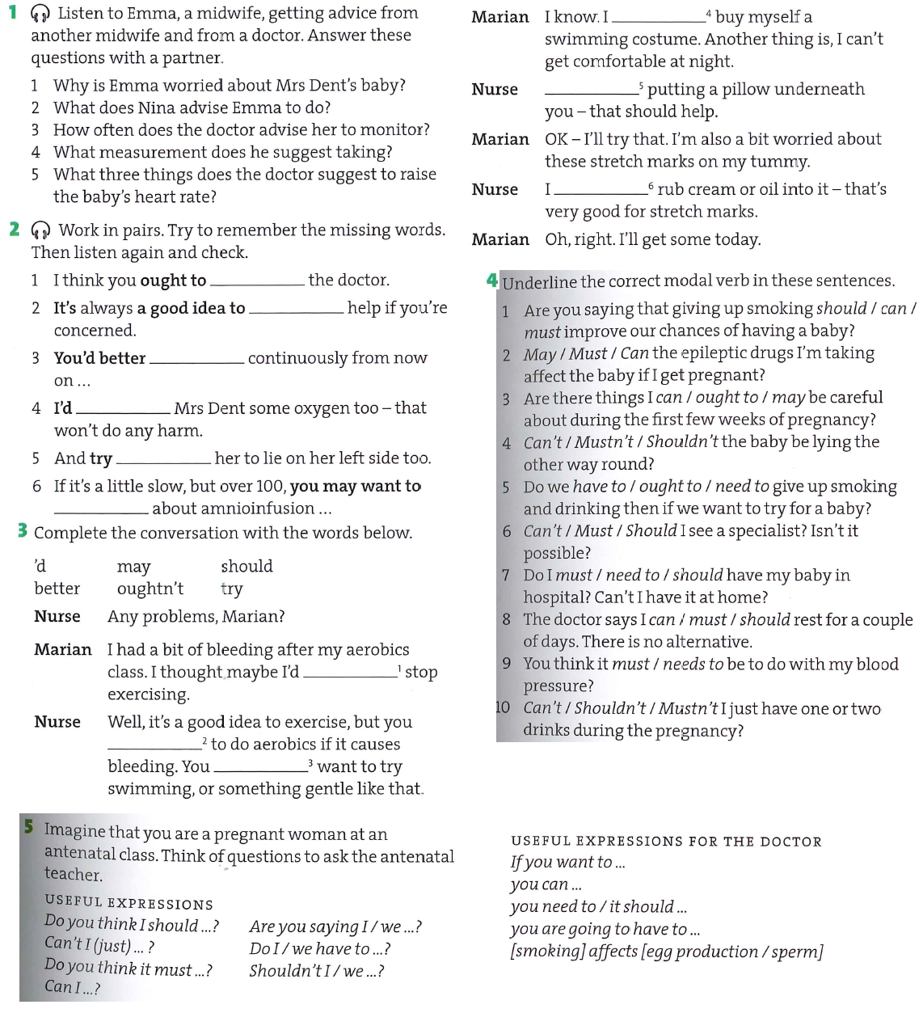5. What does BPH stands for? Can you describe it more closely?

**2. Read the text on STD’s up to breast cancer and find the words which are described in the definitions below:**

1. A substance that is excreted from an organ. ______________

2. To acquire or catch an infection/disease _________________

3. Any physical contact between two individuals involving stimulation of the genital organs of at least one _____________

4. The occurrence of infection with a particular disease/ a sudden start of a disease __________

5. Perceptible to the eye, can be seen _______________

6. synonym for “clap”

7. The part of an organ in your body that opens and closes to keep liquid flowing in the right direction _________

8. The primary sore of syphilis, occurring at the site of entry of the infection __________

9. The part of the body where the lower abdomen and the inner thigh meet ___________

10. Any unicellular, usually oval, nucleated fungus; often used for baking and making beer ________

11. A synonym for “myomas” ____________

### 3. Prostate cancer

Prostate cancer is found mainly ______(1) men over the age of fifty-five. As men ______(2) older, the chance of developing the disease increases. Although the cause of this type of cancer is unknown, evidence suggests ________(3) age, race, a high-fat diet, and increased blood levels of testosterone may play a _________ (4) in the development of the disease.

______(5) prostate cancer is detected (either through a rectal _____________ (6) or blood test), surgery to remove the prostate __________ (7) completely is the most common treatment. The seminal ________(8) are also removed during the procedure. If the prostate cancer is detected at an early _______ (9), radiation therapy may be used ________ (10) of surgery. Chemotherapy ________ (11) sometimes used to treat prostate cancer that has recurred after initial treatments.

**4. Read the text and then type the correct form of the word in CAPITALS.**

1. If a kidney stone is too large to pass and causes a serious obstruction, surgical _______ (REMOVE) may be necessary.
2. Men with BPH have other bladder symptoms including an increase in ___________ (FREQUENT) of bladder emptying both during the day and at night.
3. Many ________ (ORDER) can also affect the male and female reproductive system.
4. STDs can cause birth defects, _________ (BLIND), brain damage, cancer, heart disease, ____________ (FERTILE), mental _________ (RETARD), and ________ (DIE).
5. Genital herpes is an _________ (CURE) disease, after you contract the virus you won’t get rid of it.
6. The bacteria that cause gonorrhea are developing and increased _________ (RESIST) to routine medication therefore a variety of antibiotics is needed.
7. __________ (UTERUS) fibroids are benign growths, which means that they are not ___________ (CANCER) tumors.
8. Frequently, prostate cancer has no symptoms. When the tumour is ________ (LARGE) or the cancer has spread, the following symptoms may appear: weak or interrupted urine flow, frequent _________ (URINE) (especially at night), _________ (ABLE) to urinate, pain or burning _________ (SENSE) when urinating, blood in the urine, persistent pain in the lower back, and painful ejaculation.