**Some more practice on conditional sentences:**

[**http://www.ego4u.com/en/cram-up/grammar/conditional-sentences**](http://www.ego4u.com/en/cram-up/grammar/conditional-sentences)

**1. Match the words with their definition**

1. reaction a) transmit
2. propagate b) related to inner organs
3. involuntary c) response
4. inhibit d) to limit or block
5. cause e) autonomic
6. voluntary f) consciously
7. hemisphere g) fold
8. gyrus h) half
9. rear i) trigger
10. visceral j) back

1-c, 2. a, 3. e, 4. d, 5. i, 6. f, 7. h, 8. g, 9. j, 10. b

**2. Look at the words bellow and explain them to your partner.**

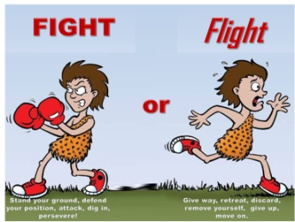Fight or flight response knee-jerk reflex grey matter



Brain stem myelin sheath

For explanation see the reading or Wikipedia

**Scrub up:**

1. More answers possible, you should be able to give reasons for your anwers

Heartburn - A burning sensation, usually centered in the middle of the chest near the sternum, caused by the reflux of acidic stomach fluids that enter the lower end of the esophagus. Also called *acid reflux*, *cardialgia*, *pyrosis*.

2. 1d, 2c, 3b, 4f, 5a

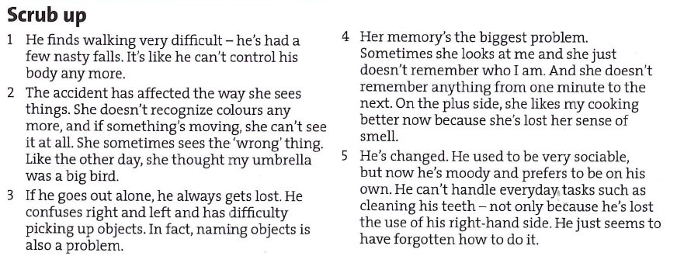

**Glasgow coma scale**

1 deeply, 2 verbal, 3 spontaneously, 4 coherently, 5 random/incomprehensible, 6 random/incomprehensible, 7 appropriately, 8 bent

- number the responses according to the amount of points a patient receives if s/he produces such a response, then watch the video and check whether you were correct

**First and second conditional**

1. a-2, b-1

2. 1) doesn’t stop…will really affect, 2) wouldn’t give…didn’t want, 3) will probably die…don’t operate, 4) wasn’t …would be/alternatively in case it is just being decided where the patient is going to be isn’t…will be, 5) will…don’t, 6) wasn’t … would be

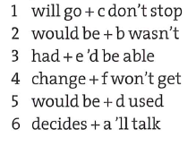3. 3) will be, 4) happens, 5) would be, 6) had, 7) were, 8) would be, 9) will wear, 10) rides

4.

**Conditionals**

* **0 conditional**

If/When you press the switch, the light comes on.

|  |  |
| --- | --- |
| Form | Meaning |
| If + simple present, __________________ | It refers to the present/past/future.  It is possible/impossible/always true. |

* **1st conditional**

If I fail the exam, I will be sad.

|  |  |
| --- | --- |
| Form | Meaning |
| If + simple present, will + infinitive | It refers to the future.  It is possible but very unlikely that the condition will be fulfilled. |

* **2nd conditional**

If I won a million crowns, I would travel around the world.

|  |  |
| --- | --- |
| Form | Meaning |
| If + past tense, would + infinitive | It refers to the future  It is possible but very unlikely, that the condition will be fulfilled. |

* **3rd conditional**

If I had been in the accident, I would have died there.

|  |  |
| --- | --- |
| Form | Meaning |
| If + past perfect, would have + past participle | It refers to the past.  It is impossible that the condition will be fulfilled. |

1. Take an umbrella in case it rains.

Unless you start with the treatment immediately, it won’t help you.

Provided the room is clean, I don’t mind which hotel we stay at.

Unless he was very ill, he would be at work.

Call this number in case of emergency.

Travelling by car is convenient, provided that you have somewhere to park.

I will leave my mobile phone switched on in case Jane calls.

You will be sick unless you stop eating junk food.

2. If you freeze a piece of metal, it contracts.

You won’t pass the exam in biophysics unless you study hard.

Humans are among the few animals to have colour vision. If you were a horse for example, you would see everything in black and white.

The brain works in two parts, the left side and the right side. Scientists can put one side of the brain to sleep, and see what happens. For example, if they turn off the right side of the patient’s brain, the patient won’t be able to sing, because musical ability comes from the right side of the brain.

If you cool the steam, it turns back into water.

If my grandfather was alive, he would be a hundred tomorrow.

Beetles are one of the most numerous species on the planet. In fact, if other insects and animals didn’t eat beetles, in about a year the beetle population would weigh as much as the whole Earth!

If you smoke, chemical changes take place in your cells because they don’t receive enough oxygen.

The world’s oceans contain huge amounts of salt. In fact, if you removed all the salt from the oceans, you would be able to use it to build a wall about 300km wide and a kilometre tall all around the Earth!

1. 3 If Alexander the Great had marched west instead of east, he would have conquered the whole of Europe.
2. If more Vikings had gone to North America, they would have brought some Indians back to Europe.
3. If the ancient Egyptians had built bigger boats, they would have crossed the Atlantic and landed in America.
4. If a storm had not hit Bartolomeu Dias’s ship off the coast of Africa in 1487, they wouldn’t have arrived in the Indian Ocean by accident.
5. If Columbus had not read about Marco Polo’s trip to China, he would not have tried to sail there by crossing the Atlantic.
6. If Columbus had sailed east in 1492, he would have reached China or Japan.
7. If the Aztecs hadn’t thought that Cortes and his men were gods, the Spaniards would not have conquered Mexico so easily.
8. If Lewis and Clark hadn’t found a way across America from St Louis to the Pacific in 1806, thousands of settlers would not have made the journey in later years to settle in the central North America.
9. If Charles Darwin hadn’t taken a voyage to South America between 1831 and 1836, he would not have written his famous book The Origin of Species.

|  |  |
| --- | --- |
| 1. evacuation | the process of getting rid of solid or liquid material from e.g. the brain |
| 1. tracheostomy | Surgical opening in the neck for the insertion of a catheter or tube to facilitate breathing |
| 1. contusion | traumatic injury of the brain, bruise of the brain tissue |
| 1. dural | relating to or affecting the tough membrane forming the outermost of the three coverings of the brain and spinal cord |
| 1. laceration | tearing or a deep cut in one’s flesh or organ |
| 1. reposition | changing position |
| 1. to ambulate | walk from place to place |
| 1. grooming | to care for the appearance, getting dressed etc. |
| 1. bowel | intestines |
| 1. retrieval | the cognitive operation of accessing information in memory |
| 1. alert | mentally perceptive and responsive |
| 1. to sustain | to maintain, to keep |
| 1. to comprehend | to understand |
| 1. impairment | the fact that a part of the body is unable to do something fully |