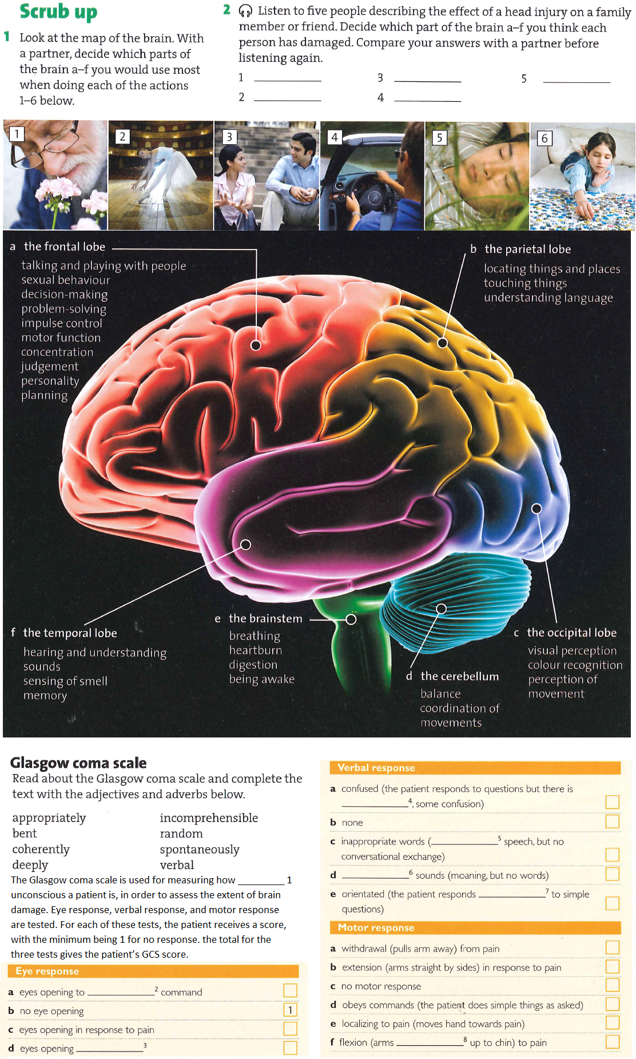

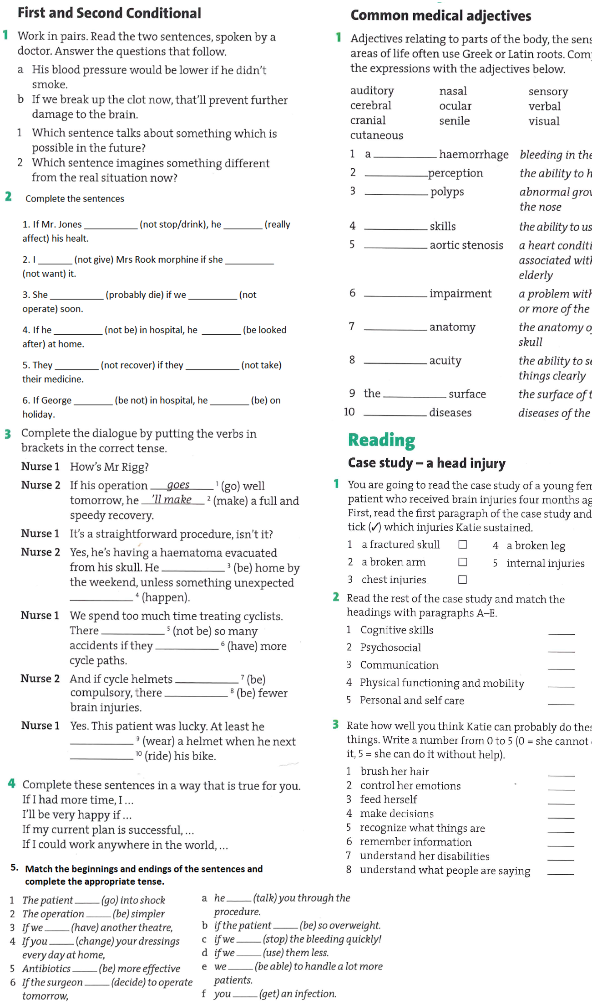

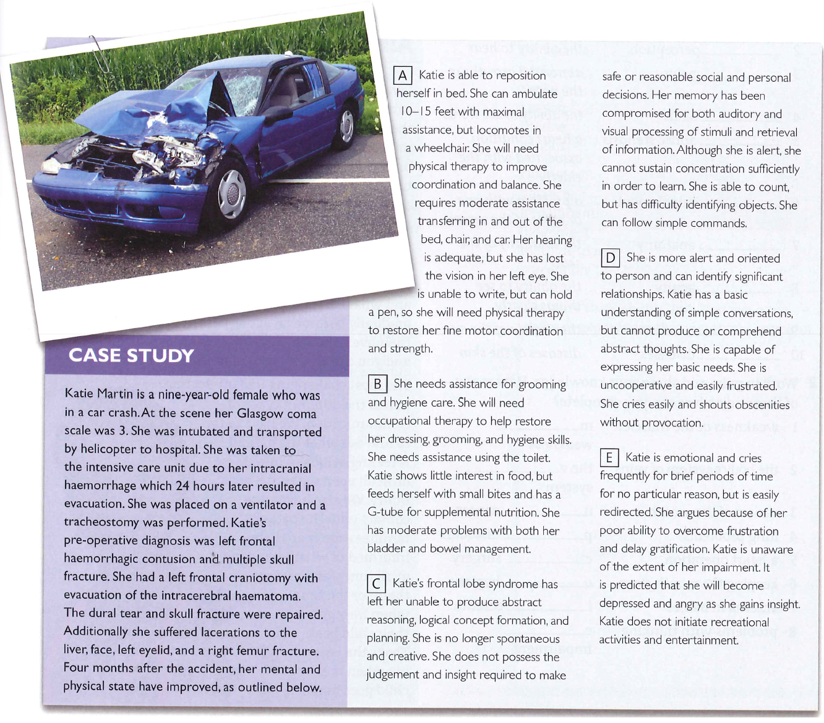

**4. Find the words bellow in the text and match them with their definitions**

|  |  |
| --- | --- |
| 1. evacuation | 1. the fact that a part of the body is unable to do something fully |
| 1. tracheostomy | 1. changing position |
| 1. contusion | 1. the process of getting rid of solid or liquid material from e.g. the brain |
| 1. dural | 1. to understand |
| 1. laceration | 1. relating to or affecting the tough membrane forming the outermost of the three coverings of the brain and spinal cord |
| 1. reposition | 1. tearing or a deep cut in one’s flesh or organ |
| 1. to ambulate | 1. to care for the appearance, getting dressed etc. |
| 1. grooming | 1. intestines |
| 1. bowel | 1. mentally perceptive and responsive |
| 1. retrieval | 1. the cognitive operation of accessing information in memory |
| 1. alert | 1. walk from place to place |
| 1. to sustain | 1. surgical opening in the neck for the insertion of a catheter or tube to facilitate breathing |
| 1. to comprehend | 1. to maintain, to keep |
| 1. impairment | 1. traumatic injury of the brain, bruise of the brain tissue |