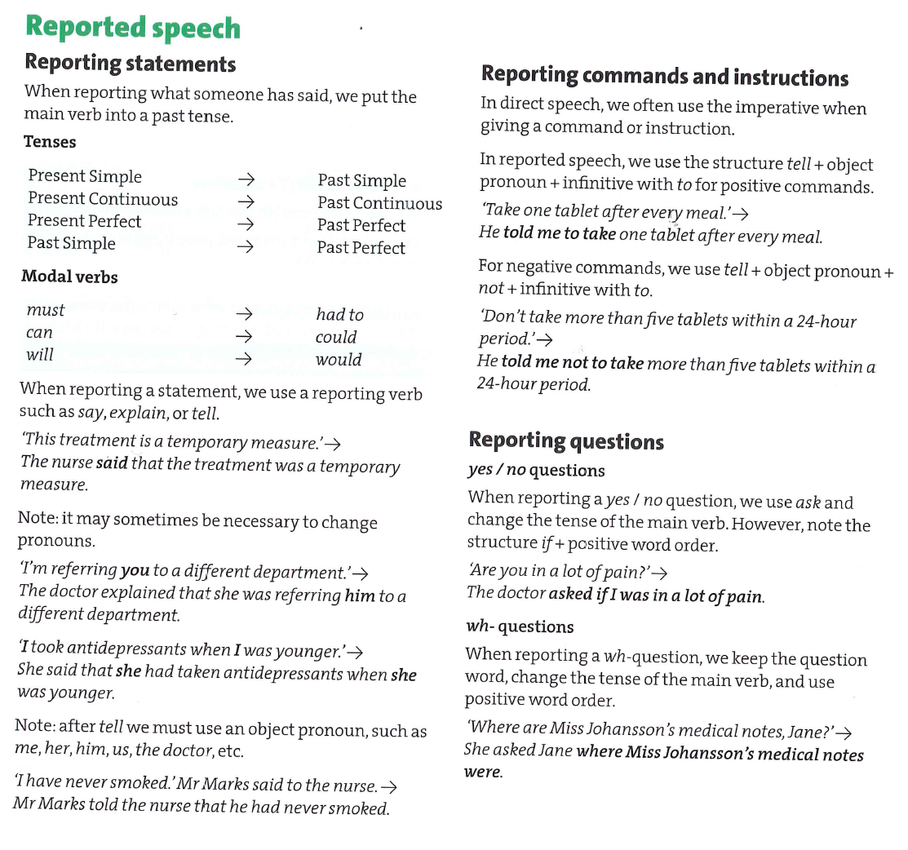

For more rules and time shifts see:

<http://www.helpforenglish.cz/article/2006032502-neprima-rec-1>

For more exercises on reported speech see:

<http://www.ego4u.com/en/cram-up/grammar/reported-speech>

