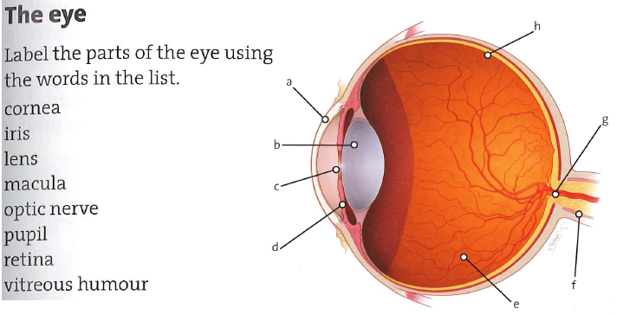eyebrow, eyelid, eyelash

eye socket/orbit, eyeball

sclera [ˈsklɪərə]

aqueous humour [ˈeɪkwɪəs hjuːmə]

choroid [ˈkɔːrɔɪd]

ciliary muscles

conjunctiva [ˌkɒndʒʌŋkˈtaɪvə]

blind spot

constrict

dilate[daɪˈleɪt], curvature [ˈkɜːvətʃə]

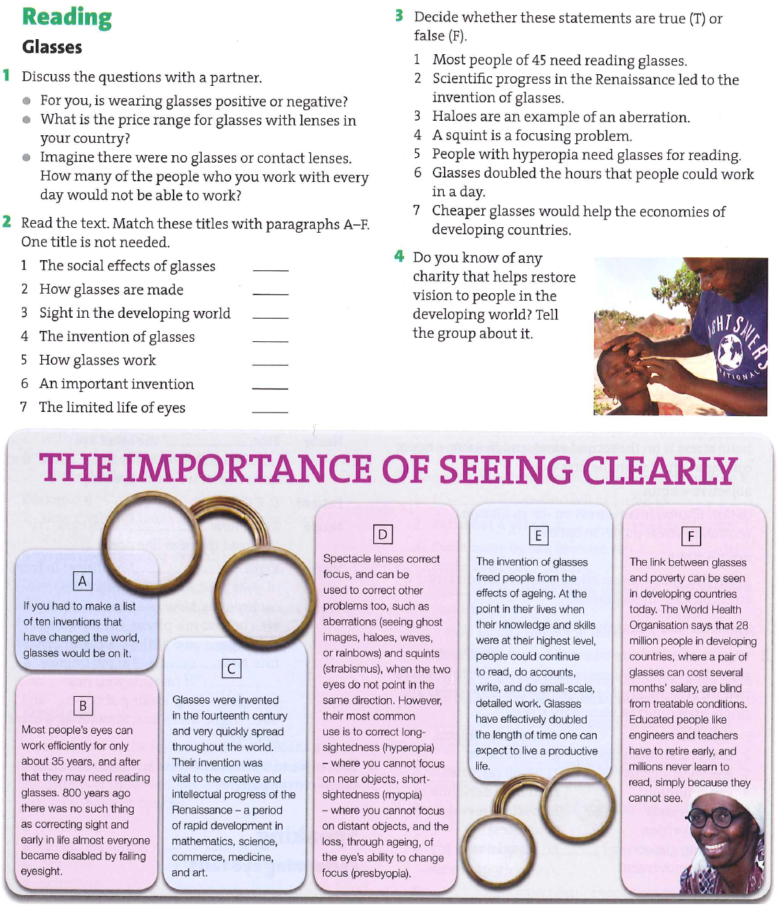

**The Ear**

The ear enables us to hear as well as maintain balance. The external part of the ear consists of auricle (­­­­___________), the external auditory ­­­­___________ (meatus) and the ­­­­___________ (tympanum). The pinna is an immobile cartilaginous framework covered with skin and provides for the perception of sound. The auditory canal is an S-shaped tube which ends with the tympanic membrane separating the ­­­­___________ and ­­­­___________ ear. The skin of the canal is furnished with hairs and special glands which produce yellow ­­­­___________ secretion for protection against insects and dust.

The middle part embodies a small cavity in the temporal bone. The cavity is connected with the nasopharynx by means of the auditory tube, known as ­­­­___________. Both are lined with mucous membrane which enables infection to permeate from the throat to the middle ear.

The cavity of the middle ear contains three tiny bones called auditory ossicles (­­­­___________, ­­­­___________and ­­­­___________), which serve for the transmission of sound vibrations. These can be reduced by means of two miniature muscles.

The ­­­­___________ ear is formed by irregularly shaped cavities containing fluid and complex membranous structures (___________, ___________ and ___________which are filled with a fluid termed ___________and are surrounded by ___________) initiating nerve impulses. It functions as the actual receptor of sound. Sound ­­­­___________ received by the external ear hit the ­­­­___________ membrane causing it to vibrate. The vibration is transmitted to the ­­­­___________ in the middle ear. The stapes, which is attached to the oval window of the inner ear, causes the membrane of the inner ear to move with the sound which is thus carried forward to the canals of the inner ear and recognized by its volume.

