**The eye**

Eye is the sense organ which helps us most to gain knowledge. Eyes are situated in the eye sockets of the skull. Images are formed in the retina. Let us examine through which parts light passes before reaching the retina. Cornea which is convex in shape and transparent as glass is found in the front of the eye. The continuation of cornea seen in white colour is called sclera. It is the outermost layer of the eye. It is this strong layer that gives shape to the eye ball.

Which is the chamber seen just behind the cornea? The fluid filled in that chamber is called the aqueous humour. This fluid which gets separated from the blood gets absorbed back into the blood in the same quantity. This fluid provides nourishment and oxygen to the cells around it.

Melanin is the pigment which gives dark colouration to the choroid. It absorbs the excess light which enters into the eye. Numerous capillaries are present in the choroid. They bring oxygen and nutrients required for the eye. You have seen the iris which is found as a screen in front of the lens. This is the continuation of the choroid. Is the colour of iris same in all people around the world. What could be the reason for this? Note the portion where the iris joins the elerotic layer. Ciliary muscles are seen in this thickened area.

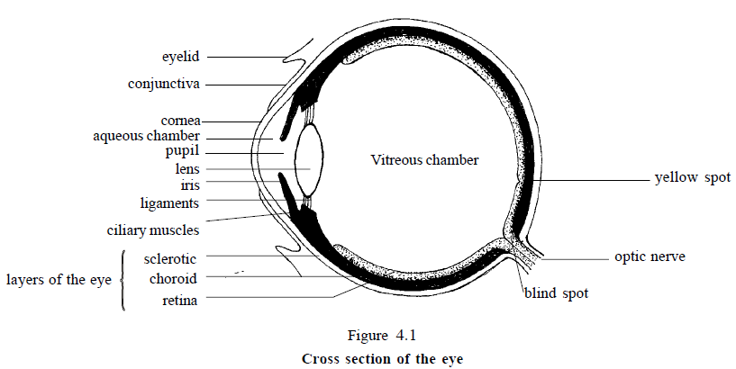

**Light and the pupil**

Observe the position of the pupil. This is the only way through which light can reach the retina. The pupil constricts in bright light and dilates in dim light. When the circular muscles contract, the size of the pupil decreases.

The lens is made of a substance which has elasticity. The lens is connected to the ciliary muscles with the help of ligaments. The curvature of the lens changes with the contraction of ciliary muscles. Light passes through the lens into this large chamber behind it. The semisolid transparent substance filled in this chamber is called vitreous humour. It gives shape to the eyeball.

**How is image formed?**

The image formed when light passes through a convex lens is inverted. It is the image of a distant object which is formed in the focus. The lens in the eye is convex. Then what are the characteristics of image formed. The light gets refracted when it passes through cornea, aqueous humour, lens and vitreous humour. As a result of this the image falls on the retina

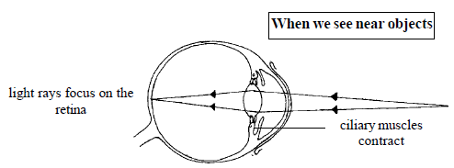 But when we look at a near object its image will be formed behind the retina. Here the curvature of the lens is increased by the contraction of the ciliary muscles, so that the image is formed on the retina.

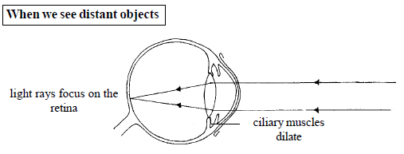 Thus depending upon the distance of the object from the eye, its ability to focus the image on the retina by altering the convexity of the lens is called the power of accommodation. In addition to the contractions of the ciliary muscles, the curvature of the cornea, shape of the pupil and the fluids in the eye also help in this process.

**Lens and vision**

As we grow old the elasticity of the lens decreases. This state is known as presbyopia. What type of lens is used in the spectacles of such people? The transparency of the lens is lost in many aged people and in some persons affected by diseases. This disorder is known as cataract. The lens incapable of functioning is replaced by an artificial lens.

**The ear**

Hearing is as important as vision. We know that ear is the sense organ which helps us in hearing. It also helps us to maintain the balance or equilibrium of our body. From the picture, it is clear that the ear has three main parts: external ear, middle ear, internal ear.

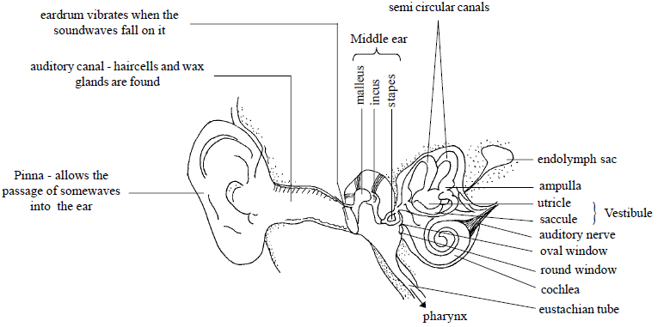

The external ear consists of pinna, auditory canal and ear drum. Pinna helps to direct the sound waves into the auditory canal. Ceruminous glands are special glands which are found in the walls of the auditory canal which is the continuation of the pinna. The wax produced by these glands and the hairs in the auditory canal together protect the ear from small insects, germs and dust. In additions to this, they help to maintain the temperature and dampness of the auditory canal. The auditory canal ends in the ear drum, which is a thin membrane separating the external ear from the middle ear. This membrane capable of vibration is connected to the ossicles of the middle ear.

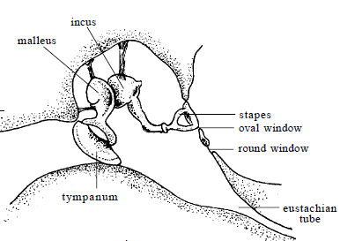 The middle ear is a chamber with air circulation. Observe figure and try to understand the shape and arrangement of the bones in the middle ear. You know that stapes is the smallest bone of the human body found in this chain of bones which are movable. The oval window which separates the middle ear from the inner ear is connected to the stapes. The bones of the middle ear are connected to each other by ligaments and are capable of vibrating in a peculiar way.

The eustachian tube connects the middle ear to pharynx. This tube helps to regulate the air pressure on both sides of the ear drum (tympanum).

The inner ear: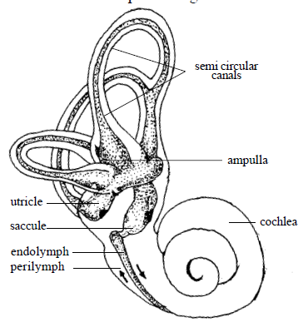 The semicircular canals, vestibule, cochlea etc. are made of membranes. These are filled with a fluid called endolymph and are surrounded by another fluid called perilymph.

**How is hearing made possible?**

Cochlea is the part of the inner ear which helps in hearing. There are three chambers of cochlea. They are located on the basilar membrane which separates the median canal and the lower tympanic canal. They are connected to the auditory nerve.

The upper chamber is connected with the oval window and lower chamber with the round window. Both these membranes are capable of vibration. We recognise the sound when the auditory nerve carries this stimulus to the brain.

**The role of the ear in maintaining the balance of the body**

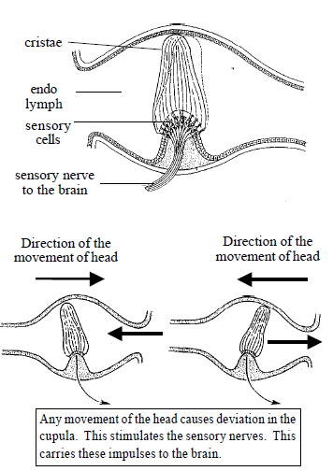 The semicircular canals and vestibule together help to maintain the balance of the body. Observe the figure and examine how this is effected. The swollen end of the semicircular canal is called ampulla. Cupula containing sensory nerves found inside the ampulla can detect any movement of the head. The semicircular canal begins from the vestibule, goes around and rejoins in the vestibule. Small particles of calcium carbonate called otoliths are found near the hair cells of the ampullae and vestibule. The movement of the head in any direction can be detected by the receptor hair cells. The nerve fibres coming from these two types of receptors reach the cerebellum through the auditory nerve.