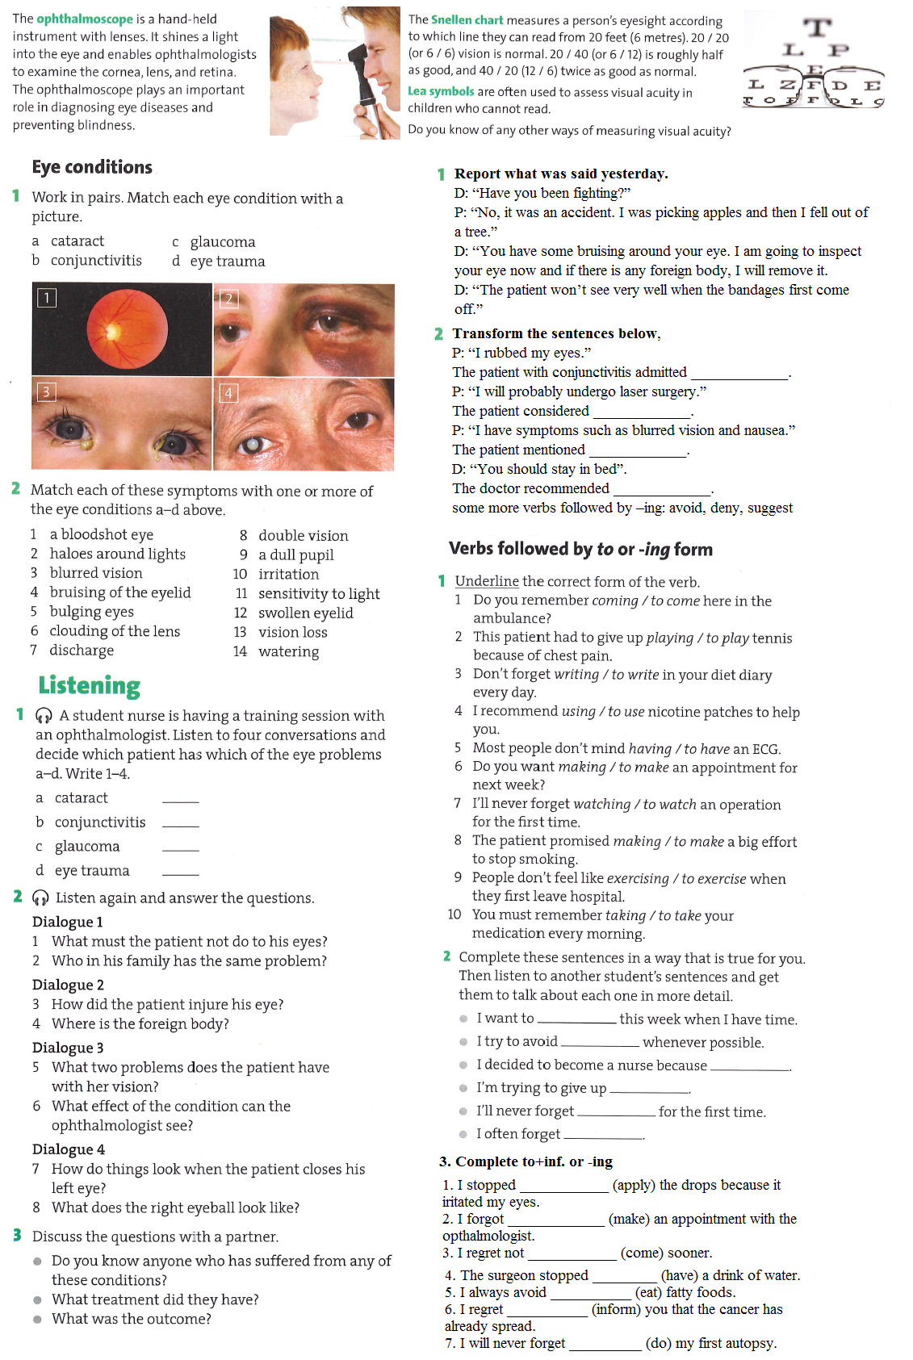

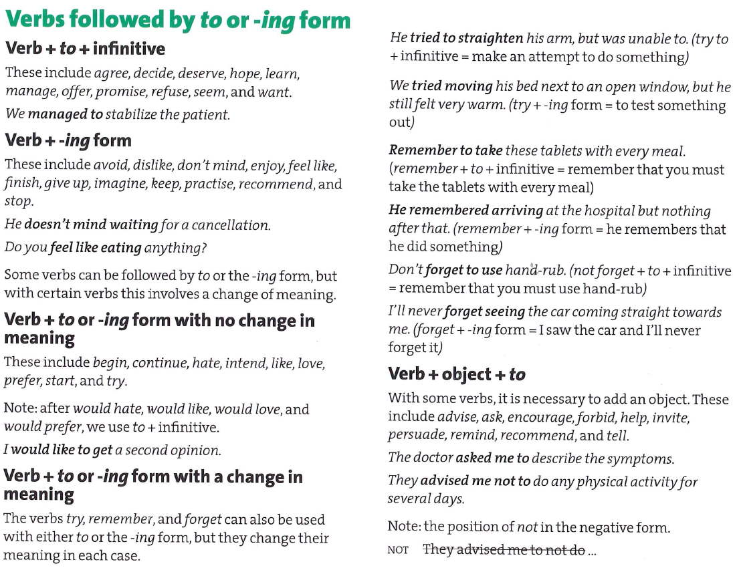

**Read the text and fill in only one most suitable word into each space.**

Ear infections are very common ________ young children. In ________, roughly 70 % of all children have at least one ear infection before the age of six. Most of these infections happen in the middle ear, which is a small place located right behind the ________. The use of antibiotics to treat ear infections has ________ questioned recently by those who argue that some ear infections, like colds, are caused by viruses rather ________ bacteria. Antibiotics are not effective ________ treating viruses, and many people are justifiably concerned ________ the overuse of antibiotics. Studies have also shown ________ about 30 % of middle ear infections do not heal without the use of antibiotic treatment. This means that about 70 % of infections go away on their ________ . The difficulty is that it is impossible, just by examining the ear even by using otoscope, to identify the 30% of children who will need the antibiotics. Identifying these children is important, as untreated inflammation of the middle ear, so called ________ media has the potential to develop serious infectious complications and lead to hearing ________.

Today, in certain situations, such as an older child with a mild infection (red ________ membrane, without any fluid in the middle ear), some physicians may choose not to treat the inflammation right away with antibiotics. ________ , if the middle ear is filled with fluid which does not drain naturally through the ________ tube or if there is persistent discharge from the ear, antibiotics will be prescribed.