Name the parts of uterine tube:

Which structures belong to the parametrium? Draw and describe a simple schema of this structures:

What does it mean the anteversion and anteflexion of the uterus? Sign it in the picture.

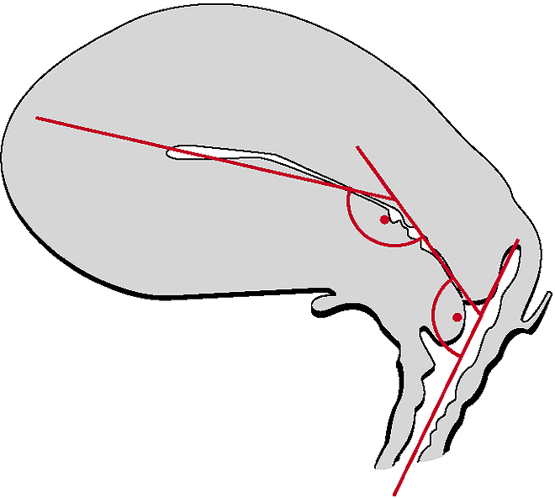

Where is the fossa Claudii (pit of Claudio)? (Describe the difference to the ovarian fossa)

Which structures belong together?

|  |  |
| --- | --- |
| * etremitas tubaria | * anterior wall of vagina |
| * palmate folds (plicae palmatae) | * fossa ovarica |
| * carina urethralis vaginae | * vagina |
| * extremitas uterina | * lig. ovarii proprium |
| * nullipara | * uterus |
| * fornix vaginae | * canalis cervicis (cervical canal) |
| * fimbria ovarica | * ovarium |
| * margo liber | * lig. suspensorium ovarii |
| * endometrium | * tuba uterina |

What´s the name of the x-ray?

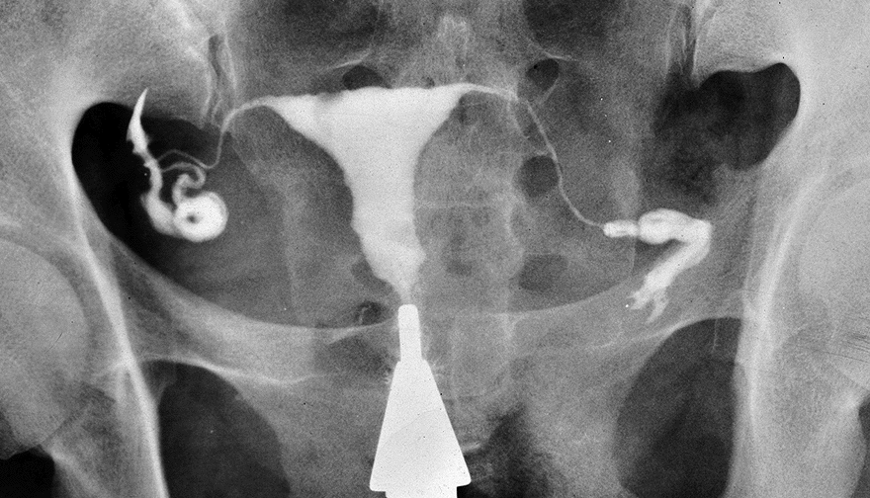

Draw and describe a schema of the female pelvic floor: