**MY OWN LEARNING AND REVISING VOCABULARY FOR MEDICAL ENGLISH CLASS**

**Consider the following account and answer the questions. Get ready to discuss the issue in following week of the semester.**

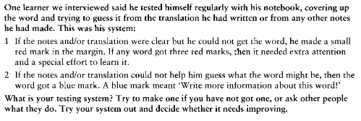

**Your notes:**