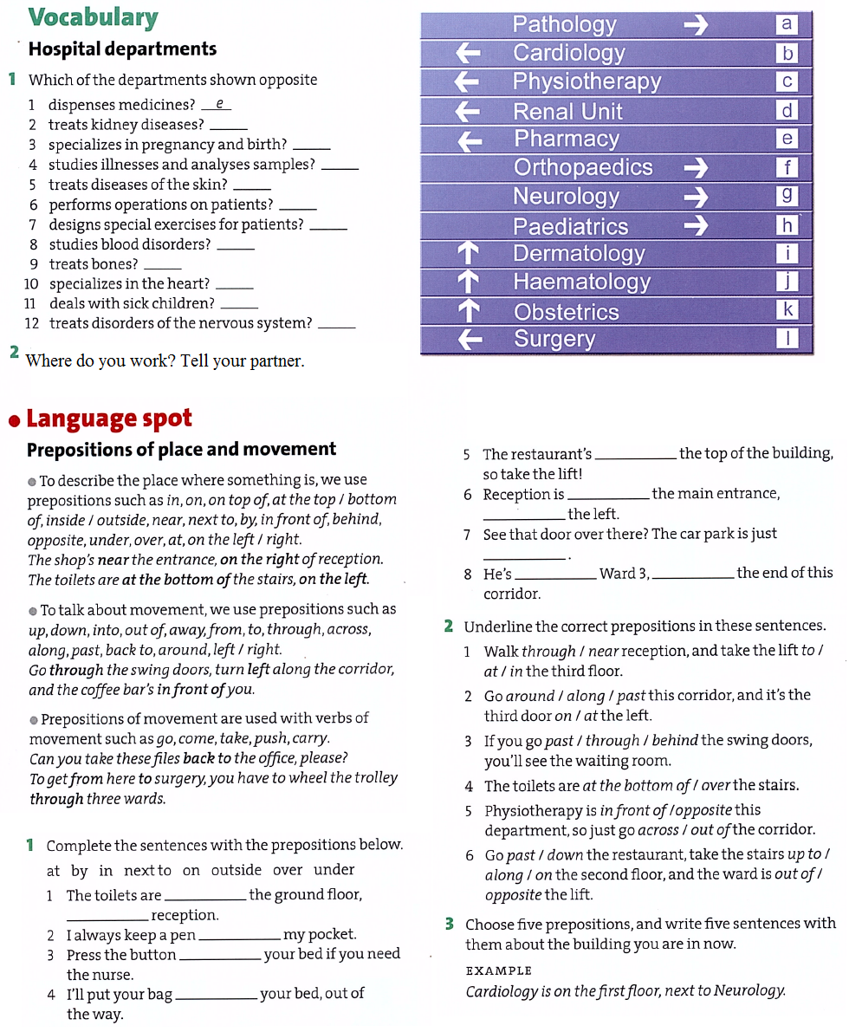

**Hospital admission - he was admitted to the hospital**

I was at a party

I have cancer

I was walking by the river

There is no blood

I checked it on the Internet

He gave me a tablet

It bit me

feel good/bad/weird/normal

it scared me

I am worried

I don’t know what type it was

I saw this big spot

The baby is due next month

I washed up the dishes

I had a few drinks

I worked on a ladder

There was a little blood

I got these pains

I slipped and fell

I hit my head

I don’t feel too bad

I stepped on a snake

I was looking in the mirror

