***Answer the following questions:***

What happens with food in the mouth?

What happens when the bolus reaches the stomach?

What is a gastric ulcer and what are its causes?

What is bile and what role does it play during digestion?

In what part of digestive system do we find villi?

What vitamins are fat-soluble?

WHAT x WHICH

What identifies x Which selects

There is a blue, red and black pen. Which pen do you want? (The choice is limited)

What do you like? (identification)

Sometimes interchangeable:

What planets are closer to the sun than the earth is? (Identify them.)

Which planets are closer to the sun than the earth is? (Select them - from your mental list of the planets)¨

**Name the organs of the digestive system.**

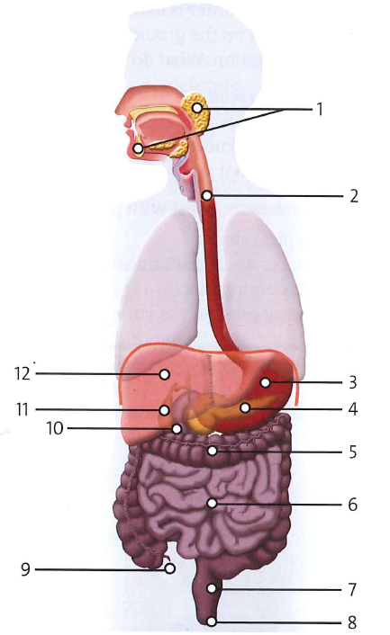

***1. The second halves of the words in the following text were omitted, complete them.***

See the reading

***2. Order these steps in the process of digestion by numbering them 1-7. Change the sentences so that the word in bold is a subject of the sentence.***

a. **Enzymes** are produced by salivary glands in the mouth. __1_

b. **Food** in the stomach is attacked by digestive juices which include powerful acid. _3__

c. When the food is in the small intestine, **undigested fat** is dissolved by juices from the pancreas and bile from the gall bladder.__5__

d. Food, in a liquid paste form, enters the colon where it removes **water**. __6__

e. **Faeces** are expelled by bowel movements. __7___

f. **Muscle action** is started by the first swallow and **food** is pushed through oesophagus.__2_

g. The food, now in a semi-solid state, slowly empties into the small intestine._4___

***3. Rewrite the sentences starting with the word given so that you do not change the meaning of the original sentence:***

***See the grammar explanation***

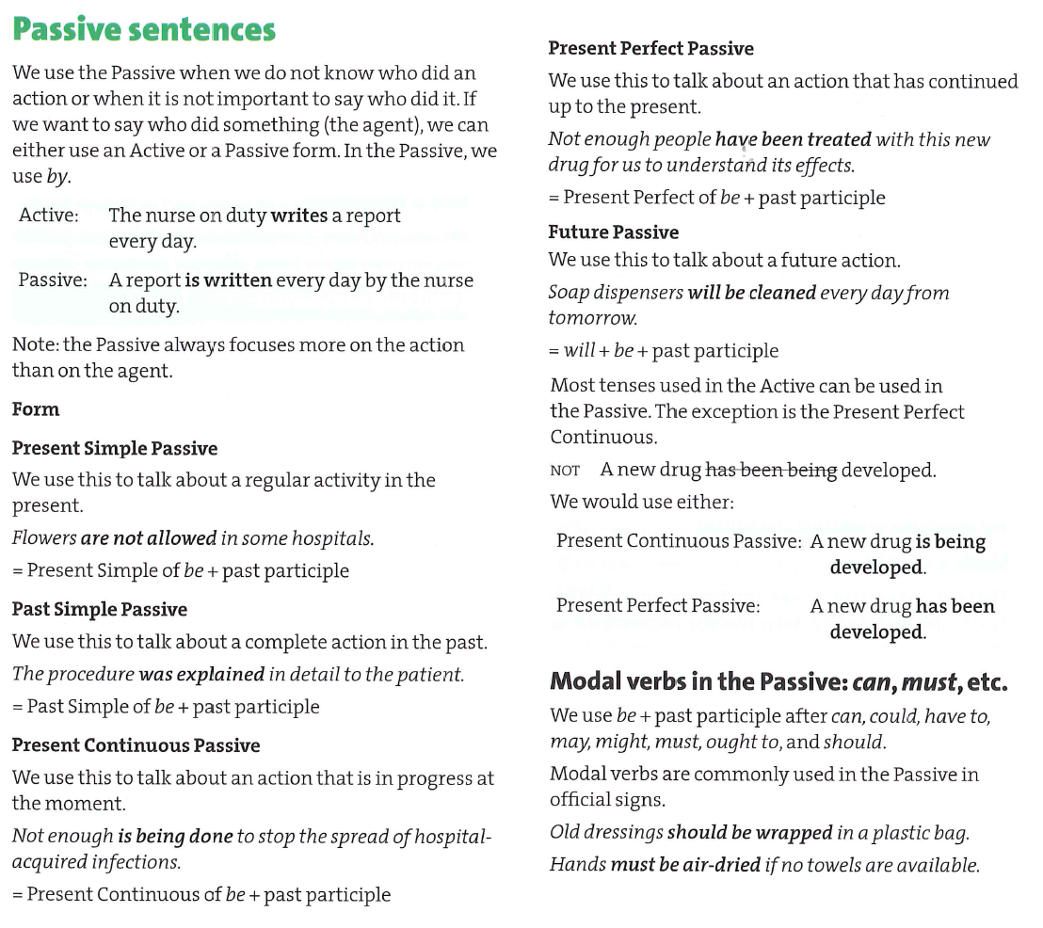

***Reading***

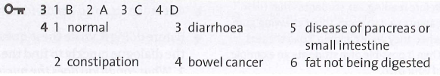

**Look up these words in the article “What faeces reveal” and match them with their meaning.**

flush a) to make a baby stop taking its mother's milk and start to eat solid food

wean b) to get something, to obtain something

acquire c) typical, characteristic

nasty d) to be covered with something with a layer of a substance

coated e) too much gas in your intestines

assess f) to make water pass through a toilet

bowel g) intestines

float h) rest or move slowly on the surface of a liquid and not sink

flatulence i) very unpleasant to taste, smell, see, or feel

distinctive j) to consider or evaluate a situation or problem

***1. Form nouns from the following verbs:***

absorption, appearance, behaviour, consumption, contraction, conversion, death, detoxify - detoxification, discovery, excretion/excrement, elimination, expansion, improvement, ingestion, constipation, qualification, recovery, distinction, secretion, stimulation, treatment

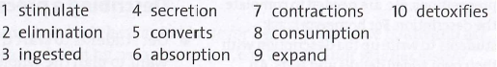

**Word formation: which suffixes may be used with the words below?**

-er/-or:

-er and –ee:

-(t)ion/-sion:

-ition/-ation:

-ist (person), -ism (activity):

-ness:

-ment:

-ity:

-ance/-ence:

-y:

add, recover, appear, exist, happy, scarce, sad, reduce, improve, employ, admit write, pollute, paint, operate, act, physics, Marx, impair, form, discover, produce, intent

**Some unusual word formation:**

free choose grow know laugh lose marry please sell speak think friend

-er/-or: writer, painter, operator, actor

-er and –ee: employer, employee

-(t)ion/-sion: reduction, pollution, admission, intention

-ition/-ation: addition, formation

-ist (person), -ism (activity): physicist, Marxist, Marxism

-ness: sadness, happiness,

-ment: improvement, impairment

-ity: scarcity, productivity

-ance/-ence: appearance, existence

-y: recovery, discovery

freedom, choice, growth, knowledge, laughter, loss, marriage, pleasure, sale, speech, thought, friendship