***1. The second halves of the words in the following text were omitted, complete them.***

Food proce______ begins with inges_______. The tee____ aid in mechan_____ digestion by mastic_____ food. It perm____ easier deglut______. During mastication, sali_____ glands secr_____ saliva to sof_____ the food into a bol_____. Saliva cont_____ amyl____ enz___, which digests star______, and muc_____.

In deglut______, the tongue pus_____ the bol_____ toward the phar____ and into the esoph______, a musc______ tube. To prev_____ food or liq____from enter_____ the wind______, the epiglo______ closes over the open_____ of the lar____ dur_____ swall______.

In the stom_____, food under______ chemical and mechan______ diges____. Perist______ contractions chu____ the bolus, which mix____ with strong diges_______ juices. The stom______ walls cont_____ three layers of smo____ muscle arranged in longitu_____, circ______ and obli_____ rows.

Powerful hydrochloric ac____ in the stomach helps break do_____ the bol___ into a liquid called chy____. When muc____ is limi____ in the stom_____, an ulc____ may form.

The small intes_____ consists of duod_____, jeju_____ and ile____. Bi____ from the gallbl____ begin the fin____ part of diges______. The undige_____ material ente____ the col____, which has si____ parts: the cec____, ascen______ colon, trans_______ colon, descen______ colon, sigm_____ colon and rec_____. The vermi_____ appendix cont____ lymph_____ tissue and interc______ patho______ microorganisms. The fin____ stage of the digest____ process is defec_______.

***2. Order these steps in the process of digestion by numbering them 1-7. Change the sentences so that the word in bold is a subject of the sentence.***

a. Salivary glands in the mouth produce **enzymes**. ___

b. Digestive juices which include powerful acid attack **food** in the stomach. ___

c. When the food is in the small intestine, juices from the pancreas and bile from the gall bladder dissolve **undigested fat**.____

d. Food, in a liquid paste form, enters the colon where it removes **water**. ____

e. Bowel movement expels **faeces**. _____

f. The first swallow starts the **muscle action** and pushes **food** through oesophagus.___

g. The food, now in a semi-solid state, slowly empties into the small intestine.____

***3. Rewrite the sentences starting with the word given so that you do not change the meaning of the original sentence:***

1) We do not allow flowers in our hospital.

Flowers___________________________________________________________________

2) They explained the procedure to the patient in detail.

The procedure______________________________________________________________

3) Medical professionals are not doing enough to stop the spread of hospital acquired infections.

Not enough _______________________________________________________________

4) We have not treated enough people with this new drug to understand its effects.

Not enough _______________________________________________________________

5) We will clean soap dispensers every day from now on.

Soap dispensers ____________________________________________________________

6) We have been developing a new drug for the past three weeks.

A new drug _______________________________________________________________

a) an action in the past that has continued up to the present b) a past finished action

c) future action d) a regular activity e) an action that is in progress at the moment

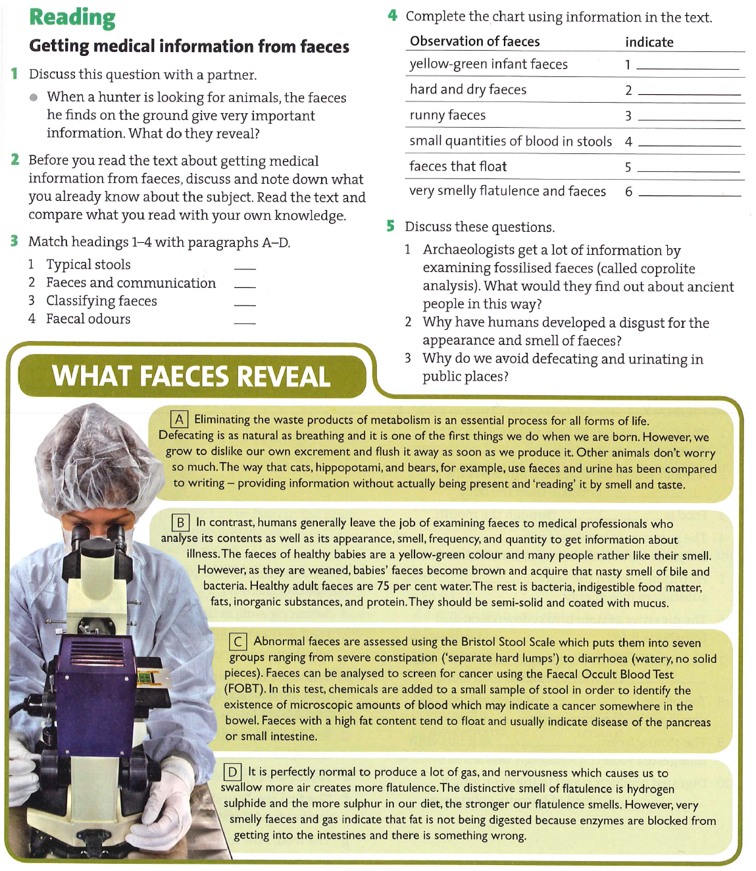

***1. Form nouns from the following verbs:***

absorb, appear, behave, consume, contract, converse, die, detoxify, discover, excrete, eliminate, expand, improve, ingest, constipate, qualify, recover, distinct, secrete, stimulate, treat

