Asking about systems

A Observe the questions and decide which body system they refer to.
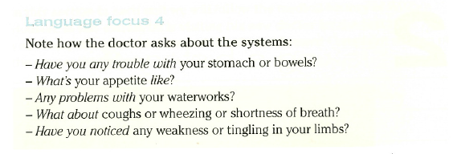

B Other questions aiming at suspected problems.
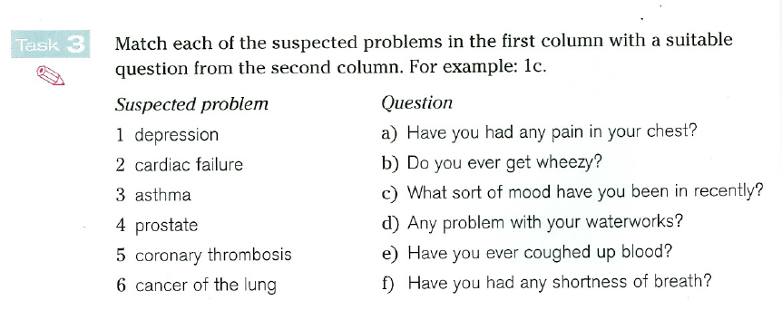
C Complete the grid with possible complaints:
ENT | MS | RS | CVS | GIS | GUS | CNS | psychiatric

